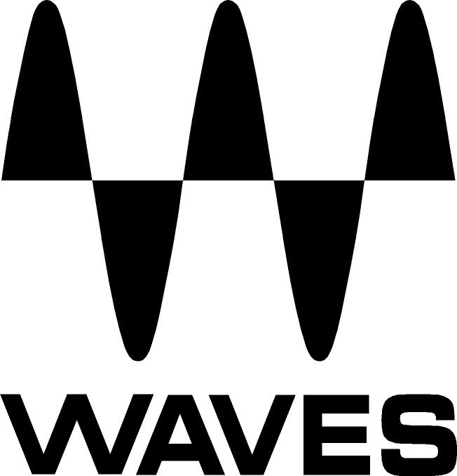

PRESS RELEASE
Contact: Clyne Media, Inc.
Tel: (615) 662-1616
Fax: (615) 662-1636

FOR IMMEDIATE RELEASE

Waves Announces eMotion LV1 Live Mixer V10 Updates and New Features

The NAMM Show, Anaheim, CA, January 24, 2019 — Waves Audio (booth 15302), a leading provider of digital signal processing solutions, announces eMotion LV1 Live Mixer V10 updates and new features. This revolutionary digital mixing console for front-of-house, monitor and broadcast engineers has now been updated to V10 with new exciting features, including I/O sharing with separate gain control for each engineer and shared pre-amp control with automatic individual gain compensation.

Based on Waves SoundGrid technology, the eMotion LV1 delivers the superior sound quality for which Waves is renowned, as well as a quick workflow needed in demanding environments. To offer unprecedented control over every aspect of your live sound, each of the mixer’s channels has its own plugin rack capable of running up to eight Waves and third-party plugins. Subsequently, you can mix live with hundreds of your favorite plugins, all running inside the mixer itself, adding the power and versatility of Waves plugins to the arsenals of engineers everywhere, while shrinking the form factor of a full mixing system down to carry-on size.

The eMotion LV1 V10 adds performance and stability improvements, and it now supports I/O sharing, allowing FOH and monitor engineers to share stageboxes between two eMotion LV1 mixers. To complement this feature, V10 also introduces both shared and separate gain control modes, enabling engineers to set their nominal input levels safely and conveniently, without affecting each other. This means you can get your sources from the stage to multiple destinations at the same time, with separate gain control for each engineer and without having to split the signal with dedicated gear.

The mixer’s channel strip – its standard EQ, filters and dynamics processing – is provided by Waves eMo plugins: eMo D5 Dynamics, eMo F2 Filter and eMo Q4 Equalizer, designed for maximum clarity and efficiency in a live environment. The LV1 also integrates smoothly with the Dugan Speech and Dugan Automixer plugins (purchased separately), which are easily accessible from each LV1 channel.

You can control eMotion LV1 using industry-standard hardware controllers, multi-touch screens and diverse portable devices, from four touchscreens to a single laptop or tablet. Whichever device you are using, the LV1 has the same intuitive workflow, with a user interface built for flexibility and speed.

eMotion LV1 uses the Waves SoundGrid infrastructure for audio networking. It can be configured as a portable or stationary setup and can connect to any SoundGrid-compatible I/O or server. This means you can easily carry your mixer with you and run it anytime, anywhere – at home, in your hotel room, on the tour bus, or at the live venue. This way you can have all the time you need to work on your sessions, whether offline or with full-on audio, and make sure you are 100% ready for your show.

With the Waves eMotion LV1 Live Mixer, you enjoy pristine audio quality, detailed control over your sound, quick and easy setup and operation, and convenient portability.

Waves LV1 V10 features:
- eMotion LV1 video training course available online
- 64 stereo/mono input channels, 36 buss/return channels
- Run 8 SoundGrid-compatible plugins directly on each channel
- Channel strip processing provided by Waves eMo plugins
- 16 auxes (stereo/mono), 8 audio groups, L/R/C/Mono, 8 matrixes (stereo/mono)
- 16 DCA faders, 8 mute groups, 8 user-assignable shortcut keys
- Create your own custom layers for super-quick workflow
- DCA spill – populate layers with DCA-linked channels
- 32-bit floating point mix engine; up to 96 kHz sample rate
- Compatible with industry-standard control surfaces
- Integrates smoothly with the Dugan Speech automixer plugin
- Connects to diverse SoundGrid I/Os & drivers and to multiple DAWs
- FOH and monitor engineers can share the same stagebox between two LV1 mixers
- Windows/Mac 64 bit-compatible

To learn more about eMotion LV1 v10, visit https://www.waves.com/introducing-emotion-lv1-v10.

Videos:
- Introducing eMotion LV1 v10 – New Version of Waves' Live Software Mixer: https://youtu.be/J8JS6HkL7hA
- eMotion LV1 Tutorial 1.7: I/O Sharing: https://youtu.be/IQ4QOA2_XHc

For eMotion LV1 online video training course, visit https://www.waves.com/courses/emotion-lv1-live-mixer-training.

…ends 634 words

Photo file: LV1_V10.JPG
Photo caption: Waves Announces eMotion LV1 Live Mixer V10 Updates and New Features. Special thanks to MxU for photo permission/ http://mxu.rocks/

About Waves Audio Ltd.:
Waves is the world’s leading developer of audio DSP solutions for the professional, broadcast, and consumer electronics audio markets. Since its start in the early '90s with the introduction of the Q10 equalizer plugin, Waves has gone on to develop a comprehensive line of over 150 audio plugins, including industry standards like the L1 and L2 Ultramaximizers, popular vintage console models, and innovative mixing tools like Vocal Rider and the Artist Signature Series. For its accomplishments, Waves received a Technical GRAMMY® Award in 2011, and the Q10 was selected as an inductee into the TECnology Hall of Fame. In 2016, Waves released the eMotion LV1 mixer, a revolutionary live digital mixing console that provides real-time audio mixing for front-of-house, monitor, studio and broadcast engineers. Waves technologies are now used to improve sound quality in virtually every sector of the audio market, from recording, mixing, mastering and post-production to broadcast, live sound, and consumer electronics. Waves has over 25 years of expertise in the development of psychoacoustic signal processing algorithms that leverage knowledge of human auditory perception to radically improve perceived sound quality. Waves’ award-winning processors are utilized to improve sound quality in the creation of hit records, major motion pictures, and top-selling video games worldwide. Waves offers computer software and hardware-plus-software solutions for the professional and broadcast markets. The company’s WavesLive division is a market leader in all live sound sectors, spearheading the development of solutions for all live platforms. Under its Maxx brand, Waves offers semiconductor and licensable algorithms for consumer electronics applications. Waves technologies dramatically enhance audio performance and are used by industry leaders such as Dell, Google, Fitbit, Acer, Asus, Hisense and more.

All other product names and trademarks are the property of their respective owners, which are in no way associated or affiliated with Waves.

North America Offices:
Waves, Inc., 2800 Merchants Drive, Knoxville, TN 37912;
Tel: 865-909-9200, Fax: 865-909-9245, Email: info@waves.com,
Web: http://www.waves.com

Corporate Headquarters Israel:
Waves Ltd., Azrieli Center, The Triangle Tower, 32nd Floor, Tel Aviv 67023, Israel;
Tel: 972-3-608-4000, Fax: 972-3-608-4056, Email: info@waves.com,
Web: http://www.waves.com

Waves Public Relations:
Clyne Media, Inc., 169-B Belle Forest Circle, Nashville, TN 37221;
Tel: 615-662-1616, Fax: 615-662-1636, Email: robert@clynemedia.com,
Web: http://www.clynemedia.com

Waves Audio is exhibiting at booth 15302 at the 2019 NAMM Show in Anaheim, CA.

