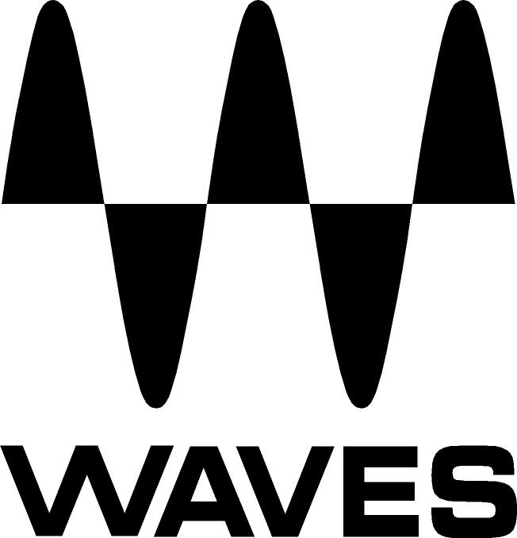

PRESS RELEASE
Contact: Clyne Media, Inc.
Tel: (615) 662-1616
Fax: (615) 662-1636

FOR IMMEDIATE RELEASE

Waves Announces SoundGrid®-Compatible Sound Studio STG Stageboxes

The NAMM Show, Anaheim, California, January 25, 2018 — Waves Audio (booth 15301), a leading provider of digital signal processing solutions and digital music production tools, announces SoundGrid®-compatible stageboxes: the STG-1608 and STG-2412.

Sound Studio stageboxes meet the audio industry’s need for top quality, rugged audio interfaces that can connect and network with modern live sound systems. They are the ultimate stageboxes with high-end audio interfaces for live sound and SoundGrid connectivity, offering pristine sound, easy connectivity and road-readiness.

These rack-mountable STGs come with IOs of 16x8 and 24x12. They feature high-end digitally controlled preamps, AD/DA converters and easy SoundGrid connectivity for real-time plugin processing and monitoring.

The built-in SoundGrid card allows users to quickly interface with the Waves eMotion LV1 live mixer or any other hardware or software in a SoundGrid network. Users can connect a single Ethernet cable to easily record, mix and monitor live or in the studio.

Built to endure the punishing road, these stageboxes are built to last and perform optimally and consistently under the most demanding conditions, on tour and in any live environment.

Sound Studio STG Stageboxes key features:
- XLR/TRS mic/line inputs
- XLR line outputs
- High-end remote-controllable Texas Instruments PGA 2500 mic preamps
- Headphone output
- 48V phantom power with LED indicator per input
- Up to 96 kHz sample rate
- Word Clock I/O
- AES digital I/O; MIDI I/O
- Rugged rack-mountable chassis
- etherCON SoundGrid network port for a secure connection
- Power input AC 100–240V
- Full 1-year warranty

…ends 234 words

Photo file: STG2412.JPG
Photo caption: Sound Studio 24x12 stagebox.

About Waves Audio Ltd.:
Waves is the world’s leading developer of audio DSP solutions for the professional, broadcast, and consumer electronics audio markets. Since its start in the early '90s with the introduction of the Q10 equalizer plugin, Waves has gone on to develop a comprehensive line of over 150 audio plugins, including industry standards like the L1 and L2 Ultramaximizers, popular vintage console models, and innovative mixing tools like Vocal Rider and the Artist Signature Series. For its accomplishments, Waves received a Technical GRAMMY® Award in 2011, and the Q10 was selected as an inductee into the TECnology Hall of Fame. In 2016, Waves released the eMotion LV1 mixer, a revolutionary live digital mixing console that provides real-time audio mixing for front-of-house, monitor, studio and broadcast engineers. Waves technologies are now used to improve sound quality in virtually every sector of the audio market, from recording, mixing, mastering and post-production to broadcast, live sound, and consumer electronics. Waves has over 25 years of expertise in the development of psychoacoustic signal processing algorithms that leverage knowledge of human auditory perception to radically improve perceived sound quality. Waves’ award-winning processors are utilized to improve sound quality in the creation of hit records, major motion pictures, and top-selling video games worldwide. Waves offers computer software and hardware-plus-software solutions for the professional and broadcast markets. The company’s WavesLive division is a market leader in all live sound sectors, spearheading the development of solutions for all live platforms. Under its Maxx brand, Waves offers semiconductor and licensable algorithms for consumer electronics applications. Waves technologies dramatically enhance audio performance and are used by industry leaders such as Dell, Google, TCL, Fujitsu, Asus, Hisense and more.
All other product names and trademarks are the property of their respective owners, which are in no way associated or affiliated with Waves.

North America Offices:
Waves, Inc., 2800 Merchants Drive, Knoxville, TN 37912;
Tel: 865-909-9200, Fax: 865-909-9245, Email: info@waves.com,
Web: http://www.waves.com

Corporate Headquarters Israel:
Waves Ltd., Azrieli Center, The Triangle Tower, 32nd Floor, Tel Aviv 67023, Israel;
Tel: 972-3-608-4000, Fax: 972-3-608-4056, Email: info@waves.com,
Web: http://www.waves.com

Waves Public Relations:
Clyne Media, Inc., 169-B Belle Forest Circle, Nashville, TN 37221;
Tel: 615-662-1616, Fax: 615-662-1636, Email: robert@clynemedia.com,
Web: http://www.clynemedia.com

Waves is exhibiting at booth 15301 at The NAMM Show 2018 in Anaheim, CA.

