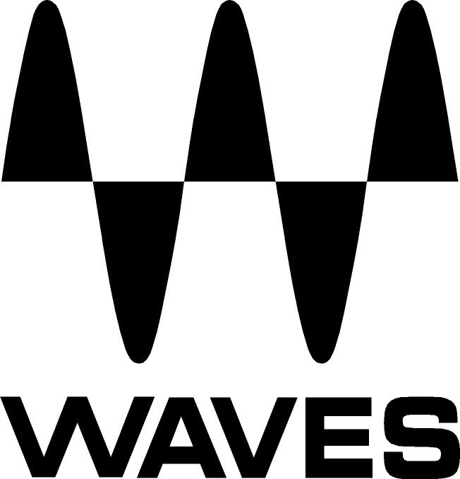

PRESS RELEASE
Contact: Clyne Media, Inc.
Tel: (615) 662-1616
Fax: (615) 662-1636

FOR IMMEDIATE RELEASE

Waves Audio Introduces the PRS SuperModels Plugin

The NAMM Show, Anaheim, California, January 25, 2018 — Waves Audio (booth 15301), a leading provider of processing solutions, introduces the new PRS SuperModels plugin. Created in collaboration with Paul Reed Smith, the Waves PRS SuperModels plugin superbly models three high-end PRS guitar amps: the coveted PRS Archon; the PRS Dallas; and the “Formula One” of amps – the ultra-rare PRS Blue Sierra/V9.

Easy to use, with remarkable tones right out of the box, these models authentically replicate every component of the three exquisite amplifiers. From tubes to circuitry, every detail was painstakingly modeled, literally part by part, with the Waves team and Paul Reed Smith, who supplied Waves with the original amplifiers and full schematics

PRS Archon delivers a shimmering clean or aggressive overdrive; push it harder and you get glorious distortion. A serious pro amp with lush gain, the Archon is ideal for lead or for crunching rhythm, while also offering a clean channel that players of all genres will appreciate.

PRS Blue Sierra/V9: Never-before-released even in its hardware form, this ultra-rare amp was originally created as a prototype that eventually became the original format for the PRS J-MOD 100. Evocative of Boutique American guitar amps, it is equally great for clean sounds and medium-gain overdrive tones. No matter the setting, you’ll find it easy to get a big 3D sound and hard to get a bad one.

PRS Dallas: The Dallas tube guitar amp provides the sounds of classic American reverb amps. The all-tube design produces an open 3D tone for huge-sounding cleans, or an overdriven sound with natural-sounding reverb. A highly musical amp design that was one of Doug Sewell’s first entries in the world amp market, the Dallas offers sweet highs, solid lows and beautiful midrange tones.

Different size speakers produce different sounds. PRS SuperModels lets you choose from eight different speaker cabinet IRs (audio snapshots of speaker cabinets), captured by Paul Reed Smith and Waves at his dedicated personal studio, using his own proven high-end microphones and mic preamps.

As a bonus, you can add up to two of your favorite third-party IRs simultaneously. The plugin’s innovative Phase Fix and Time Fix controls will automatically correct any phase or latency issues between the different IRs. The Smart Mix control will balance the perceived volume of IRs when you use two cabinets. An IR browser will automatically load and switch the IR, leaving you free for playing.

Each amp boasts two more helpful features not included in the original hardware amps: a tone-shaping boost for when you need that vital extra push that normally comes from a boost pedal, and a digital tuner for both standard and extended-range guitars. In addition, a special new noise gate is integrated, that senses at the input and gates at the output.

With three boutique amplifiers to choose from, PRS SuperModels places countless tone options at your fingertips. Whether you are playing rock, jazz, country, metal, blues or any other genre, this exquisite amp plugin will cover all your guitar-playing needs.

Waves PRS SuperModels features:
- Superb modeling of 3 top-of-the-line PRS amplifiers: Archon, Dallas, Blue Sierra / V9
- Created in collaboration with Paul Reed Smith
- Eight speaker cabinet IRs with automatic IR browser
- Exceptional noise gate to filter out amp noise and hiss
- Auto-gain control for maximum performance
- Unique tone-shaping boost not featured in the hardware amps
- Digital tuner sensitive to standard & extended-range guitars
- Smart Mix, Phase Fix & Time Fix controls for perfectly matching 2 cabinets
- Use as a plugin in your DAW or as a standalone application
- Designed for studio, home and live playing (with laptop and audio interface)
- SoundGrid-compatible for ultra-low-latency performance

…ends 597 words

Photo file: PRS_Dallas.JPG
Photo caption: Waves PRS Dallas model, part of the PRS SuperModels plugin

About Waves Audio Ltd.:
Waves is the world’s leading developer of audio DSP solutions for the professional, broadcast, and consumer electronics audio markets. Since its start in the early '90s with the introduction of the Q10 equalizer plugin, Waves has gone on to develop a comprehensive line of over 150 audio plugins, including industry standards like the L1 and L2 Ultramaximizers, popular vintage console models, and innovative mixing tools like Vocal Rider and the Artist Signature Series. For its accomplishments, Waves received a Technical GRAMMY® Award in 2011, and the Q10 was selected as an inductee into the TECnology Hall of Fame. In 2016, Waves released the eMotion LV1 mixer, a revolutionary live digital mixing console that provides real-time audio mixing for front-of-house, monitor, studio and broadcast engineers. Waves technologies are now used to improve sound quality in virtually every sector of the audio market, from recording, mixing, mastering and post-production to broadcast, live sound, and consumer electronics. Waves has over 25 years of expertise in the development of psychoacoustic signal processing algorithms that leverage knowledge of human auditory perception to radically improve perceived sound quality. Waves’ award-winning processors are utilized to improve sound quality in the creation of hit records, major motion pictures, and top-selling video games worldwide. Waves offers computer software and hardware-plus-software solutions for the professional and broadcast markets. The company’s WavesLive division is a market leader in all live sound sectors, spearheading the development of solutions for all live platforms. Under its Maxx brand, Waves offers semiconductor and licensable algorithms for consumer electronics applications. Waves technologies dramatically enhance audio performance and are used by industry leaders such as Dell, Google, TCL, Fujitsu, Asus, Hisense and more.
All other product names and trademarks are the property of their respective owners, which are in no way associated or affiliated with Waves.

North America Offices:
Waves, Inc., 2800 Merchants Drive, Knoxville, TN 37912;
Tel: 865-909-9200, Fax: 865-909-9245, Email: info@waves.com,
Web: http://www.waves.com

Corporate Headquarters Israel:
Waves Ltd., Azrieli Center, The Triangle Tower, 32nd Floor, Tel Aviv 67023, Israel;
Tel: 972-3-608-4000, Fax: 972-3-608-4056, Email: info@waves.com,
Web: http://www.waves.com

Waves Public Relations:
Clyne Media, Inc., 169-B Belle Forest Circle, Nashville, TN 37221;
Tel: 615-662-1616, Fax: 615-662-1636, Email: robert@clynemedia.com,
Web: http://www.clynemedia.com

Waves is exhibiting at booth 15301 at The NAMM Show 2018 in Anaheim, CA.

