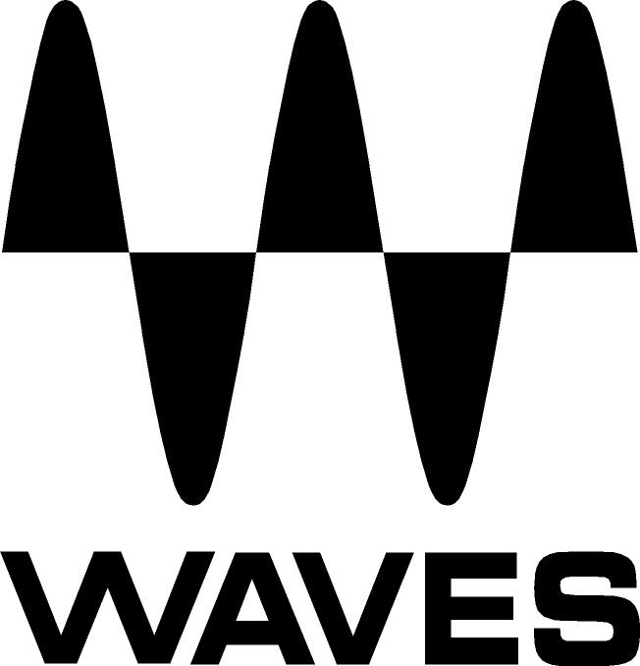

PRESS RELEASE
Contact: Clyne Media, Inc.
Tel: (615) 662-1616
Fax: (615) 662-1636

FOR IMMEDIATE RELEASE

Waves Audio Now Shipping the Waves Primary Source Expander Plugin

THE NAMM SHOW, ANAHEIM, CA, January 19, 2017 — Waves Audio (booth 6620), a leading provider of digital signal processing solutions, is now shipping the Waves Primary Source Expander (PSE) plugin. PSE lets users reduce stage bleed and sensitivity to feedback when a mic is idle by automatically lowering mic levels between musical phrases – perfect for live sound and for mixing live recordings.

At the heart of the Primary Source Expander plugin is a precision expander, tailored especially for melodic sources such as vocals, guitars, strings, brass, woodwinds and more. PSE works like a fader that smoothly attenuates the channel’s level when the source goes below the threshold that’s been set. The user determines both the threshold and the amount of attenuation. Reducing stage noise leakage when microphones are idle will help users get an overall mix that is more coherent, more focused, and has better phase relations.

PSE also provides advanced sidechain and ducking controls for greater consistency and precision when treating complex live scenarios. Whether mixing FOH or monitors in a live venue or working on a live recording in the studio, PSE will ensure that mics are as loud and clean as they can be, while preserving the source’s original tone and the natural ambience of your location.

Waves Primary Source Expander plugin features:
- Reduces stage bleed and sensitivity to feedback when mics are idle
- Smoothly attenuates levels when source drops below the threshold defined
- User-friendly GUI for quick operation – set and forget
- Internal and external sidechain with HP/LP filters
- Ducking mode for added precision in complex live scenarios
- Release time presets

Learn more: www.waves.com/plugins/pse-primary-source-expander.

Videos:
- Maximum Mic Gain, No Feedback – Primary Source Expander Plugin in Action: https://www.youtube.com/watch?v=NsP_5J64ssc
- Reduce Stage Noise and Feedback – Waves Primary Source Expander Plugin Tutorial: https://www.youtube.com/watch?v=5Ag_-xku3Uw
- Introducing Primary Source Expander – Feedback and Stage Noise Prevention Plugin: https://www.youtube.com/watch?v=wm1X2s2wVDk

…ends 296 words

Photo file: PSE.JPG
Photo caption: The graphic user interface for the Waves Primary Source Expander (PSE) plugin.

About Waves Audio Ltd.:
Waves is the world’s leading developer of audio DSP solutions for the professional, broadcast, and consumer electronics audio markets. Since its start in the early '90s with the introduction of the Q10 equalizer plugin, Waves has gone on to develop a comprehensive line of over 200 audio plugins, including industry standards like the L1 and L2 Ultramaximizers, popular vintage console models, and innovative mixing tools like Vocal Rider and the Artist Signature Series. For its accomplishments, Waves received a Technical GRAMMY® Award in 2011, and the Q10 was selected as an inductee into the TECnology Hall of Fame. In 2016, Waves released the eMotion LV1 mixer, a revolutionary live digital mixing console that provides real-time audio mixing for front-of-house, monitor, studio and broadcast engineers. Waves technologies are now used to improve sound quality in virtually every sector of the audio market, from recording, mixing, mastering and post-production to broadcast, live sound, and consumer electronics. Waves has over 20 years of expertise in the development of psychoacoustic signal processing algorithms that leverage knowledge of human auditory perception to radically improve perceived sound quality. Waves’ award-winning processors are utilized to improve sound quality in the creation of hit records, major motion pictures, and top-selling video games worldwide. Waves offers computer software and hardware-plus-software solutions for the professional and broadcast markets. The company’s WavesLive division is a market leader in all live sound sectors, spearheading the development of solutions for all live platforms. Under its Maxx brand, Waves offers semiconductor and licensable algorithms for consumer electronics applications. Waves Maxx technologies dramatically enhance audio performance and are used by industry leaders such as Dell, LG, TCL, Lenovo, Asus, Denon and more.

All other product names and trademarks are the property of their respective owners, which are in no way associated or affiliated with Waves.

North America Offices:
Waves, Inc., 2800 Merchants Drive, Knoxville, TN 37912;
Tel: 865-909-9200, Fax: 865-909-9245, Email: info@waves.com, Web: http://www.waves.com

Corporate Headquarters Israel:
Waves Ltd., Azrieli Center, The Triangle Tower, 32nd Floor
Tel Aviv 67023, Israel; Tel: 972-3-608-4000, Fax: 972-3-608-4056, Email: info@waves.com,
Web: http://www.waves.com

Waves Public Relations:
Clyne Media, Inc., 169-B Belle Forest Circle, Nashville, TN 37221;
Tel: 615-662-1616, Fax: 615-662-1636, Email: robert@clynemedia.com,
Web: http://www.clynemedia.com

Waves is exhibiting at booth 6620 at the 2017 NAMM Show in Anaheim, CA.

