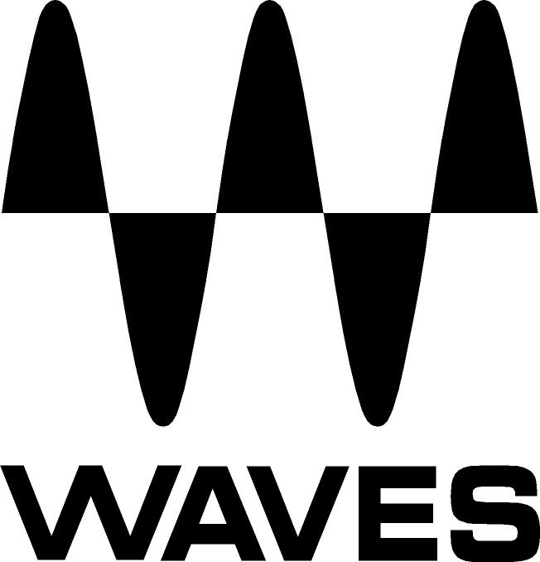

PRESS RELEASE
Contact: Clyne Media, Inc.
Tel: (615) 662-1616
Fax: (615) 662-1636

FOR IMMEDIATE RELEASE

Waves Audio Offers Nx Virtual Mix Room over Headphones

THE NAMM SHOW, ANAHEIM, CA, January 19, 2017 — Waves Audio (booth 6620) is displaying its Waves Nx Virtual Mix Room, a plugin that puts you in the sweet spot – everywhere you go. Powered by the company’s groundbreaking Nx technology, Waves Nx lets you hear, on any pair of headphones, the same natural depth, natural reflections, and panoramic stereo image you would be hearing from speakers in an actual room. It turns headphones into a more reliable mixing and monitoring tool by letting you hear everything with real-world dimension.

Waves Nx finally bridges the gap between monitoring on speakers and monitoring on headphones. Waves Nx with real-time head tracking works by taking advantage of your computer’s camera. By letting you hear the depth and stereo spread you would be hearing on external monitors, Nx gives you an accurate representation of how your headphone mix will translate to loudspeakers without any coloration of your sound. By delivering the natural listening experience of a physical room, Waves Nx also makes the headphone experience more comfortable and ear-friendly over long periods of time.

As a result of the success of Nx Virtual Mix Room, Waves has also introduced a consumer application, Nx Head Tracker, that allows you to enjoy the enhanced realism of being in the Virtual Mix Room, anywhere and everywhere you go. Waves Nx tracks the actual movements of the user’s head, to render the slight nuances that create a real, dynamic and variable sensory experience – appropriately positioning the audio in the left and right headphones to simulate movement through the audio space.

…ends 253 words

Photo file 1: Waves_Nx_GUI_Stereo.JPG
Photo caption 1: Waves Nx graphical user interface in stereo mode.

Photo file 2: Waves_Nx_GUI_Surround.JPG
Photo caption 2: Waves Nx graphical user interface in 5.1 surround mode.

About Waves Audio Ltd.:
Waves is the world’s leading developer of audio DSP solutions for the professional, broadcast, and consumer electronics audio markets. Since its start in the early '90s with the introduction of the Q10 equalizer plugin, Waves has gone on to develop a comprehensive line of over 200 audio plugins, including industry standards like the L1 and L2 Ultramaximizers, popular vintage console models, and innovative mixing tools like Vocal Rider and the Artist Signature Series. For its accomplishments, Waves received a Technical GRAMMY® Award in 2011, and the Q10 was selected as an inductee into the TECnology Hall of Fame. In 2016, Waves released the eMotion LV1 mixer, a revolutionary live digital mixing console that provides real-time audio mixing for front-of-house, monitor, studio and broadcast engineers. Waves technologies are now used to improve sound quality in virtually every sector of the audio market, from recording, mixing, mastering and post-production to broadcast, live sound, and consumer electronics. Waves has over 20 years of expertise in the development of psychoacoustic signal processing algorithms that leverage knowledge of human auditory perception to radically improve perceived sound quality. Waves’ award-winning processors are utilized to improve sound quality in the creation of hit records, major motion pictures, and top-selling video games worldwide. Waves offers computer software and hardware-plus-software solutions for the professional and broadcast markets. The company’s WavesLive division is a market leader in all live sound sectors, spearheading the development of solutions for all live platforms. Under its Maxx brand, Waves offers semiconductor and licensable algorithms for consumer electronics applications. Waves Maxx technologies dramatically enhance audio performance and are used by industry leaders such as Dell, LG, TCL, Lenovo, Asus, Denon and more.

All other product names and trademarks are the property of their respective owners, which are in no way associated or affiliated with Waves.

North America Offices:
Waves, Inc., 2800 Merchants Drive, Knoxville, TN 37912;
Tel: 865-909-9200, Fax: 865-909-9245, Email: info@waves.com, Web: http://www.waves.com

Corporate Headquarters Israel:
Waves Ltd., Azrieli Center, The Triangle Tower, 32nd Floor
Tel Aviv 67023, Israel; Tel: 972-3-608-4000, Fax: 972-3-608-4056, Email: info@waves.com,
Web: http://www.waves.com

Waves Public Relations:
Clyne Media, Inc., 169-B Belle Forest Circle, Nashville, TN 37221;
Tel: 615-662-1616, Fax: 615-662-1636, Email: robert@clynemedia.com,
Web: http://www.clynemedia.com

Waves is exhibiting at booth 6620 at the 2017 NAMM Show in Anaheim, CA.

