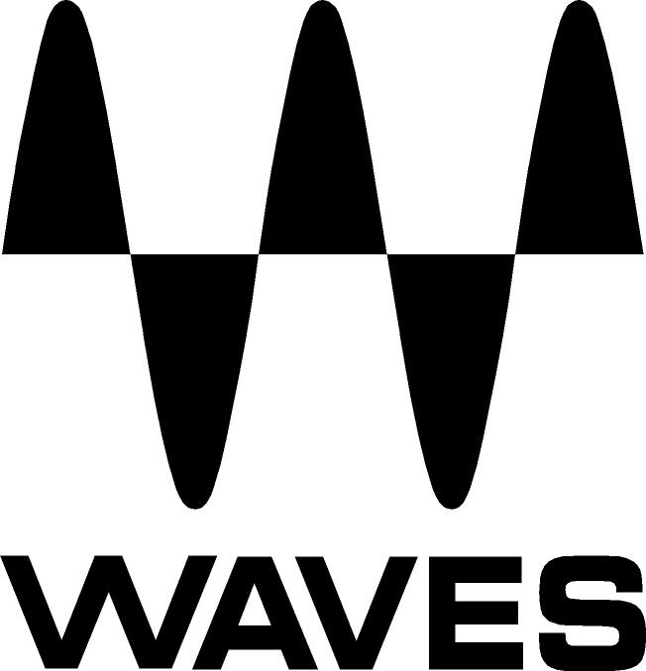

PRESS RELEASE
Contact: Clyne Media, Inc.
Tel: (615) 662-1616
Fax: (615) 662-1636

FOR IMMEDIATE RELEASE

Waves Audio Introduces Electric Grand 80 Piano

THE NAMM SHOW, ANAHEIM, CA, January 19, 2017 — Waves Audio (booth 6620) announces the Electric Grand 80 Piano, a perfect sampling of the legendary 80-model electric grand piano, faithfully sampled from the classic electric grand piano which defined 80s pop, rock and R&B hits by Elton John, George Duke and many others and served electronic music innovators from Vangelis to the present.

Featured on hits by Peter Gabriel, Journey, U2, The Police, Herbie Hancock, Phil Collins, Toto, Hall & Oates, Billy Joel and countless others, the original 80-model electric grand continues to be a favorite among modern rock bands like Keane and electronic musicians such as Ulrich Schnauss. “I had one of the original Yamaha CP-80 electric grand pianos for years,” says top studio musician Charlie Judge, “and it’s great to have that sound once again.”

Electric grands are known for their reverberated chords and polished, shiny leads. Since the original model electric piano uses fewer strings per key than other models, it creates a tone that can be more easily mixed into your music compared to traditional acoustic piano. The Waves version brings to life this electro-acoustic sound, with features from the original such as tone controls and tremolo. Also included is Sustain Resonance, which controls the simulated sympathetic resonance of unplayed strings – perfect for adding depth to long chords and solos alike.

The instrument’s mixer section lets you blend four separately sampled sounds from the original piano: the main sound, the key up, the internal mechanics, and the sustain pedal. With high-quality effects plus a studio-grade compressor and limiter included, you now have everything you need to play Electric Grand 80 in the studio or live on stage.

Waves Electric Grand 80 Piano features:
- Sampled from the classic 80-model electric grand piano heard on hits by Elton John, Peter Gabriel, Journey, Herbie Hancock and many others
- Includes tone controls from the original instrument
- Mix section for adding different sampled sounds from the original (key up, mechanics, sustain pedal)
- Compressor and limiter included
- Effects include tremolo, autopan, phaser, chorus, reverb
- Can be played as a plugin or a standalone instrument

Video: https://youtu.be/AOJ7hmBSNd0

For more information, please visit www.waves.com/80.
…ends 349 words

Photo file: ElectricGrand80.JPG
Photo caption: Waves Electric Grand 80 piano

About Waves Audio Ltd.:
Waves is the world’s leading developer of audio DSP solutions for the professional, broadcast, and consumer electronics audio markets. Since its start in the early '90s with the introduction of the Q10 equalizer plugin, Waves has gone on to develop a comprehensive line of over 200 audio plugins, including industry standards like the L1 and L2 Ultramaximizers, popular vintage console models, and innovative mixing tools like Vocal Rider and the Artist Signature Series. For its accomplishments, Waves received a Technical GRAMMY® Award in 2011, and the Q10 was selected as an inductee into the TECnology Hall of Fame. In 2016, Waves released the eMotion LV1 mixer, a revolutionary live digital mixing console that provides real-time audio mixing for front-of-house, monitor, studio and broadcast engineers. Waves technologies are now used to improve sound quality in virtually every sector of the audio market, from recording, mixing, mastering and post-production to broadcast, live sound, and consumer electronics. Waves has over 20 years of expertise in the development of psychoacoustic signal processing algorithms that leverage knowledge of human auditory perception to radically improve perceived sound quality. Waves’ award-winning processors are utilized to improve sound quality in the creation of hit records, major motion pictures, and top-selling video games worldwide. Waves offers computer software and hardware-plus-software solutions for the professional and broadcast markets. The company’s WavesLive division is a market leader in all live sound sectors, spearheading the development of solutions for all live platforms. Under its Maxx brand, Waves offers semiconductor and licensable algorithms for consumer electronics applications. Waves Maxx technologies dramatically enhance audio performance and are used by industry leaders such as Dell, LG, TCL, Lenovo, Asus, Denon and more.

All other product names and trademarks are the property of their respective owners, which are in no way associated or affiliated with Waves.

North America Offices:
Waves, Inc., 2800 Merchants Drive, Knoxville, TN 37912;
Tel: 865-909-9200, Fax: 865-909-9245, Email: info@waves.com, Web: http://www.waves.com

Corporate Headquarters Israel:
Waves Ltd., Azrieli Center, The Triangle Tower, 32nd Floor
Tel Aviv 67023, Israel; Tel: 972-3-608-4000, Fax: 972-3-608-4056, Email: info@waves.com,
Web: http://www.waves.com

Waves Public Relations:
Clyne Media, Inc., 169-B Belle Forest Circle, Nashville, TN 37221;
Tel: 615-662-1616, Fax: 615-662-1636, Email: robert@clynemedia.com,
Web: http://www.clynemedia.com

Waves is exhibiting at booth 6620 at the 2017 NAMM Show in Anaheim, CA.

