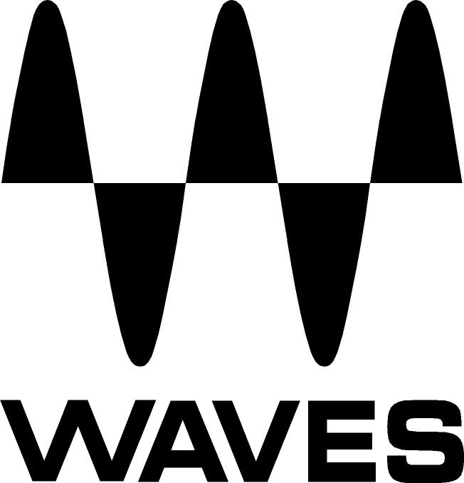

PRESS RELEASE
Contact: Clyne Media, Inc.
Tel: (615) 662-1616
Fax: (615) 662-1636

FOR IMMEDIATE RELEASE

Waves Audio Now Shipping the Waves Electric 200 Piano

THE NAMM SHOW, ANAHEIM, CA, January 19, 2017 — Waves Audio (booth 6620), a leading provider of digital signal processing solutions and digital music production tools, is now shipping the Waves Electric 200 piano, an addition to its expanding line of virtual instruments. Electric 200 is a precise sampling of two classic 200-model electric pianos, as featured on legendary songs by Stevie Wonder, Marvin Gaye and Queen. The plugin features studio-quality effects, compressor, limiter and an amp.

Waves Electric 200 captures the bite, bark and punchy reed tone of the electric piano model used on classic recordings by music giants from Ray Charles, Pink Floyd, Steely Dan and many more. Sampled from two individual instruments, each with its own distinct tone, Electric 200 gives users the flexibility to create classic and adventurous sounds in rock, jazz, R&B and electronic music – “a quantum leap forward in feature, tone, responsiveness, realism and grit from the other sampled Wurlitzer pianos out there,” according to top studio musician Charlie Judge (Carrie Underwood, Blake Shelton, Keith Urban). It is designed to deliver the human touch that is so essential when sampling tonally complex analog instruments. For an authentic feel with true physical presence, users can mix in the sound of the internal piano mechanisms, as if the original instruments were sitting right in front of them.

The included high-quality effects offer an impressive array of versatility in just a few knobs. You can use the phaser for a classic ‘70s stomp pedal sound, add the reverb for natural spatial placement within the mix, or jam live with the intuitive controls for smooth modulation effects. Combined with musical tone controls, the Waves Electric 200 provides endless possibilities for adding this sought-after electric piano sound to your music.

Learn more: https://www.waves.com/200

Videos:

Introducing the Waves Electric 200 Piano Plugin: https://youtu.be/ZmQ-n1xfgdY

Waves Electric 200 Piano Virtual Instrument Demo: https://youtu.be/A-lk2RvMNdk

…ends 298 words

Photo file: E200.JPG
Photo caption: The interface for Waves Electric 200 piano

About Waves Audio Ltd.:
Waves is the world’s leading developer of audio DSP solutions for the professional, broadcast, and consumer electronics audio markets. Since its start in the early '90s with the introduction of the Q10 equalizer plugin, Waves has gone on to develop a comprehensive line of over 200 audio plugins, including industry standards like the L1 and L2 Ultramaximizers, popular vintage console models, and innovative mixing tools like Vocal Rider and the Artist Signature Series. For its accomplishments, Waves received a Technical GRAMMY® Award in 2011, and the Q10 was selected as an inductee into the TECnology Hall of Fame. In 2016, Waves released the eMotion LV1 mixer, a revolutionary live digital mixing console that provides real-time audio mixing for front-of-house, monitor, studio and broadcast engineers. Waves technologies are now used to improve sound quality in virtually every sector of the audio market, from recording, mixing, mastering and post-production to broadcast, live sound, and consumer electronics. Waves has over 20 years of expertise in the development of psychoacoustic signal processing algorithms that leverage knowledge of human auditory perception to radically improve perceived sound quality. Waves’ award-winning processors are utilized to improve sound quality in the creation of hit records, major motion pictures, and top-selling video games worldwide. Waves offers computer software and hardware-plus-software solutions for the professional and broadcast markets. The company’s WavesLive division is a market leader in all live sound sectors, spearheading the development of solutions for all live platforms. Under its Maxx brand, Waves offers semiconductor and licensable algorithms for consumer electronics applications. Waves Maxx technologies dramatically enhance audio performance and are used by industry leaders such as Dell, LG, TCL, Lenovo, Asus, Denon and more.

All other product names and trademarks are the property of their respective owners, which are in no way associated or affiliated with Waves.

North America Offices:
Waves, Inc., 2800 Merchants Drive, Knoxville, TN 37912;
Tel: 865-909-9200, Fax: 865-909-9245, Email: info@waves.com, Web: http://www.waves.com

Corporate Headquarters Israel:
Waves Ltd., Azrieli Center, The Triangle Tower, 32nd Floor
Tel Aviv 67023, Israel; Tel: 972-3-608-4000, Fax: 972-3-608-4056, Email: info@waves.com,
Web: http://www.waves.com

Waves Public Relations:
Clyne Media, Inc., 169-B Belle Forest Circle, Nashville, TN 37221;
Tel: 615-662-1616, Fax: 615-662-1636, Email: robert@clynemedia.com,
Web: http://www.clynemedia.com

Waves is exhibiting at booth 6620 at the 2017 NAMM Show in Anaheim, CA.

