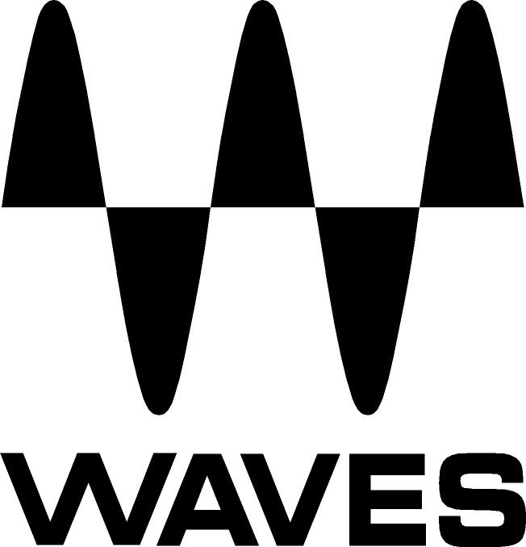

PRESS RELEASE
Contact: Clyne Media, Inc.
Tel: (615) 662-1616
Fax: (615) 662-1636

FOR IMMEDIATE RELEASE

Waves Audio Introduces the Dugan Speech Automixer Plugin

THE NAMM SHOW, ANAHEIM, CA, January 19, 2017 — Waves Audio (booth 6620) announces the Waves Dugan Speech plugin, the new official software version of the Dugan automixer for automatic control of multiple mic gains, designed for integrated use inside the eMotion LV1 live mixing console.

Powered by Dan Dugan's patented voice-activated process, Dugan Speech controls the gains of multiple microphones automatically and in real time, dramatically reducing noise, feedback and comb filtering from adjacent microphones.

Dugan Speech ensures that system gain remains consistent, even when several speakers are talking at the same time. It makes perfectly matched crossfades, without any signal compression whatsoever, and without a noise gate that would cause undesirable artifacts.

The familiar Dugan automixer interface is incorporated into a designated layer mode within the eMotion LV1 mixing console, which users can easily access from any LV1 channel.

Dugan Speech is the definitive solution for television news and discussion panels, talk shows, faith-based services and events, film and TV dialog recording, conferences, and any other event involving several microphones and participants.

Waves Dugan Speech plugin features:
- Mixes multiple live microphones automatically and in real time
- Auto-mixes up to 64 channels simultaneously
- Integrates smoothly into the eMotion LV1 live mixer
- Developed in association with Dan Dugan
- Dugan mute/override groups integrated into the LV1 mixer’s Mute function
- Multi-touch compatibility
- Ideal for scenarios involving several participants and microphones

…ends 219 words

Photo file: DuganSpeech.JPG
Photo caption: The interface of the Dugan Speech System, integrated with the eMotion LV1 live mixing console.

About Waves Audio Ltd.:
Waves is the world’s leading developer of audio DSP solutions for the professional, broadcast, and consumer electronics audio markets. Since its start in the early '90s with the introduction of the Q10 equalizer plugin, Waves has gone on to develop a comprehensive line of over 200 audio plugins, including industry standards like the L1 and L2 Ultramaximizers, popular vintage console models, and innovative mixing tools like Vocal Rider and the Artist Signature Series. For its accomplishments, Waves received a Technical GRAMMY® Award in 2011, and the Q10 was selected as an inductee into the TECnology Hall of Fame. In 2016, Waves released the eMotion LV1 mixer, a revolutionary live digital mixing console that provides real-time audio mixing for front-of-house, monitor, studio and broadcast engineers. Waves technologies are now used to improve sound quality in virtually every sector of the audio market, from recording, mixing, mastering and post-production to broadcast, live sound, and consumer electronics. Waves has over 20 years of expertise in the development of psychoacoustic signal processing algorithms that leverage knowledge of human auditory perception to radically improve perceived sound quality. Waves’ award-winning processors are utilized to improve sound quality in the creation of hit records, major motion pictures, and top-selling video games worldwide. Waves offers computer software and hardware-plus-software solutions for the professional and broadcast markets. The company’s WavesLive division is a market leader in all live sound sectors, spearheading the development of solutions for all live platforms. Under its Maxx brand, Waves offers semiconductor and licensable algorithms for consumer electronics applications. Waves Maxx technologies dramatically enhance audio performance and are used by industry leaders such as Dell, LG, TCL, Lenovo, Asus, Denon and more.

All other product names and trademarks are the property of their respective owners, which are in no way associated or affiliated with Waves.

North America Offices:
Waves, Inc., 2800 Merchants Drive, Knoxville, TN 37912;
Tel: 865-909-9200, Fax: 865-909-9245, Email: info@waves.com, Web: http://www.waves.com

Corporate Headquarters Israel:
Waves Ltd., Azrieli Center, The Triangle Tower, 32nd Floor
Tel Aviv 67023, Israel; Tel: 972-3-608-4000, Fax: 972-3-608-4056, Email: info@waves.com,
Web: http://www.waves.com

Waves Public Relations:
Clyne Media, Inc., 169-B Belle Forest Circle, Nashville, TN 37221;
Tel: 615-662-1616, Fax: 615-662-1636, Email: robert@clynemedia.com,
Web: http://www.clynemedia.com

Waves is exhibiting at booth 6620 at the 2017 NAMM Show in Anaheim, CA.

