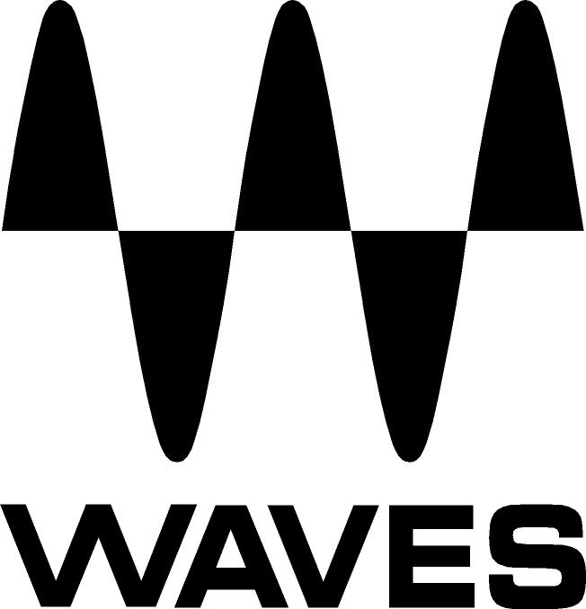

PRESS RELEASE
Contact: Clyne Media, Inc.
Tel: (615) 662-1616
Fax: (615) 662-1636

FOR IMMEDIATE RELEASE

Waves Audio Now Shipping the Abbey Road Vinyl Plugin

THE NAMM SHOW, ANAHEIM, CA, January 19, 2017 — Waves Audio (booth 6620), a leading provider of digital signal processing solutions, is now shipping the Waves Abbey Road Vinyl Plugin – a precise model of Abbey Road Studios’ vinyl cutting and playback gear, designed to give your music the vintage warmth of vinyl records played on classic turntables and needles.

There are few things in music that capture the emotion of diehard fans more than vinyl. The retro feel of a record, combined with the analog warmth of its sound, makes vinyl a beautiful nostalgic statement. Designed with Abbey Road Studios, this plugin faithfully captures every stage of the vinyl production and playback process: you can choose between the sound of a pure acetate (lacquer) cut or the print master vinyl pressing from the factory; play the records on two distinct turntable types with a choice of three classic cartridges; and even send your tracks through Abbey Road’s legendary TG12410 mastering console on the path into the vinyl lathe.

For added authenticity and creativity, Abbey Road Vinyl even lets you move the position of the tone arm across the record, changing the frequency response and distortion like in the real world. You can also add vinyl noise, pops and crackles, apply a gradual slow-down/stop turntable effect, and add wow and flutter effects for extra analog warmth.

Abbey Road Vinyl is the long-awaited tool for diverse audio users: from mixing engineers craving a distinct smooth sound, to EDM and hip hop artists who cherish that "needle" touch, to sound designers reaching for authentic vinyl qualities and producers seeking a true-to-vinyl dimension on their tracks.

Mick Olesh, Waves EVP of Sales & Marketing, comments, “Waves is excited to include this unique and novel plugin in the Waves Abbey Road Collection, yet another result of Waves’ fruitful cooperation with Abbey Road studios.”

Mirek Stiles, Head of Audio Products at Abbey Road, comments, “One of the really amazing things about this plugin is that it allows you to experiment with the vinyl sound in ways and situations that just wouldn’t be practical in the real world. This is a really authentic plugin of the vinyl sound, which no one has done before. The sound that’s been captured with this plugin, and the work that Waves has done, is absolutely amazing.”

Geoff Pesche, Vinyl Mastering and Cutting Engineer at Abbey Road Studios, who has cut modern classics such as New Order’s “Blue Monday” and Dire Straits’ Brothers In Arms, as well as Coldplay, Dizzee Rascal and Blur, adds, "This is the true sound of vinyl cutting at Abbey Road: the noise, the clicks, the bumps, the wow and flutter, all that ‘nasty’ stuff on records that people love – the analog sound and the warmth."

Waves Abbey Road Vinyl features:
- Add authentic vintage vinyl sound to your tracks
- Precise model of the original vinyl cutting gear at Abbey Road Studios
- Choose between acetate master and printed vinyl pressing
- 2 turntables, 3 cartridges
- Slow-down/stop turntable mechanism
- Control tone arm position for variable frequency response/distortion
- Add phase distortion; noise, pops and crackles; wow and flutter; modulation
- Add the sound of Abbey Road’s EMI TG12410 mastering desk

The Abbey Road Vinyl plugin is included in the Waves Abbey Road Collection bundle.

To learn more, visit www.waves.com/plugins/abbey-road-vinyl.

Videos:
Introducing the Waves Abbey Road Vinyl Plugin: https://youtu.be/f_HZ3YQWeXw

The Art of Vinyl Cutting and Mastering at Abbey Road Studios: https://youtu.be/sJcV34UmWRI

…ends 556 words

Photo file: Waves_AbbeyRoadVinyl.JPG
Photo caption: The graphic user interface for the Waves Abbey Road Vinyl plugin

About Abbey Road Studios:
Abbey Road Studios is the most famous recording studios in the world and a global music icon.

Home to countless landmark recordings and pioneering advances in recording technology, the legendary studio complex has a phenomenal history spanning over 80 years, encompassing celebrated work by many of the world’s most famous recording artists including The Beatles, Pink Floyd, Frank Ocean, Florence + The Machine, Radiohead, Oasis, Kanye West, Lady Gaga and Adele.

Since the score for Raiders of The Lost Ark was recorded at the studios in 1980, Abbey Road has developed into one of the world’s premiere locations for movie scoring. Blockbuster films such as The Lord of The Rings Trilogy, The King’s Speech and Skyfall feature scores recorded there, while recent projects include the Oscar-winning score to Gravity. Additionally, a number of high-profile video games such as Halo 5 and Call of Duty have recorded in-game music at Abbey Road Studios.

The studios house a number of state of the art mastering suites. Recent projects mastered or re-mastered by Abbey Road’s award-winning engineers include music from Sam Smith, Ed Sheeran, Queen, The Smiths, Depeche Mode, New Order, Mary J. Blige.

Abbey Road Studios also offers online mixing and mastering, audio products for professional and home studio music producers, live concert recording, archiving and video services. The studios also host a select number of special events each year.

Abbey Road recently launched Abbey Road Red, Europe’s first music-focused technology incubator which supports the endeavours of entrepreneurs, research and developers.

Abbey Road Institute recently began offering vocational diplomas in music production and audio engineering to students at the studio complex in London and state of the art facilities in Paris, Berlin, Amsterdam, Munich, Melbourne and Sydney.

About Waves Audio Ltd.:
Waves is the world’s leading developer of audio DSP solutions for the professional, broadcast, and consumer electronics audio markets. Since its start in the early '90s with the introduction of the Q10 equalizer plugin, Waves has gone on to develop a comprehensive line of over 200 audio plugins, including industry standards like the L1 and L2 Ultramaximizers, popular vintage console models, and innovative mixing tools like Vocal Rider and the Artist Signature Series. For its accomplishments, Waves received a Technical GRAMMY® Award in 2011, and the Q10 was selected as an inductee into the TECnology Hall of Fame. In 2016, Waves released the eMotion LV1 mixer, a revolutionary live digital mixing console that provides real-time audio mixing for front-of-house, monitor, studio and broadcast engineers. Waves technologies are now used to improve sound quality in virtually every sector of the audio market, from recording, mixing, mastering and post-production to broadcast, live sound, and consumer electronics. Waves has over 20 years of expertise in the development of psychoacoustic signal processing algorithms that leverage knowledge of human auditory perception to radically improve perceived sound quality. Waves’ award-winning processors are utilized to improve sound quality in the creation of hit records, major motion pictures, and top-selling video games worldwide. Waves offers computer software and hardware-plus-software solutions for the professional and broadcast markets. The company’s WavesLive division is a market leader in all live sound sectors, spearheading the development of solutions for all live platforms. Under its Maxx brand, Waves offers semiconductor and licensable algorithms for consumer electronics applications. Waves Maxx technologies dramatically enhance audio performance and are used by industry leaders such as Dell, LG, TCL, Lenovo, Asus, Denon and more.

All other product names and trademarks are the property of their respective owners, which are in no way associated or affiliated with Waves.

North America Offices:
Waves, Inc., 2800 Merchants Drive, Knoxville, TN 37912;
Tel: 865-909-9200, Fax: 865-909-9245, Email: info@waves.com, Web: http://www.waves.com

Corporate Headquarters Israel:
Waves Ltd., Azrieli Center, The Triangle Tower, 32nd Floor
Tel Aviv 67023, Israel; Tel: 972-3-608-4000, Fax: 972-3-608-4056, Email: info@waves.com,
Web: http://www.waves.com

Waves Public Relations:
Clyne Media, Inc., 169-B Belle Forest Circle, Nashville, TN 37221;
Tel: 615-662-1616, Fax: 615-662-1636, Email: robert@clynemedia.com,
Web: http://www.clynemedia.com

Waves is exhibiting at booth 6620 at the 2017 NAMM Show in Anaheim, CA.

