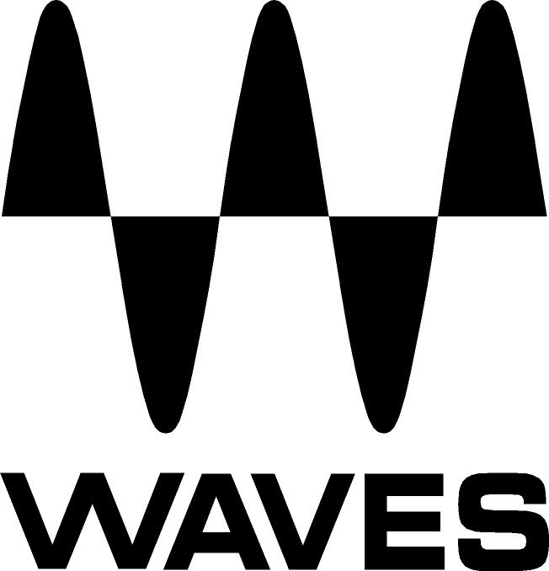

PRESS RELEASE
Contact: Clyne Media, Inc.
Tel: (615) 662-1616
Fax: (615) 662-1636

FOR IMMEDIATE RELEASE

Waves Audio Now Shipping the Greg Wells MixCentric Plugin

THE NAMM SHOW, ANAHEIM, CA, January 21, 2016 — Waves Audio (Booth 6620, Hall A), a leading provider of digital signal processing solutions, is now shipping the Waves Greg Wells MixCentric plugin, part of the Waves Signature Series. Created in collaboration with multiple GRAMMY®-nominated producer, musician and mixing engineer Greg Wells (Adele, Katy Perry, OneRepublic), who has songs on over 85 million units sold, Greg Wells MixCentric is an intuitive plugin that offers a quick solution for putting a finishing touch on your mix.

Using EQ, compression and harmonic distortion to process your master buss or groups, the Greg Wells MixCentric plugin enhances and balances the tonality of your mix. Combined with your limiter of choice, it brings your mix up to par with fully mastered and released material.

Whether used in mono or stereo mode, this plugin gives users direct access to Greg Wells’ signature sound with the turn of just a single knob.

Greg Wells remarks, “This plugin is very special, and much agonizing and experimenting went into it. The MixCentric plugin will quickly get your track sounding like an expertly EQ’ed and compressed mix, using the same techniques employed by many of the best mix engineers. There is an enormous amount going on behind the deceptive simplicity of the control knob, including many different settings that come in and out and change as you move the knob position. Play with it and discover the incredible power of this user-friendly plugin. There has never been a plugin like MixCentric, and I wish I had it 20 years ago!”

The Waves Greg Wells MixCentric plugin is available separately or as part of the new Greg Wells Signature Series bundle, which also includes the Greg Wells VoiceCentric and Greg Wells PianoCentric plugins.

Video Links:
Greg Wells demonstrates his Mixing Plugin MixCentric: https://youtu.be/N7e0CPhg_z4‬
‬‪Introducing the Greg Wells Signature Series Plugin Collection: https://youtu.be/tQH4jeh5Jcs‬

For more information, please visit http://www.waves.com/plugins/greg-wells-mixcentric.
…ends 289 words

Photo file 1: GW_MixCentric_GUI.JPG
Photo caption 1: The graphic user interface of the Waves Greg Wells MixCentric plugin.

Photo file 2: GW_Bundle.JPG
Photo caption 2: The Waves Greg Wells Signature Series bundle, which includes Greg Wells MixCentric, VoiceCentric and PianoCentric plugins.

About Waves Audio Ltd.:
Waves is the world’s leading developer of audio DSP solutions for the professional, broadcast, and consumer electronics audio markets. Since its start in the early '90s with the introduction of the Q10 equalizer plugin, Waves has gone on to develop a comprehensive line of over 200 audio plugins, including industry standards like the L1 and L2 Ultramaximizers, popular vintage console models, and innovative mixing tools like Vocal Rider and the Artist Signature Series. For its accomplishments, Waves received a Technical GRAMMY® Award in 2011, and the Q10 was selected as an inductee into the TECnology Hall of Fame. Waves technologies are now used to improve sound quality in virtually every sector of the audio market, from recording, mixing, mastering and post-production to broadcast, live sound, and consumer electronics. Waves has over 20 years of expertise in the development of psychoacoustic signal processing algorithms that leverage knowledge of human auditory perception to radically improve perceived sound quality. Waves’ award-winning processors are utilized to improve sound quality in the creation of hit records, major motion pictures, and top-selling video games worldwide. Waves offers computer software and hardware-plus-software solutions for the professional and broadcast markets. The company’s WavesLive division is a market leader in all live sound sectors, spearheading the development of solutions for all live platforms. Under its Maxx brand, Waves offers semiconductor and licensable algorithms for consumer electronics applications. Waves Maxx technologies dramatically enhance audio performance and are used by industry leaders such as Dell, LG, TCL, Lenovo, Asus, Denon and more.

All other product names and trademarks are the property of their respective owners, which are in no way associated or affiliated with Waves.

North America Offices:
Waves, Inc., 2800 Merchants Drive, Knoxville, TN 37912;
Tel: 865-909-9200, Fax: 865-909-9245, Email: info@waves.com, Web: http://www.waves.com

Corporate Headquarters Israel:
Waves Ltd., Azrieli Center, The Triangle Tower, 32nd Floor
Tel Aviv 67023, Israel; Tel: 972-3-608-4000, Fax: 972-3-608-4056, Email: info@waves.com,
Web: http://www.waves.com

Waves Public Relations:
Clyne Media, Inc., 169-B Belle Forest Circle, Nashville, TN 37221;
Tel: 615-662-1616, Fax: 615-662-1636, Email: robert@clynemedia.com,
Web: http://www.clynemedia.com

Waves Audio is exhibiting at Booth 6620 (Hall A) at the 2016 NAMM Show in Anaheim, California.

