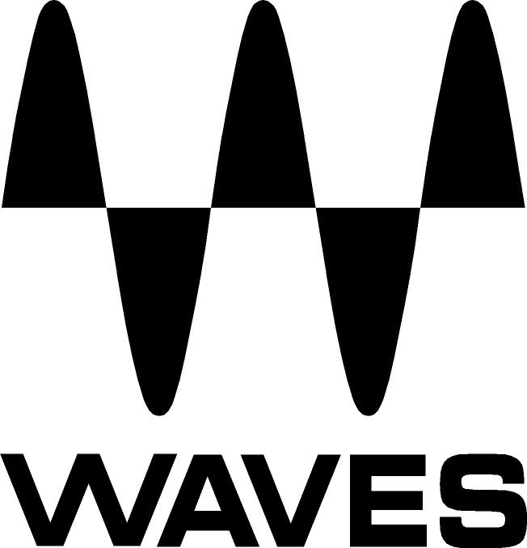

PRESS RELEASE
Contact: Clyne Media, Inc.
Tel: (615) 662-1616
Fax: (615) 662-1636

FOR IMMEDIATE RELEASE

Waves Audio Teams with HARMAN Professional to Unveil the Waves dbx® 160 Plugin

THE NAMM SHOW, ANAHEIM, CA, January 22, 2015 — Waves Audio (booth 6824) has teamed with HARMAN Professional to introduce the Waves dbx® 160 compressor plugin. Founded in 1971, dbx has always aimed “to get closer to the realism of a live performance.” This goal guided the development of the Waves dbx 160 plugin, allowing users to achieve stunning realism in the studio or to add nuance to an actual live performance.

Considered one of the best drum compressors ever, the fast-acting dbx 160 stands tall among its peers, boasting a very clean sound with minimum THD. The original dbx 160 compressor was used in almost every major recording in the late 1970s and throughout the 80s, and later models in the 160 series also became an industry standard.

Created in collaboration with dbx and authorized by HARMAN, the Waves dbx 160 utilizes advanced and meticulous modeling technologies that result in the most authentic-sounding emulation in existence. Waves offers this realism in both Native and SoundGrid® versions.

The Waves dbx 160 is intended for use in the studio and live. It also features an MS matrix, mix and noise controls, and a stereo component (the original hardware was mono only).

Jason Kunz, dbx Market Manager of Recording & Broadcast, comments, “We at dbx Professional Products are very excited to be working with Waves on the legacy 160 dbx plugin. The meticulous detail that Waves dedicates to their product development is clearly heard in the finished product."
...ends 236 words

Photo Files: dbx160.JPG

About Waves Ltd.:
Waves is the world’s leading developer of audio DSP solutions for the professional, broadcast, and consumer electronics audio markets. Since its start in the early '90s with the introduction of the Q10 equalizer plugin, Waves has gone on to develop a comprehensive line of over 200 audio plugins, including industry standards like the L1 and L2 Ultramaximizers, popular vintage console models, and innovative mixing tools like Vocal Rider and the Artist Signature Series. For its accomplishments, Waves received a Technical GRAMMY® Award in 2011, and the Q10 was selected as an inductee into the TECnology Hall of Fame. Waves technologies are now used to improve sound quality in virtually every sector of the audio market, from recording, mixing, mastering and post-production to broadcast, live sound, and consumer electronics. Waves has over 20 years of expertise in the development of psychoacoustic signal processing algorithms that leverage knowledge of human auditory perception to radically improve perceived sound quality. Waves’ award-winning processors are utilized to improve sound quality in the creation of hit records, major motion pictures, and top-selling video games worldwide. Waves offers computer software and hardware-plus-software solutions for the professional and broadcast markets. The company’s WavesLive division is a market leader in all live sound sectors, spearheading the development of solutions for all live platforms. Under its Maxx brand, Waves offers semiconductor and licensable algorithms for consumer electronics applications. Waves Maxx technologies dramatically enhance audio performance and are used by industry leaders such as Dell, ASUS, JVC, and many others.

All other product names and trademarks are the property of their respective owners, which are in no way associated or affiliated with Waves.

North America Offices:
Waves, Inc., 2800 Merchants Drive, Knoxville, TN 37912;
Tel: 865-909-9200, Fax: 865-909-9245, Email: info@waves.com, Web: http://www.waves.com

Corporate Headquarters Israel:
Waves Ltd., Azrieli Center, The Triangle Tower, 32nd Floor
Tel Aviv 67023, Israel; Tel: 972-3-608-4000, Fax: 972-3-608-4056, Email: info@waves.com,
Web: http://www.waves.com

Waves Public Relations:
Clyne Media, Inc., 169-B Belle Forest Circle, Nashville, TN 37221;
Tel: 615-662-1616, Fax: 615-662-1636, Email: robert@clynemedia.com,
Web: http://www.clynemedia.com

Waves Audio is exhibiting at booth 6824 at the 2015 NAMM Show in Anaheim, CA.

