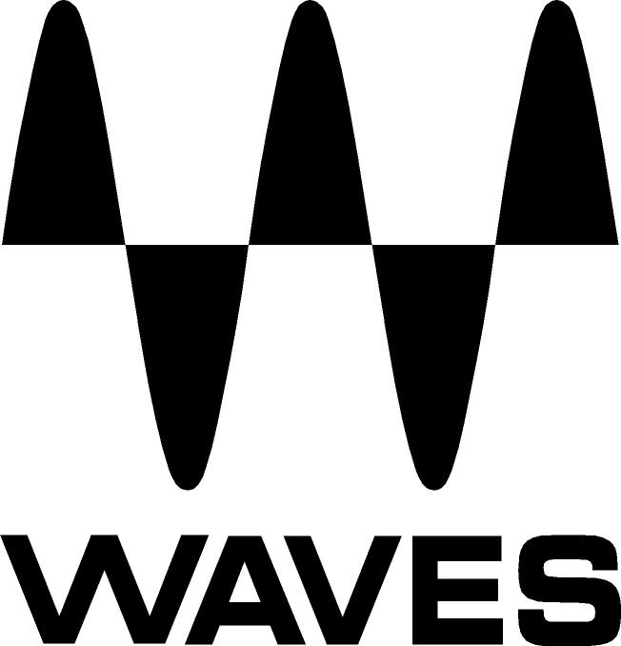

PRESS RELEASE
Contact: Clyne Media, Inc.
Tel: (615) 662-1616
Fax: (615) 662-1636

FOR IMMEDIATE RELEASE

Waves Tracks Live Now Available

THE NAMM SHOW, ANAHEIM, CA, January 22, 2015 — Waves Audio (booth 6824) announces the availability of Waves Tracks Live, a multitrack recording software solution created with and for live sound engineers and designed to capture live performances of any kind, from the smallest gig to the largest production.

Tracks Live enables easy switching between stereo out and multi out modes, allowing you to toggle back and forth between recording and virtual soundcheck with the click of a button. The automatic multichannel re-routing engine also adapts to any changes you make on the fly, making it easier than ever to set up big shows with hundreds of tracks.

Designed with close attention to every detail to ensure superior user experience, Tracks Live will make your live recording process faster, easier and absolutely reliable.

Highlights
- ASIO/Core Audio-compatible and works with virtually any audio interface
- PC- and Mac-compatible
- Record and play back hundreds of tracks
- Supported sample rate of up to 192 kHz
- File formats compatible with all popular DAWS
- Automatic track routing configuration
- Fast switching between recording and virtual soundcheck
- Meter bridge view for easy monitoring
- System lock (to protect against accidental key pressing)

Photo Files: Trackslogo.JPG, TracksLive_Interface.JPG

About Waves Ltd.:
Waves is the world’s leading developer of audio DSP solutions for the professional, broadcast, and consumer electronics audio markets. Since its start in the early '90s with the introduction of the Q10 equalizer plugin, Waves has gone on to develop a comprehensive line of over 200 audio plugins, including industry standards like the L1 and L2 Ultramaximizers, popular vintage console models, and innovative mixing tools like Vocal Rider and the Artist Signature Series. For its accomplishments, Waves received a Technical GRAMMY® Award in 2011, and the Q10 was selected as an inductee into the TECnology Hall of Fame. Waves technologies are now used to improve sound quality in virtually every sector of the audio market, from recording, mixing, mastering and post-production to broadcast, live sound, and consumer electronics. Waves has over 20 years of expertise in the development of psychoacoustic signal processing algorithms that leverage knowledge of human auditory perception to radically improve perceived sound quality. Waves’ award-winning processors are utilized to improve sound quality in the creation of hit records, major motion pictures, and top-selling video games worldwide. Waves offers computer software and hardware-plus-software solutions for the professional and broadcast markets. The company’s WavesLive division is a market leader in all live sound sectors, spearheading the development of solutions for all live platforms. Under its Maxx brand, Waves offers semiconductor and licensable algorithms for consumer electronics applications. Waves Maxx technologies dramatically enhance audio performance and are used by industry leaders such as Dell, ASUS, JVC, and many others.

All other product names and trademarks are the property of their respective owners, which are in no way associated or affiliated with Waves.

North America Offices:
Waves, Inc., 2800 Merchants Drive, Knoxville, TN 37912;
Tel: 865-909-9200, Fax: 865-909-9245, Email: info@waves.com, Web: http://www.waves.com

Corporate Headquarters Israel:
Waves Ltd., Azrieli Center, The Triangle Tower, 32nd Floor
Tel Aviv 67023, Israel; Tel: 972-3-608-4000, Fax: 972-3-608-4056, Email: info@waves.com,
Web: http://www.waves.com

Waves Public Relations:
Clyne Media, Inc., 169-B Belle Forest Circle, Nashville, TN 37221;
Tel: 615-662-1616, Fax: 615-662-1636, Email: robert@clynemedia.com,
Web: http://www.clynemedia.com

Waves Audio is exhibiting at booth 6824 at the 2015 NAMM Show in Anaheim, CA.

