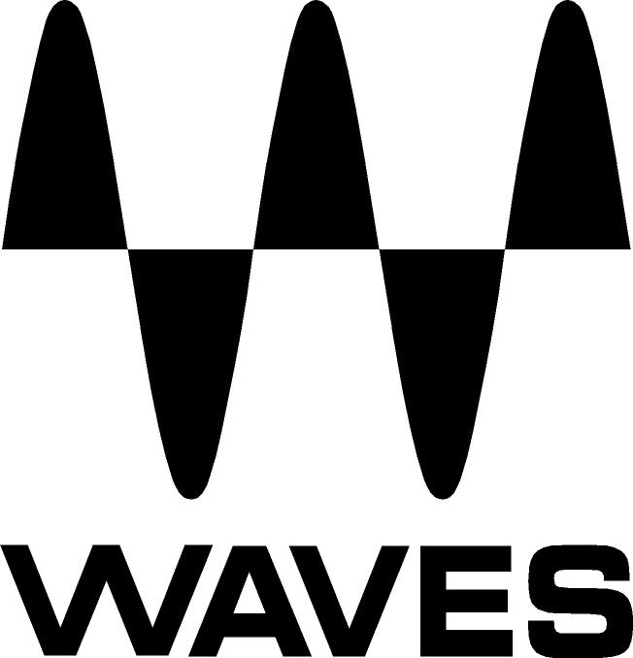

PRESS RELEASE
Contact: Clyne Media, Inc.
Tel: (615) 662-1616
Fax: (615) 662-1636

FOR IMMEDIATE RELEASE

Waves Audio Unveils H-Reverb

THE NAMM SHOW, ANAHEIM, CA, January 22, 2015 — Waves Audio (booth 6824) is now shipping the Waves H-Reverb plugin, a pioneering reverb based on innovative algorithmic FIR (Finite Impulse Response) reverberation technology. H-Reverb provides richer, deeper reverb tails that sit beautifully in the mix while breathing crisp air into your tracks. By fusing classic reverb sounds with forward-thinking features that break new ground in digital reverb processing, H-Reverb provides uncompromising sound quality and creative control.

H-Reverb incorporates Waves’ advanced analog modeling along with a drive control, offering signal behavior that until now was found exclusively in high-end hardware reverb devices. This unique design also enables input drive, a technique favored by many top engineers. The FIR engine also lets you shape and customize the reverb decay envelope in ways beyond the linear standard, resulting in perfectly gated, real reverse, and very long and dense reverb tails.

To top it off, H-Reverb includes an impressive library of artist presets from the industry’s leading mixing engineers. Their personal settings may be the perfect space you’re looking for, or simply the perfect point to start from. Their inclusion marks a new standard in the quest for reverb perfection.

Mick Olesh, Waves EVP of Sales & Marketing, states, “Waves is extremely excited about releasing the H-Reverb. We went to great lengths to make this the most comprehensive and best-sounding reverb plugin possible, incorporating invaluable input from industry-leading mixing engineers.”
Additional features include:

- Impulse-variable resonant filtering for creating unfamiliar and advanced reverb effects
- EQ and dynamics module for compression, ducking and de-essing
- ADA analog modeling and drive control for input clipping
- Full buildup timing and shaping
- Pre-delay BPM sync
- Artist presets from the industry’s leading mixing engineers
- Support for full 5.1-channel surround setups

...ends 282 words

Photo Files: HReverb_Collapsed.JPG, HReverg_Expanded.JPG

About Waves Ltd.:
Waves is the world’s leading developer of audio DSP solutions for the professional, broadcast, and consumer electronics audio markets. Since its start in the early '90s with the introduction of the Q10 equalizer plugin, Waves has gone on to develop a comprehensive line of over 200 audio plugins, including industry standards like the L1 and L2 Ultramaximizers, popular vintage console models, and innovative mixing tools like Vocal Rider and the Artist Signature Series. For its accomplishments, Waves received a Technical GRAMMY® Award in 2011, and the Q10 was selected as an inductee into the TECnology Hall of Fame. Waves technologies are now used to improve sound quality in virtually every sector of the audio market, from recording, mixing, mastering and post-production to broadcast, live sound, and consumer electronics. Waves has over 20 years of expertise in the development of psychoacoustic signal processing algorithms that leverage knowledge of human auditory perception to radically improve perceived sound quality. Waves’ award-winning processors are utilized to improve sound quality in the creation of hit records, major motion pictures, and top-selling video games worldwide. Waves offers computer software and hardware-plus-software solutions for the professional and broadcast markets. The company’s WavesLive division is a market leader in all live sound sectors, spearheading the development of solutions for all live platforms. Under its Maxx brand, Waves offers semiconductor and licensable algorithms for consumer electronics applications. Waves Maxx technologies dramatically enhance audio performance and are used by industry leaders such as Dell, ASUS, JVC, and many others.

All other product names and trademarks are the property of their respective owners, which are in no way associated or affiliated with Waves.

North America Offices:
Waves, Inc., 2800 Merchants Drive, Knoxville, TN 37912;
Tel: 865-909-9200, Fax: 865-909-9245, Email: info@waves.com, Web: http://www.waves.com

Corporate Headquarters Israel:
Waves Ltd., Azrieli Center, The Triangle Tower, 32nd Floor
Tel Aviv 67023, Israel; Tel: 972-3-608-4000, Fax: 972-3-608-4056, Email: info@waves.com,
Web: http://www.waves.com

Waves Public Relations:
Clyne Media, Inc., 169-B Belle Forest Circle, Nashville, TN 37221;
Tel: 615-662-1616, Fax: 615-662-1636, Email: robert@clynemedia.com,
Web: http://www.clynemedia.com

Waves Audio is exhibiting at booth 6824 at the 2015 NAMM Show in Anaheim, CA.

