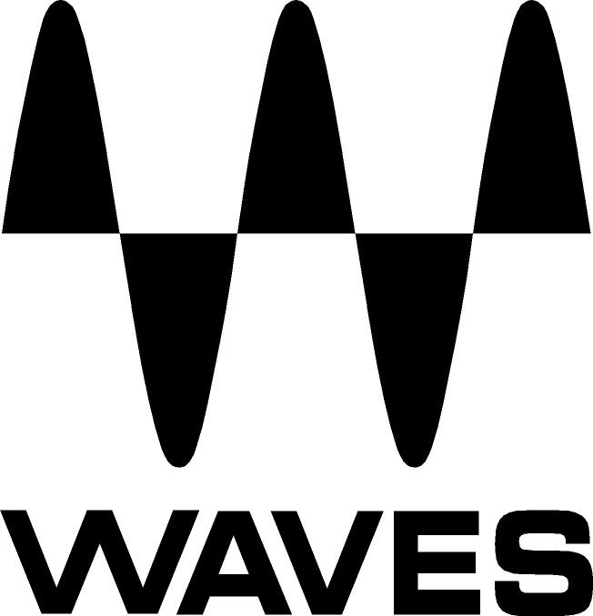

PRESS RELEASE
Contact: Clyne Media, Inc.
Tel: (615) 662-1616
Fax: (615) 662-1636

FOR IMMEDIATE RELEASE

Waves Audio Announces the Waves Signature Series Butch Vig Vocals Plugin

THE NAMM SHOW, ANAHEIM, CA, January 22, 2015 — Waves Audio (booth 6824) introduces the Waves Signature Series Butch Vig Vocals plugin. Among the most influential rock producers of recent decades, Butch Vig has directly shaped the sound of modern rock. From Nirvana and Smashing Pumpkins to Foo Fighters and his own band Garbage, Vig has contributed his signature sound to some of the most legendary albums from the grunge era to the present.

The defining element of the “Butch Vig Sound” is undoubtedly Vig’s vocal stamp. The celebrated producer ushered in the sound of distorted vocals in a beautifully musical way, and it is this sound that the Butch Vig Vocals plugin faithfully recreates. With instantly hyped vocals that cut through the mix with an in-your-face attitude, the Waves Signature Series Butch Vig Vocals plugin gives users the opportunity to work with the sound of rock royalty.

This plugin delivers straightforward vocal processing with pleasant distortion and lots of air frequencies, adding an uncompromising quality to any vocal track.

...ends 161 words

Photo File: ButchVigVocal.JPG

About Waves Ltd.:
Waves is the world’s leading developer of audio DSP solutions for the professional, broadcast, and consumer electronics audio markets. Since its start in the early '90s with the introduction of the Q10 equalizer plugin, Waves has gone on to develop a comprehensive line of over 200 audio plugins, including industry standards like the L1 and L2 Ultramaximizers, popular vintage console models, and innovative mixing tools like Vocal Rider and the Artist Signature Series. For its accomplishments, Waves received a Technical GRAMMY® Award in 2011, and the Q10 was selected as an inductee into the TECnology Hall of Fame. Waves technologies are now used to improve sound quality in virtually every sector of the audio market, from recording, mixing, mastering and post-production to broadcast, live sound, and consumer electronics. Waves has over 20 years of expertise in the development of psychoacoustic signal processing algorithms that leverage knowledge of human auditory perception to radically improve perceived sound quality. Waves’ award-winning processors are utilized to improve sound quality in the creation of hit records, major motion pictures, and top-selling video games worldwide. Waves offers computer software and hardware-plus-software solutions for the professional and broadcast markets. The company’s WavesLive division is a market leader in all live sound sectors, spearheading the development of solutions for all live platforms. Under its Maxx brand, Waves offers semiconductor and licensable algorithms for consumer electronics applications. Waves Maxx technologies dramatically enhance audio performance and are used by industry leaders such as Dell, ASUS, JVC, and many others.

All other product names and trademarks are the property of their respective owners, which are in no way associated or affiliated with Waves.

North America Offices:
Waves, Inc., 2800 Merchants Drive, Knoxville, TN 37912;
Tel: 865-909-9200, Fax: 865-909-9245, Email: info@waves.com, Web: http://www.waves.com

Corporate Headquarters Israel:
Waves Ltd., Azrieli Center, The Triangle Tower, 32nd Floor
Tel Aviv 67023, Israel; Tel: 972-3-608-4000, Fax: 972-3-608-4056, Email: info@waves.com,
Web: http://www.waves.com

Waves Public Relations:
Clyne Media, Inc., 169-B Belle Forest Circle, Nashville, TN 37221;
Tel: 615-662-1616, Fax: 615-662-1636, Email: robert@clynemedia.com,
Web: http://www.clynemedia.com

Waves Audio is exhibiting at booth 6824 at the 2015 NAMM Show in Anaheim, CA.

