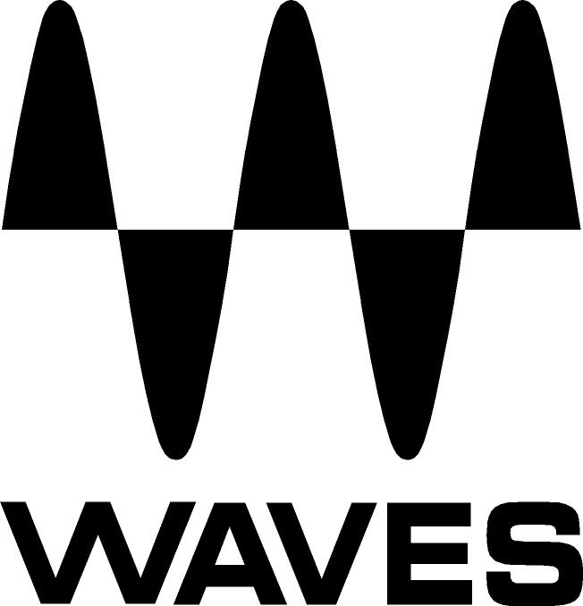

PRESS RELEASE
Contact: Clyne Media, Inc.
Tel: (615) 662-1616
Fax: (615) 662-1636

FOR IMMEDIATE RELEASE

Waves Audio SoundGrid® Platform Grows in Popularity,

Opens Up to Third-Party Plugin Developers

NAMM SHOW, ANAHEIM, CA, January 24, 2013 — In late 2010, Waves Audio (booth 6824) introduced its SoundGrid® platform, which offers Waves Audio-over-Ethernet networking and processing for low-latency real-time professional audio applications. Rapidly growing in popularity since its release, the SoundGrid platform now is used to provide live sound processing for many of the biggest names in entertainment, including Rihanna, Taylor Swift, Bruce Springsteen, Maroon 5, Ozzy Osbourne and many more. Beyond the world of live sound, SoundGrid is scheduled for full compliance with the IEEE’s latest AVB (Audio Video Bridge), in addition to Waves AEB (Audio Exclusive Broadcast) protocols.

Waves recently celebrated the sale of their one thousandth SoundGrid DSP Server. Simultaneously, Waves has announced that it is releasing its API (application programming interface) for third-party developers. This means that in the very near future, Waves SoundGrid platform will support not only Waves plugins, but plugins from other developers as well, beginning with those associated with Plugin Alliance. Users will benefit from SoundGrid’s unparalleled power and performance over an ever-expanding range of professional audio tools.
"We are excited to see what Waves has developed with the SoundGrid technology, and will be looking into porting some of our real-time tools for SoundGrid in 2013", says Dirk Ulrich, CEO of Plugin Alliance USA and Brainworx Germany.

Visit www.waves.com and www.waveslive.com for more information.
...ends 175 words

About Waves Ltd.:
From its start in the early '90s with the introduction of the Q10 equalizer plugin, Waves, the world’s leading developer of audio DSP solutions for professional, broadcast, and consumer electronics audio markets, has gone on to develop a comprehensive line of over 130 audio plugins including industry standards like the L1 and L2 Ultramaximizers, popular vintage console models, and innovative mixing tools like Vocal Rider and the Artist Signature Series. For its accomplishments, in 2011 Waves received a Technical GRAMMY® award, and the Q10 was selected as an inductee into the TECnology Hall of Fame. Waves technologies are now used to improve sound quality in virtually every sector of the audio market, from recording, mixing, mastering and post-production to broadcast, live sound, and consumer electronics. Waves has over 20 years of expertise in the development of psycho-acoustic signal processing algorithms that leverage knowledge on the human perception of hearing to radically improve perceived sound quality. Waves’ award-winning processors are utilized to improve sound quality in the creation of hit records, major motion pictures, and top-selling video games worldwide. Waves offers computer software solutions, as well as hardware-plus-software solutions, for the professional and broadcast markets. Under its Maxx brand, Waves offers semiconductor and licensable algorithms for consumer electronics applications. Waves Maxx technologies dramatically enhance audio performance and are used by industry leaders such as Dell, Sony, Sanyo, ASUS, and many others.

All other product names and trademarks are the property of their respective owners, which are in no way associated or affiliated with Waves.

Waves Contacts:
North America Offices:
Waves, Inc., 2800 Merchants Drive, Knoxville, TN 37912;
Tel: 865-909-9200, Fax: 865-909-9245, Email: info@waves.com, Web: http://www.waves.com

Corporate Headquarters Israel:
Waves Ltd., Azrieli Center, The Triangle Tower, 32nd Floor
Tel Aviv 67023, Israel; Tel: 972-3-608-4000, Fax: 972-3-608-4056, Email: info@waves.com,
Web: http://www.waves.com

Waves Public Relations:
Clyne Media, Inc., 169-B Belle Forest Circle, Nashville, TN 37221;
Tel: 615-662-1616, Fax: 615-662-1636, Email: robert@clynemedia.com,
Web: http://www.clynemedia.com

Waves Audio is exhibiting at booth 6824 at the 2013 NAMM Show in Anaheim, CA.

