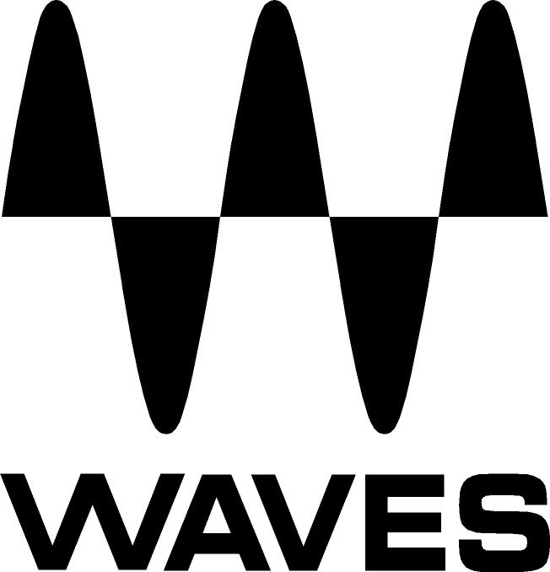

PRESS RELEASE
Contact: Clyne Media, Inc.
Tel: (615) 662-1616
Fax: (615) 662-1636

FOR IMMEDIATE RELEASE

Waves Audio Teams with Abbey Road Studios

to Offer REDD Console Plugins

— REDD.17 and REDD.37-.51 plugins truly deliver the enhanced dimension, richness and depth of the original coveted classic consoles —

NAMM SHOW, ANAHEIM, CA, January 24, 2013 — Waves Audio (booth 6824), a leading provider of audio DSP solutions for professional, broadcast, and consumer electronics audio markets, has again teamed with London’s legendary Abbey Road Studios to offer the new REDD Console plugins. Abbey Road Studios were at the epicenter of a seismic shift that rocked the world of music during the 1960s, and changed the course of popular culture forever. The Beatles, The Hollies, Pink Floyd and countless other luminaries made musical history at Abbey Road Studios, trailblazing a revolution that resonates to this day. And at the heart of it all were REDD consoles, custom-designed, built by and named after Abbey Road Studios' in-house Record Engineering Development Department (REDD). Renowned for their silky smooth EQ curves, extraordinary warmth and lush stereo imagery, there's something magical about the REDDs that simply sounds like no other console. Waves meticulously recreated the unique color, character and tonal complexity of the original desks: the REDD.17 still belonging to Abbey Road Studios, and the REDD.37 console now owned by Lenny Kravitz. The result is REDD: an impressive pair of plugins that truly deliver the enhanced dimension, richness and depth of these coveted console classics.

Mirek Stiles - Head of Audio Products, Abbey Road Studios, stated, “Ever since I first heard the word REDD at Abbey Road Studios almost 13 years ago, to me these consoles have had a legendary almost mythical aura around them. Most of the original REDD consoles have been lost over time but by using the few examples left over and studying the original schematics and design notes from the archives I believe Waves and Abbey Road have revived an important part of musical history that will enable producers of all generations to discover and fall in love with the lost sound of REDD.”

“Waves is proud to be working together with Abbey Road Studios to preserve the legacy of the legendary REDD consoles,” said Gilad Keren, CEO and Co-Founder of Waves Audio. “The REDD consoles were used to help create so much timeless music in the past, and by making their sound available via plugins, we hope to contribute to the creation of timeless music that will be made in the future.”

Controls:
- Amp Type determines the type of amplifier (REDD.37-.51 only).
- Channel Select determines the channel configuration.
- Bass Lift controls the 9 dB low shelf that compensates for low frequency loss caused by using condenser microphones in a Figure 8 configuration.
- EQ Select toggles between Classic and Pop EQ types. The Classic treble EQ features a shelf boost or cut at 10 kHz; Pop EQ is a peak boost centered around 5kHz, with a shelf cut centered at 10 kHz. Both Pop and Classic settings feature a continuous 10 dB of boost or cut at 100 Hz. (REDD.37-.51 only).
- Tone High controls high shelf equalization.
- Tone Low controls low shelf equalization.
- Monitor controls the source of the monitor output.
- Spread selects stereo processing mode (Stereo component only).
- Drive controls the amount of drive added to the signal. Lower values result in a cleaner sound; higher values result in a more distorted sound.
- Analog controls the level of modeled noise and hum.
- Output controls the output level of the signal.
- VU Meters display output VU readings.

Both REDD.17 and REDD.37-.51 are Native- and SoundGrid®-compatible and are available at a U.S. MSRP of $349.00, with a special introductory price of $199.00.

Visit www.waves.com for more information.

REDD Consoles – The Sound That Changed the Course of Music History:
Since its opening in 1931, Abbey Road Studios has been widely regarded as a bastion of recording excellence and innovation. EMI's Recording Engineer Development Department was established in 1955 by Abbey Road Studios technical engineer Lenn Page to address the needs of the then-burgeoning stereophonic format. Within a year, the team's efforts had led to the production of the REDD.1 console, Abbey Road's first dedicated stereo mixing system, which consisted of a REDD.8 mixer and a rack that housed its amplifiers and other components. In 1957, its successor was created: The REDD.17, designed by Peter Burkowitz of EMI's German affiliate, was one of the first desks to conform to the design the industry has come to expect from mixing consoles, with EQ on each of its eight channels. Like the REDD.1 before it, the REDD.17 was a mono/stereo board. Later the following year, in response to the growing popularity of the four-track recording format, the third in the series, the REDD.37, was unveiled. Both the REDD.17 and REDD.37 were powered exclusively by legendary Siemens V72 valve amplifiers and, in the case of the REDD.37, at least 31 of them! The REDD.37 was followed by the REDD.51, which used newer REDD.47 amps, and offered lower distortion and more headroom than the V72s. Originally created in 1959, it was not until 1963 that the .51 found its way to Abbey Road. Four of the .51 desks were ultimately built; by 1968, they were slowly phased out by EMI's next generation of solid-state eight and sixteen track consoles, the TG series.
...ends 836 words

Photo files: REDD_GUI_17.JPG, REDD_GUI_37_51.JPG

About Waves Ltd.:
From its start in the early '90s with the introduction of the Q10 equalizer plugin, Waves, the world’s leading developer of audio DSP solutions for professional, broadcast, and consumer electronics audio markets, has gone on to develop a comprehensive line of over 130 audio plugins including industry standards like the L1 and L2 Ultramaximizers, popular vintage console models, and innovative mixing tools like Vocal Rider and the Artist Signature Series. For its accomplishments, in 2011 Waves received a Technical GRAMMY® award, and the Q10 was selected as an inductee into the TECnology Hall of Fame. Waves technologies are now used to improve sound quality in virtually every sector of the audio market, from recording, mixing, mastering and post-production to broadcast, live sound, and consumer electronics. Waves has over 20 years of expertise in the development of psycho-acoustic signal processing algorithms that leverage knowledge on the human perception of hearing to radically improve perceived sound quality. Waves’ award-winning processors are utilized to improve sound quality in the creation of hit records, major motion pictures, and top-selling video games worldwide. Waves offers computer software solutions, as well as hardware-plus-software solutions, for the professional and broadcast markets. Under its Maxx brand, Waves offers semiconductor and licensable algorithms for consumer electronics applications. Waves Maxx technologies dramatically enhance audio performance and are used by industry leaders such as Dell, Sony, Sanyo, ASUS, and many others.

About Abbey Road Studios:
Abbey Road Studios are the most famous recording studios in the world and an iconic symbol of British music. They have been home to countless landmark recordings and pioneering advances in recording technology. Opened in November 1931, Abbey Road Studios were the world’s first purpose built recording studios. The hallowed building has a phenomenal 80 year history working with many of the world’s most famous artists including The Beatles, Pink Floyd, The Hollies, Kate Bush, Oasis, Florence and the Machine, Adele and Lady Gaga. Also one of the world’s premiere locations for movie scoring, since the 1980s films such as Raiders of the Lost Ark, the Lord of The Rings Trilogy, Braveheart and The King’s Speech have been recorded there. The list continues with many other major titles, including Shrek, Prometheus, Harry Potter, Skyfall and The Hobbit. www.AbbeyRoad.com

All other product names and trademarks are the property of their respective owners, which are in no way associated or affiliated with Waves. REDD is a trademark of EMI (IP) Limited, used under license.

Waves Contacts:
North America Offices:
Waves, Inc., 2800 Merchants Drive, Knoxville, TN 37912;
Tel: 865-909-9200, Fax: 865-909-9245, Email: info@waves.com, Web: http://www.waves.com

Corporate Headquarters Israel:
Waves Ltd., Azrieli Center, The Triangle Tower, 32nd Floor
Tel Aviv 67023, Israel; Tel: 972-3-608-4000, Fax: 972-3-608-4056, Email: info@waves.com,
Web: http://www.waves.com

Waves Public Relations:
Clyne Media, Inc., 169-B Belle Forest Circle, Nashville, TN 37221;
Tel: 615-662-1616, Fax: 615-662-1636, Email: robert@clynemedia.com,
Web: http://www.clynemedia.com

Waves Audio is exhibiting at booth 6824 at the 2013 NAMM Show in Anaheim, CA.

