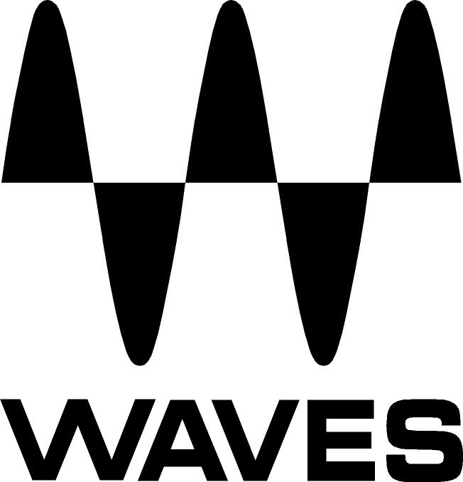

PRESS RELEASE
Contact: Clyne Media, Inc.
Tel: (615) 662-1616
Fax: (615) 662-1636

FOR IMMEDIATE RELEASE

Waves Audio Introduces GEQ Graphic Equalizer Plugin

NAMM SHOW, ANAHEIM, CA, January 24, 2013 — Waves Audio (booth 6824) introduces its GEQ graphic equalizer plugin. Developed primarily for live users (but sure to find a home in the studio as well), GEQ features selectable cut and boost at 1/3 octave intervals, using two unique filter types.

GEQ Features
- Classic component with proportional Q
- Modern component with independent non-interactive filter types
- 30 ISO bands
- 6 dB, 12 dB, 18 dB selectable cut & boost
- Independent HPF, LPF and a parametric bell per side
- Zero latency
- 2 input RTA with external input options
- RTA input difference mode with auto-suggest function
- Link L/R
- Touch Support with Fader Draw functionality

The GEQ Graphic Equalizer Plugin will be available soon with U.S. MSRP TBA. Visit www.waves.com and www.waveslive.com for more information.
...ends 121 words

Photo Files: GEQ_Classic.JPG

About Waves Ltd.:
From its start in the early '90s with the introduction of the Q10 equalizer plugin, Waves, the world’s leading developer of audio DSP solutions for professional, broadcast, and consumer electronics audio markets, has gone on to develop a comprehensive line of over 130 audio plugins including industry standards like the L1 and L2 Ultramaximizers, popular vintage console models, and innovative mixing tools like Vocal Rider and the Artist Signature Series. For its accomplishments, in 2011 Waves received a Technical GRAMMY® award, and the Q10 was selected as an inductee into the TECnology Hall of Fame. Waves technologies are now used to improve sound quality in virtually every sector of the audio market, from recording, mixing, mastering and post-production to broadcast, live sound, and consumer electronics. Waves has over 20 years of expertise in the development of psycho-acoustic signal processing algorithms that leverage knowledge on the human perception of hearing to radically improve perceived sound quality. Waves’ award-winning processors are utilized to improve sound quality in the creation of hit records, major motion pictures, and top-selling video games worldwide. Waves offers computer software solutions, as well as hardware-plus-software solutions, for the professional and broadcast markets. Under its Maxx brand, Waves offers semiconductor and licensable algorithms for consumer electronics applications. Waves Maxx technologies dramatically enhance audio performance and are used by industry leaders such as Dell, Sony, Sanyo, ASUS, and many others.

All other product names and trademarks are the property of their respective owners, which are in no way associated or affiliated with Waves.

Waves Contacts:
North America Offices:
Waves, Inc., 2800 Merchants Drive, Knoxville, TN 37912;
Tel: 865-909-9200, Fax: 865-909-9245, Email: info@waves.com, Web: http://www.waves.com

Corporate Headquarters Israel:
Waves Ltd., Azrieli Center, The Triangle Tower, 32nd Floor
Tel Aviv 67023, Israel; Tel: 972-3-608-4000, Fax: 972-3-608-4056, Email: info@waves.com,
Web: http://www.waves.com

Waves Public Relations:
Clyne Media, Inc., 169-B Belle Forest Circle, Nashville, TN 37221;
Tel: 615-662-1616, Fax: 615-662-1636, Email: robert@clynemedia.com,
Web: http://www.clynemedia.com

Waves Audio is exhibiting at booth 6824 at the 2013 NAMM Show in Anaheim, CA.

