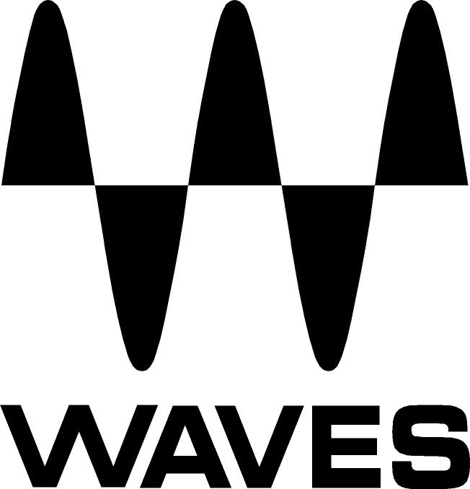

PRESS RELEASE
Contact: Clyne Media, Inc.
Tel: (615) 662-1616
Fax: (615) 662-1636

FOR IMMEDIATE RELEASE

Waves Audio Offers Element Synthesizer

NAMM SHOW, ANAHEIM, CA, January 24, 2013 — Waves Audio (booth 6824), a leading provider of audio DSP solutions for professional, broadcast, and consumer electronics audio markets, recently introduced Element, its first-ever synthesizer. Powered by Virtual Voltage™ technology, Element is an analog-style polyphonic instrument engineered to deliver the fat, gritty sound of the classics, with all the precision, flexibility and control of contemporary digital synths. Element includes a vast array of convenient features and functions, including integrated effects, a 16-step arpeggiator/sequencer, MIDI Learn for all controls and a massive preset library, with total tweakability. Plus, all parameters are laid out right in front of the user, so when inspiration strikes, there’s no need to scroll through page after page to customize sounds. Searing leads, booming basses, ethereal pads, electro-percussion, sequential motions, mind-blowing FX and lots more: Element does it all.

London-based Yoad Nevo, who has enjoyed a successful career as a producer/engineer for such artists as Air, Goldfrapp and Pet Shop Boys, in addition to being a longtime Waves developer, was instrumental in the development of Element. He states, “In my work, I use synthesizers quite a bit. Even though I have a large collection of analog synths, I’m always on the lookout for cool new virtual instruments. So when Waves decided to build a synth from the ground up, there were certain things I made sure it had. We knew we wanted to create a synth that would be straightforward and easy to use, so we started with a basic subtractive synthesis engine. We then developed the engine further, adding features and functions along the way, until it grew into a mature synth.”
Nevo continues, “Element provides fat sound right off the bat, but also has very comprehensive editing capabilities, which I used to create most of its presets. We made sure to include all its features on a single page: the step sequencer, modulation matrix and effects section, everything. Whether scrolling through presets of creating completely new sounds from scratch, we saw to it that Element would provide users with instant sonic gratification.”

Waves Element is now available at a U.S. MSRP of $200, with a special introductory price of $99. Visit www.waves.com for more information.
...ends 357 words

Photo File: Element_A14.JPG

About Waves Ltd.:
From its start in the early '90s with the introduction of the Q10 equalizer plugin, Waves, the world’s leading developer of audio DSP solutions for professional, broadcast, and consumer electronics audio markets, has gone on to develop a comprehensive line of over 130 audio plugins including industry standards like the L1 and L2 Ultramaximizers, popular vintage console models, and innovative mixing tools like Vocal Rider and the Artist Signature Series. For its accomplishments, in 2011 Waves received a Technical GRAMMY® award, and the Q10 was selected as an inductee into the TECnology Hall of Fame. Waves technologies are now used to improve sound quality in virtually every sector of the audio market, from recording, mixing, mastering and post-production to broadcast, live sound, and consumer electronics. Waves has over 20 years of expertise in the development of psycho-acoustic signal processing algorithms that leverage knowledge on the human perception of hearing to radically improve perceived sound quality. Waves’ award-winning processors are utilized to improve sound quality in the creation of hit records, major motion pictures, and top-selling video games worldwide. Waves offers computer software solutions, as well as hardware-plus-software solutions, for the professional and broadcast markets. Under its Maxx brand, Waves offers semiconductor and licensable algorithms for consumer electronics applications. Waves Maxx technologies dramatically enhance audio performance and are used by industry leaders such as Dell, Sony, Sanyo, ASUS, and many others.

All other product names and trademarks are the property of their respective owners, which are in no way associated or affiliated with Waves.

Waves Contacts:
North America Offices:
Waves, Inc., 2800 Merchants Drive, Knoxville, TN 37912;
Tel: 865-909-9200, Fax: 865-909-9245, Email: info@waves.com, Web: http://www.waves.com

Corporate Headquarters Israel:
Waves Ltd., Azrieli Center, The Triangle Tower, 32nd Floor
Tel Aviv 67023, Israel; Tel: 972-3-608-4000, Fax: 972-3-608-4056, Email: info@waves.com,
Web: http://www.waves.com

Waves Public Relations:
Clyne Media, Inc., 169-B Belle Forest Circle, Nashville, TN 37221;
Tel: 615-662-1616, Fax: 615-662-1636, Email: robert@clynemedia.com,
Web: http://www.clynemedia.com

Waves Audio is exhibiting at booth 6824 at the 2013 NAMM Show in Anaheim, CA.

