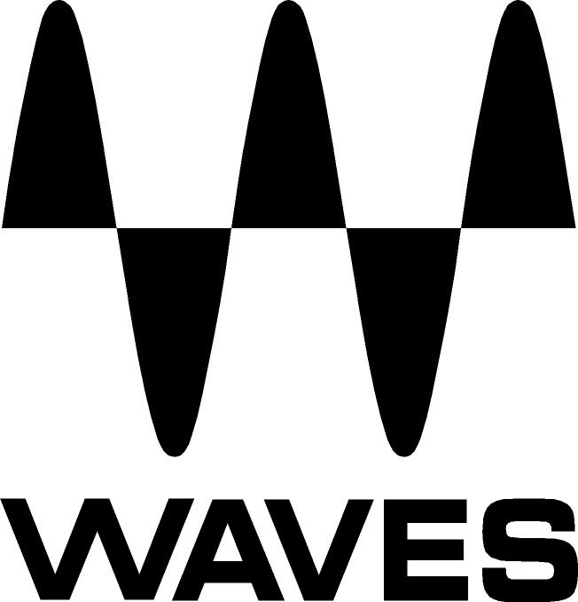

PRESS RELEASE
Contact: Clyne Media, Inc.
Tel: (615) 662-1616
Fax: (615) 662-1636

FOR IMMEDIATE RELEASE

Waves Audio Unveils NLS Non-Linear Summing Plugin

WINTER NAMM SHOW, ANAHEIM, CA, January 19, 2012 — Waves Audio (Booth 6242/Hall A), the industry-leading developer of professional audio digital signal processing technologies and the recipient of a Technical GRAMMY® Award, unveils its NLS Non-Linear Summing plugin. NLS brings users the analog summing sound of three legendary consoles. Created in association with three of today’s leading producers/engineers – Mark “Spike” Stent, Mike Hedges and Yoad Nevo, NLS captures the sound of:

- The SSL 4000G console belonging to Mark “Spike”’ Stent (Radiohead, Björk, Muse, Maroon 5, Madonna)

- The EMI TG12345 Mk 4 desk owned by Mike Hedges (The Cure, Siouxsie and the Banshees, Dido, Faithless, Manic Street Preachers, U2), heard on such timeless recordings as Pink Floyd’s The Dark Side of the Moon

- The Neve 5116 console custom-made for Yoad Nevo (Bryan Adams, Pet Shop Boys, Sugababes, Goldfrapp, Air)

In the creation of this plugin, Waves meticulously modeled over 100 individual channels in all, painstakingly analyzing and recreating the distinctive color, character, and behavior of each and every input and summing bus amp. Waves NLS delivers to the digital realm the depth and richness that has long been associated exclusively with analog gear.

The Waves NLS Plugin will be available Q1 2012 with pricing to be announced. For more information, please visit www.waves.com.
...ends 206 words

Photo File: NLS_brochure.pdf

About Waves Ltd.:
From its start in the early '90s with the introduction of the Q10 equalizer plugin, Waves, a leading provider of audio DSP solutions for professional, broadcast, and consumer electronics audio markets, has gone on to develop a comprehensive line of over 100 audio plugins including industry standards like the L1 and L2 Ultramaximizers, popular vintage console models, and innovative mixing tools like Vocal Rider and the Artist Signature Series. For its accomplishments, in 2011 Waves received a Technical GRAMMY®, and the Q10 was selected as an inductee into the TECnology Hall of Fame. Waves technologies are now used to improve sound quality in virtually every sector of the audio market, from recording, mixing, mastering and post production to broadcast, live sound, and consumer electronics. Waves has over 15 years of expertise in the development of psycho-acoustic signal processing algorithms that leverage knowledge on the human perception of hearing to radically improve perceived sound quality. Waves’ award-winning processors are utilized to improve sound quality in the creation of hit records, major motion pictures, and popular video games worldwide. Waves offers computer software solutions, as well as hardware-plus-software solutions, for the professional and broadcast markets. Under its Maxx brand, Waves offers semiconductor and licensable algorithms for consumer electronics applications. Waves’ Maxx technologies dramatically enhance audio performance and are used by industry leaders such as Dell, Sony, Sanyo, JVC, Toshiba, and many others. For more information, visit the Waves web site at http://www.waves.com.

All other product names and trademarks are the property of their respective owners, which are in no way associated or affiliated with Waves.

Waves Contacts:
North America Offices:
Waves, Inc., 2800 Merchants Drive, Knoxville, TN 37912;
Tel: 865-909-9200, Fax: 865-909-9245, Email: info@waves.com, Web: http://www.waves.com

Corporate Headquarters Israel:
Waves Ltd., Azrieli Center, The Triangle Tower, 32nd Floor
Tel Aviv 67023, Israel; Tel: 972-3-608-4000, Fax: 972-3-608-4056, Email: info@waves.com,
Web: http://www.waves.com

Waves Public Relations:
Clyne Media, Inc., 169-B Belle Forest Circle, Nashville, TN 37221;
Tel: 615-662-1616, Fax: 615-662-1636, Email: robert@clynemedia.com,
Web: http://www.clynemedia.com

Waves Audio is exhibiting at Booth 6242 (Hall A) at the 2012 Winter NAMM Show in Anaheim, CA.

