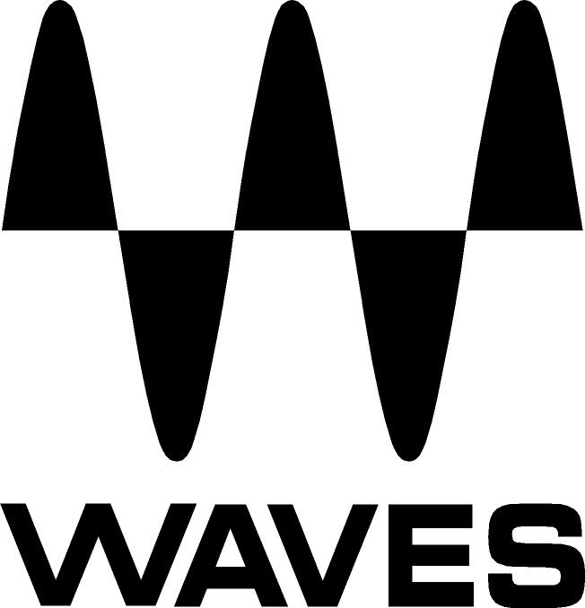
PRESS RELEASE
Contact: Clyne Media, Inc.
Tel: (615) 662-1616
Fax: (615) 662-1636

FOR IMMEDIATE RELEASE

Waves Now Shipping the Vocal Bender Plugin for Real-Time Voice Manipulation

Knoxville, TN, February 17, 2021 — Waves Audio, the world’s leading developer of professional audio signal processing technologies and leading maker of audio plugins for mixing, music production, mastering, sound design, broadcast, post-production and live sound, is now shipping Vocal Bender, a real-time voice manipulation plugin.

With Waves’ Vocal Bender plugin, you can now manipulate your vocals in real time for the most popular sounds in hip-hop, pop, R&B and electronic genres. With zero latency and two simple Pitch and Formant controls, you can easily track, mix and perform hit-sounding pitch-shifted vocals, instantly.

Vocal Bender is the fastest and simplest way to get “that sound” – Travis Scott deep-voiced ad-libs, Billie Eilish-style vocal doubles, Frank Ocean-style pitch-and formant-shifted lead vocals, or the high-pitched vocal topline in every EDM drop. You can go extreme and make your vocals move between genders, change age, sound miniature or appear gigantic. On the subtle side, simply add soft harmonies, vibrato or vocal doubling for thickness.

Waves created this tool for musicians and producers to get your ideas down quickly, saving precious time when working creatively. It allows you to track through the plugin, so you can hear the pitch and formant effects on your voice as you track. You can even use Vocal Bender in live performances: pull it up on your live DAW session and manipulate your live vocal sound, without latency.

In addition to the main Pitch and Formant controls, the plugin also has a “Flatten” feature to lock into a single pitch and sound robotic. You can also open up Vocal Bender’s trunk to access four extra modulators, including LFO and sequencing. With a few clicks you’ll add vibrato, pitch drops, sequenced pitching, and more. The modulators bring more musicality and movement to your sound, and help you differentiate your style.

Waves Vocal Bender features:
- Real-time monophonic voice manipulation plugin
- Easy vocal pitch shifting and formant control
- The most popular vocal sounds in hip-hop, pop, EDM, R&B
- LFO, SEQ, Amplitude and Pitch modulators for deeper musical effects: Vibrato, pitch drops, sequenced pitching, more
- “Flatten” feature for robotic vocals
- Mix knob for blending harmonies and doubles on inserts
- Zero latency for studio recording and live performance

Vocal Bender is included in Waves’ Mercury, Pro Show and SD7 Pro Show bundles.

For more information, visit https://www.waves.com/plugins/vocal-bender.

Videos:
- Introducing Vocal Bender – Real-Time Voice Manipulation Plugin: https://youtu.be/O53_bMbJusM

Real-Time Vocal Manipulation – Getting Started with Vocal Bender: https://youtu.be/X5jGKon0sOg

Vocal Bender in Action – Real-Time Hip Hop, Pop, EDM Vocal FX: https://youtu.be/ukhIuCNHj2o

…ends 406 words

Photo file 1: VB_Full1.JPG
Photo caption 1: Waves Vocal Bender user interface

About Waves Audio Ltd.:
Waves is the world’s leading developer of audio DSP solutions for the professional, broadcast, and consumer electronics audio markets. Since its start in the early '90s with the introduction of the Q10 equalizer plugin, Waves has gone on to develop a comprehensive line of over 150 audio plugins, including industry standards like the L1 and L2 Ultramaximizers, popular vintage console models, and innovative mixing tools like Vocal Rider and the Artist Signature Series. For its accomplishments, Waves received a Technical GRAMMY® Award in 2011, and the Q10 was selected as an inductee into the TECnology Hall of Fame. In 2016, Waves released the eMotion LV1 mixer, a revolutionary live digital mixing console that provides real-time audio mixing for front-of-house, monitor, studio and broadcast engineers. Waves technologies are now used to improve sound quality in virtually every sector of the audio market, from recording, mixing, mastering and post-production to broadcast, live sound, and consumer electronics. Waves has over 25 years of expertise in the development of psychoacoustic signal processing algorithms that leverage knowledge of human auditory perception to radically improve perceived sound quality. Waves’ award-winning processors are utilized to improve sound quality in the creation of hit records, major motion pictures, and top-selling video games worldwide. Waves offers computer software and hardware-plus-software solutions for the professional and broadcast markets. The company’s WavesLive division is a market leader in all live sound sectors, spearheading the development of solutions for all live platforms. Under its Maxx brand, Waves offers semiconductor and licensable algorithms for consumer electronics applications. Waves technologies dramatically enhance audio performance and are used by industry leaders such as Dell, Google, Fitbit, Acer, Asus, Hisense and more.

North America Offices:
Waves, Inc., 2800 Merchants Drive, Knoxville, TN 37912;
Tel: 865-909-9200, Fax: 865-909-9245, Email: info@waves.com,
Web: http://www.waves.com

Corporate Headquarters Israel:
Waves Ltd., Azrieli Center, The Triangle Tower, 32nd Floor, Tel Aviv 67023, Israel;
Tel: 972-3-608-4000, Fax: 972-3-608-4056, Email: info@waves.com,
Web: http://www.waves.com

Waves Public Relations:
Clyne Media, Inc., 169-B Belle Forest Circle, Nashville, TN 37221;
Tel: 615-662-1616, Fax: 615-662-1636, Email: robert@clynemedia.com,
Web: http://www.clynemedia.com

