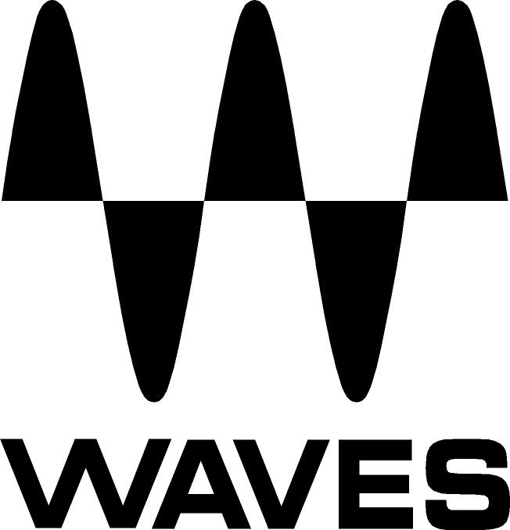

PRESS RELEASE
Contact: Clyne Media, Inc.
Tel: (615) 662-1616
Fax: (615) 662-1636

FOR IMMEDIATE RELEASE

Waves Audio Now Shipping the Scheps Omni Channel

KNOXVILLE, TN, January 24, 2018 — Waves Audio, a leading provider of processing solutions, announces the Scheps Omni Channel plugin. Designed with GRAMMY®-winning mixer Andrew Scheps (Adele, Jay-Z, Metallica), this flexible channel strip delivers Andrew’s time-tested combinations of compression, EQ, saturation colors and more – all crafted to work together seamlessly and cohesively.

Mixers choosing which channel strip to work with often face a dilemma: Channel strip plugins based on vintage mixing consoles can sound amazing but tend to tie you down to a very specific and limited sonic color. Modular channel strip plugins let you mix and match diverse processors with flexibility, but the different processors might not work together cohesively and won’t necessarily interact as a true channel strip.

Scheps Omni Channel gives you the best of both worlds. Through years of mixing diverse music genres, Andrew Scheps has perfected certain combinations of go-to processors – some based on classic hardware units, some being innovative modules developed from scratch – each with its own unique character. They are all now provided to you in one flexible yet fully cohesive channel strip plugin.

Scheps Omni Channel features six modules that you can use in any order you like:

- The Pre-module provides three types of analog saturation, letting you add diverse colors of harmonic distortion as well as filters and thump (resonance) controls.
- The Compression module features three completely different compressors ranging from fast to slow and smooth, with a unified control set so you can quickly compare them. A Wet/Dry control allows you to parallel compress within the module.
- The EQ module is a four-band equalizer; each band providing a distinct musical sound that holds up on its own or can be switched to fully parametric if surgical EQ is required.
- The DS² module is so much more than a de-esser, with two full-range bands and four filter types allowing it to “de-anything” – remove any offending frequencies on any source, not just S’s or T’s.
- The Gate module gives you all the standard controls (threshold, attack and release) for gating/expansion, but also lets you adjust the maximum noise reduction to maintain a consistent noise floor.
- The Scheps Omni Channel also features an insert slot that can be positioned anywhere in the chain, where you can insert an additional Waves plugin of your choice, including an extra instance of any of the Scheps Omni Channel modules.

For live sound, Scheps Omni Channel offers zero latency and fullest discrete control over each stereo channel. Select controls of the compressor, EQ and filters are mapped conveniently to the eMotion LV1 live mixing console, serving as the console’s channel strip.

A set of Andrew Scheps’ “Focus” presets, created for different sources, highlights the most important controls you should be focusing on to achieve your current task. Also included are presets from top mix engineers, including Tony Visconti, Dave Darlington, Brad Divens, Billy Bush, Jacquire King, Ken “Pooch” Van Druten and Eddie “El Brujo” Caipo.

No matter what musical genre you are working with, the Scheps Omni Channel plugin enables you to quickly audition sonic flavors, helping you stay focused while you mix.

Waves Audio Scheps Omni Channel features:
- Designed with GRAMMY-winning mixer Andrew Scheps (Adele, Jay-Z, Metallica)
- Flexible channel strip plugin based on Andrew’s tried and tested processing combinations
- Pre, compression, EQ and gating modules, each with diverse options for sonic flexibility
- DS² module with 2 full-range bands and 4 filter types
- Insert slot: Load an additional Waves plugin anywhere in the channel strip
- Drag and drop any module anywhere in the channel strip
- Internal MS/Duo/Stereo routing per module
- Stereo component provides full discrete control over each channel
- Flexible shaping of internal or external sidechain input
- Zero latency

To learn more: http://www.waves.com/plugins/scheps-omni-channel

Videos:
- Introducing the Scheps Omni Channel Strip Plugin: https://youtu.be/qom3_OIFJ20
- Scheps Omni Channel Strip Plugin – 5 Minute Demo: https://youtu.be/Y3r1x46vZDY
- Creating the Perfect Channel Strip – Interview with Andrew Scheps: https://youtu.be/31_sr7I4Ch8
…ends 610 words

Photo file: Scheps_Omni_GUI.JPG
Photo caption: User interface for the Waves Scheps Omni Channel plugin

About Waves Audio Ltd.:
Waves is the world’s leading developer of audio DSP solutions for the professional, broadcast, and consumer electronics audio markets. Since its start in the early '90s with the introduction of the Q10 equalizer plugin, Waves has gone on to develop a comprehensive line of over 150 audio plugins, including industry standards like the L1 and L2 Ultramaximizers, popular vintage console models, and innovative mixing tools like Vocal Rider and the Artist Signature Series. For its accomplishments, Waves received a Technical GRAMMY® Award in 2011, and the Q10 was selected as an inductee into the TECnology Hall of Fame. In 2016, Waves released the eMotion LV1 mixer, a revolutionary live digital mixing console that provides real-time audio mixing for front-of-house, monitor, studio and broadcast engineers. Waves technologies are now used to improve sound quality in virtually every sector of the audio market, from recording, mixing, mastering and post-production to broadcast, live sound, and consumer electronics. Waves has over 25 years of expertise in the development of psychoacoustic signal processing algorithms that leverage knowledge of human auditory perception to radically improve perceived sound quality. Waves’ award-winning processors are utilized to improve sound quality in the creation of hit records, major motion pictures, and top-selling video games worldwide. Waves offers computer software and hardware-plus-software solutions for the professional and broadcast markets. The company’s WavesLive division is a market leader in all live sound sectors, spearheading the development of solutions for all live platforms. Under its Maxx brand, Waves offers semiconductor and licensable algorithms for consumer electronics applications. Waves technologies dramatically enhance audio performance and are used by industry leaders such as Dell, Google, TCL, Fujitsu, Asus, Hisense and more.
All other product names and trademarks are the property of their respective owners, which are in no way associated or affiliated with Waves.

North America Offices:
Waves, Inc., 2800 Merchants Drive, Knoxville, TN 37912;
Tel: 865-909-9200, Fax: 865-909-9245, Email: info@waves.com,
Web: http://www.waves.com

Corporate Headquarters Israel:
Waves Ltd., Azrieli Center, The Triangle Tower, 32nd Floor, Tel Aviv 67023, Israel;
Tel: 972-3-608-4000, Fax: 972-3-608-4056, Email: info@waves.com,
Web: http://www.waves.com

Waves Public Relations:
Clyne Media, Inc., 169-B Belle Forest Circle, Nashville, TN 37221;
Tel: 615-662-1616, Fax: 615-662-1636, Email: robert@clynemedia.com,
Web: http://www.clynemedia.com

