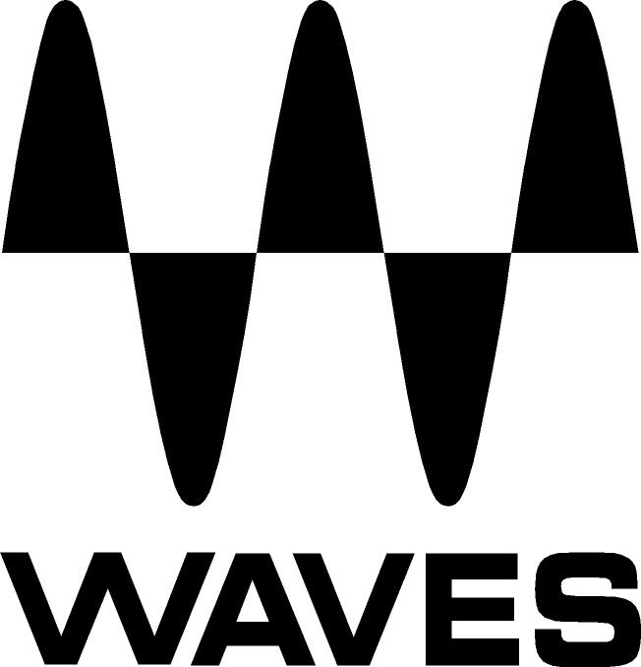

PRESS RELEASE
Contact: Clyne Media, Inc.
Tel: (615) 662-1616
Fax: (615) 662-1636

FOR IMMEDIATE RELEASE

WAVES OFFERS SOUNDGRID COMPACT SYSTEM

FOR YAMAHA CONSOLES

— Company makes available new sound reinforcement package for Yamaha consoles, including everything needed to take a show on the road, all for around $1100 U.S. MSRP —

— Lightweight and small enough to fit into a carry-on, the SoundGrid Compact System allows Yamaha users to process their live performance using Waves plugins —

KNOXVILLE, TN, April 6, 2011 — Waves, the industry leader in professional audio digital signal processing technologies and recipient of a 2011 Technical GRAMMY® Award, offers the new SoundGrid Compact System for Yamaha consoles. As a leading manufacturer of live and studio mixing consoles, Yamaha provides the perfect platform for this processing. The system includes everything Yamaha users need to process their live performances using Waves plugins, as well as the tools to capture their performances into a DAW. The SoundGrid Compact System represents the first time Waves has assembled all the components needed to run Waves plugins on a Yamaha console into a single, very affordable package, making the purchasing experience easier and more straightforward for users.

With the SoundGrid Compact System, users can process up to 16 live audio channels using up to 40 plugins in real time with super low latency; record MultiRack-processed tracks in real time, direct to a DAW in the same computer, pre- or post-processing (or both, for maximum flexibility); and adjust their plugins, racks and console settings, without having the band on stage.

The Waves SoundGrid Compact System includes a number of hardware and software components. Hardware includes the SoundGrid Compact Server (measuring a mere 19 cm x 29 cm x 5.5 cm), the WSG-Y16 mini-YGDAI I/O Card, a Network Switch, iLok USB Key and Cat 6 Network Cables. Software components include the following popular Waves plugins: MultiRack Plugin Host Application, Renaissance Reverb, Renaissance EQ, Renaissance Axx, Renaissance Bass and H-Delay.

Waves’ SoundGrid Compact System is compatible with the following Yamaha products: PM5D, DSP5D, M7CL, LS9-32, LS9-16, DM2000, DM1000, 02R96, 01V96, DME64N, DME24N and TX6n/TX5n/TX4n.

The Waves SoundGrid Compact System is now available with a U.S. MSRP of $1100.00.

About SoundGrid
Waves SoundGrid gives users the ability to run large numbers of Waves’ award-winning audio processors using standard PCs via Ethernet, far surpassing the specs of dedicated DSP-based platforms. SoundGrid offers super low latency performance, which means users can take advantage of even more audio processors and CPU-intensive processors than ever before. Waves is leveraging the recent advances in both Ethernet and CPU technologies to provide better, more cost-effective performance for the pro audio and live sound markets.

For more information, please visit www.waves.com.
...ends 368 words
Photo File: Waves_SGCompact.JPG

About Waves Ltd.:
From its start in the early '90s with the introduction of the Q10 equalizer plugin, Waves, a leading provider of audio DSP solutions for professional, broadcast, and consumer electronics audio markets, has gone on to develop a comprehensive line of over 100 audio plugins including industry standards like the L1 and L2 Ultramaximizers, popular vintage console models, and innovative mixing tools like Vocal Rider and the Artist Signature Series. For its accomplishments, in 2011 Waves received a Technical GRAMMY, and the Q10 was selected as an inductee into the TECnology Hall of Fame. Waves technologies are now used to improve sound quality in virtually every sector of the audio market, from recording, mixing, mastering and post production to broadcast, live sound, and consumer electronics. Waves has over 15 years of expertise in the development of psycho-acoustic signal processing algorithms that leverage knowledge on the human perception of hearing to radically improve perceived sound quality. Waves’ award-winning processors are utilized to improve sound quality in the creation of hit records, major motion pictures, and popular video games worldwide. Waves offers computer software solutions, as well as hardware-plus-software solutions, for the professional and broadcast markets. Under its Maxx brand, Waves offers semiconductor and licensable algorithms for consumer electronics applications. Waves’ Maxx technologies dramatically enhance audio performance and are used by industry leaders such as Sony, Sanyo, JVC, Toshiba, and many others. For more information, visit the Waves web site at http://www.waves.com.

All other product names and trademarks are the property of their respective owners, which are in no way associated or affiliated with Waves. GRAMMY is a registered trademark of the National Academy of Recording Arts & Sciences.

Waves Contacts:
North America Offices:
Waves, Inc., 2800 Merchants Drive, Knoxville, TN 37912;
Tel: 865-909-9200, Fax: 865-909-9245, Email: info@waves.com, Web: http://www.waves.com

Corporate Headquarters Israel:
Waves Ltd., Azrieli Center, The Triangle Tower, 32nd Floor
Tel Aviv 67023, Israel; Tel: 972-3-608-4000, Fax: 972-3-608-4056, Email: info@waves.com,
Web: http://www.waves.com

Waves Public Relations:
Clyne Media, Inc., 169-B Belle Forest Circle, Nashville, TN 37221;
Tel: 615-662-1616, Fax: 615-662-1636, Email: robert@clynemedia.com,
Web: http://www.clynemedia.com

