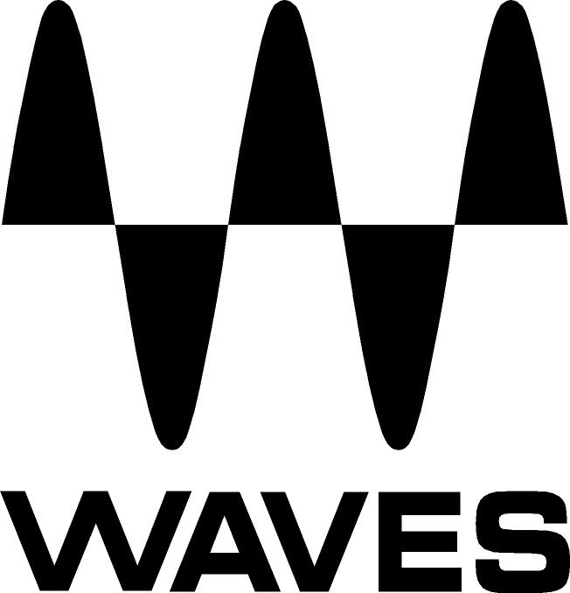
PRESS RELEASE
Contact: Clyne Media, Inc.
Tel: (615) 662-1616
Fax: (615) 662-1636

FOR IMMEDIATE RELEASE

FOH Engineer Brian Hernandez and Monitor Engineer Carlos Del Valle Choose Waves eMotion LV1 Live Mixer for the 2019 Rosalía Tour

KNOXVILLE, TN, October 31, 2019 — FOH engineer Brian Hernandez (El Guincho, Los Punsetes, Extraperlo) and monitor engineer Carlos Del Valle (Extremoduro, David Bisbal, Kakkmaddafakka, Manolo Garcia) choose the eMotion LV1 Live Mixer for both FOH and monitors as well as SoundGrid® servers and an arsenal of essential Waves plugins – all for the 2019 world tour of Spanish singer, songwriter and record producer Rosalía.

Acknowledged initially for her modern interpretations of flamenco music, Spanish star Rosalía has been praised by international influencers and has collaborated with J Balvin, Pharrell Williams and James Blake. Her album El Mal Querer was number-one on the sales and streaming charts and is the most listened-to album on Spotify Spain in the first 24 hours of its release. Rosalía is the first Spanish artist to have a triple-number-one during the same week on the album sales chart, album streaming charts and singles sales chart.

2019 sees Rosalía as headliner at major European festivals such as Primavera Sound in Barcelona, Ceremonia in Mexico and Lollapalooza in Argentina and Chile. FOH engineer Brian Hernandez notes, “The main reason for choosing the LV1 was its minimal footprint without compromising sound quality. I’m using a Waves Axis One computer, a SoundGrid Extreme Server C, NETGEAR 108 and a DiGiGrid IOC interface for local I/O and two Icon Platform M and X controllers with two LG 23-inch touch screens. All of these fit into two Pelican cases. I use a Mac computer, which is connected via Waves SoundGrid for recording and virtual sound check. This is a ‘diva pop show’, and everything has to be dialed in to the last detail. The tour is almost all fly dates, and we couldn't afford to not have the same setup every night, so it seemed to be the best option. Also, considering the LV1’s flexibility – you simply adjust the I/O and controller setup to meet the specific demands from the artist and also the requirements needed either for a large I/O count to a small club gig. The setup is pretty fast, since it’s only two Pelican cases, so no need for anyone to help rolling in a large console. I’m very impressed with the sound quality and the amount of detail. It feels like there is a lot of definition in the low end and I have more headroom to play with.”

On plugin processing, Hernandez adds “The Waves C6 MultiBand Compressor and the F6 floating-Band Dynamic EQ are an absolute must. They really help in getting a sense of full range by adding or taking away frequencies only when necessary, not permanently like most EQs. Not only with these plugins, but overall, the LV1 architecture allows the best sidechaining possibilities, which are indispensable when mixing Rosalía’s show. The Waves Primary Source Expander (PSE) and the WNS Noise Suppressor are a massive upgrade by allowing the aesthetics of the album to really translate into the live show, since we can have a much cleaner stage. Rosalía is incredibly dynamic and can go from soft to full flamenco delivery without any processing being noticeable. I use PSE by first riding the setting, depending on the song, and two WNS plugins in a row (like serial compression but for treating attenuation of unwanted noise). The Waves Renaissance Vox really helps to sit the vocals in the right spot, and it has an excellent sounding gate that helps cleaning up. The Waves X-FDBK is really helpful to dial-in quick cuts that I assign to a user-assigned key and engage it for when she goes down to the pit or out on a catwalk – a very efficient and huge timesaver during soundcheck/line check.”

On vocal processing, Hernandez comments, “The main thing is that Rosalía dances while she sings for most of the show, and that makes it even more dynamic, so all the aforementioned plugins really help to keep her in the sweet spot of the mix, and we also use a minimum of the Waves Tune Real-Time plugin to help with all the jumping around there is in the choreography.”

Monitor engineer Carlos Del Valle’s setup includes an eMotion LV1, an Axis One computer and a SoundGrid Extreme Server C with the 2U rack mount, two Dell 24-inch touch screens and two Icon Controllers. Del Valle remarks, “On stage, we use a DSPRO StageGrid 4000 for Ableton Live, redundant inputs, clappers and synths from the stage, a DiGiGrid IOX high-count interface for vocal inputs and additional outputs, and a DiGiGrid MGB (MADI to SoundGrid interface) for Tune Real-Time sends/returns. All these stage inputs are shared between FOH and MONs. We feed a total of 10 IEM systems for band, techs and cue, and a sub for the keyboard player and Musical Director. I use eight Aux busses for IEMs, two Matrixes for Cue and Techs.”

He adds, “Our LV1 rig has proven to be a very flexible setup, and the fact that it flies in four Pelican cases, and is not a big rack of equipment, has allowed us to modify our setup according to the available space we have onstage. We can have the control surface close to the IO racks, or with a simple CAT6 cable we can move it next to the patch or IEM rack in festivals. The fact that we can provide consistency for the artists is crucial, and on this tour, we’ve done very big festivals and small clubs as well. We had the ease of mind of having our own mixer and session every time.

About using plugins, Del Valle notes, “There a couple of things that I would find very difficult to solve without Waves plugins. First of all, Rosalía’s vocal chain: There is the Abbey Road REDD at the top of the channel for low cuts and gain, then an F6 for fixed channel EQ, then followed by two instances of WNS, one controlling 100Hz to 750Hz and the other for 750 to 16Khz. Then, into another F6, which changes with every snapshot to correct nuances of every song, and finally into the Waves Tune Real Time plugin for autotune FX. All this with zero latency, which is great for in-ears! The quiet character of some songs and the loud crowds have made tools like the WNS an absolute must. It helped me clean the vocal channel in ways other tools failed, since I can have control of the band in cases where there is significant room or stage noise, or if the crowd is getting into the mic, I can reduce it significantly. The WNS noise suppressor is a must-have. I really don’t know how we did catwalks or noisy stages without this before. It’s a total game-changer for vocal mics!”

He adds, “The Waves F6 has completely changed the way I approach EQ. I tend to use very subtle EQ changes with fixed gain and hit hard only when needed. I use this plugin almost as a default substitute for any other channel EQ, so it’s across most of my channels, with the only exception being if there is no need for EQ. Other instances Waves plugins are helpful are the parallel compression built in into some compressors, such as the dbx160 Compressor/Limiter, or the F6 with the ‘mix’ knob. I find I use this a lot in drum and vocal groups. Another great tool is the sidechain input on the F6 bands. It allows me to send the vocal into the side chain and control the midrange of the music when the vocal is active, carving a precious space for it in the mix. When I need a coloring EQ that really gives a character to the source, I go for the Abbey Road RS56 Passive EQ. The very low and very high bands in this EQ are magic. I could put any Waves Abbey Road plugin here; they are my favorite emulations. Of all the great sounding Waves reverbs, I like the Renaissance Reverb because you can throw it on anything, and it just works. The API 2500 dynamic compressor – I love this thing. You can’t really be super transparent when it hits, but if you are looking for character, this is the one. It is great. I use it on busses and stereo sources all the time and love the individual feature for left and right. Not strictly for live sound but for TV and corporate, there is no other tool like the Dugan Automixer, which automatically controls the gains of multiple mics in real time. Having it on every channel is a luxury.”

Hernandez and Del Valle sum it up: “The great thing about Waves tools is that they help you to get a lot closer to the sound the artist produced on their recordings, since they’ve used a lot of the same plugins, or, you have emulations of the physical gear they had access to in the studio. Including instances up to the point of the producer of the record being able to give us specific reverb presets that the artist likes to hear in the studio. It also helps everything to sound tighter, and you can do a quite a bit of processing without it being noticeable. Independently from the gig itself, having Waves plugins is always a better starting point.”

…ends 1563 words

Photo file 1: BrianHerndanez.JPG
Photo caption 1: FOH engineer Brian Hernandez

Photo file 2: CarlosDelValle.JPG
Photo caption 2: Monitor engineer Carlos Del Valle

About Waves Audio Ltd.:
Waves is the world’s leading developer of audio DSP solutions for the professional, broadcast, and consumer electronics audio markets. Since its start in the early '90s with the introduction of the Q10 equalizer plugin, Waves has gone on to develop a comprehensive line of over 150 audio plugins, including industry standards like the L1 and L2 Ultramaximizers, popular vintage console models, and innovative mixing tools like Vocal Rider and the Artist Signature Series. For its accomplishments, Waves received a Technical GRAMMY® Award in 2011, and the Q10 was selected as an inductee into the TECnology Hall of Fame. In 2016, Waves released the eMotion LV1 mixer, a revolutionary live digital mixing console that provides real-time audio mixing for front-of-house, monitor, studio and broadcast engineers. Waves technologies are now used to improve sound quality in virtually every sector of the audio market, from recording, mixing, mastering and post-production to broadcast, live sound, and consumer electronics. Waves has over 25 years of expertise in the development of psychoacoustic signal processing algorithms that leverage knowledge of human auditory perception to radically improve perceived sound quality. Waves’ award-winning processors are utilized to improve sound quality in the creation of hit records, major motion pictures, and top-selling video games worldwide. Waves offers computer software and hardware-plus-software solutions for the professional and broadcast markets. The company’s WavesLive division is a market leader in all live sound sectors, spearheading the development of solutions for all live platforms. Under its Maxx brand, Waves offers semiconductor and licensable algorithms for consumer electronics applications. Waves technologies dramatically enhance audio performance and are used by industry leaders such as Dell, Google, Fitbit, Acer, Asus, Hisense and more.

North America Offices:
Waves, Inc., 2800 Merchants Drive, Knoxville, TN 37912;
Tel: 865-909-9200, Fax: 865-909-9245, Email: info@waves.com,
Web: http://www.waves.com

Corporate Headquarters Israel:
Waves Ltd., Azrieli Center, The Triangle Tower, 32nd Floor, Tel Aviv 67023, Israel;
Tel: 972-3-608-4000, Fax: 972-3-608-4056, Email: info@waves.com,
Web: http://www.waves.com

Waves Public Relations:
Clyne Media, Inc., 169-B Belle Forest Circle, Nashville, TN 37221;
Tel: 615-662-1616, Fax: 615-662-1636, Email: robert@clynemedia.com,
Web: http://www.clynemedia.com

