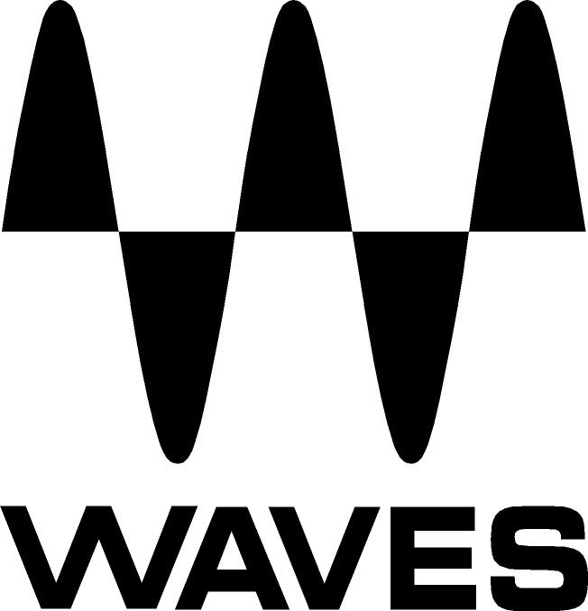

PRESS RELEASE
Contact: Clyne Media, Inc.
Tel: (615) 662-1616
Fax: (615) 662-1636

FOR IMMEDIATE RELEASE

FOH Engineer Paul Ramsay Uses Waves MultiRack and Waves Plugins on Kasabian’s Current Tour

TEL AVIV, ISRAEL, November 17, 2014 — Renowned live FOH engineer Paul Ramsay (known for his work with such artists as The Who, Annie Lennox and Skunk Anansie) uses Waves MultiRack, Waves Extreme Servers, and Waves plugins on English rock act Kasabian’s current tour.

Ramsay notes, “I started working with Waves plugins on Roger Daltrey’s solo 2011 U.S. tour. I had a DiGiCo SD7 with a pair of Waves SoundGrid servers. It all went really well, and I was very happy with the results. I didn't take any external outboard like I normally do with a SD7, other than a TC M6000. I've been mixing on DiGiCo consoles since the start of 2003, first with the D5, then with the SD7 when that came out. I think they are the best-sounding consoles and by far the best surface to mix on, hands down. The backup is second to none. Now, with integrated Waves plugins, I use no outboard gear at all other than a Lake for system EQ. I used to always carry my trusty rackmounted TC M6000 and TC 2290 along with a selection of valve compressors and high-end outboard EQs, ending up with a large double rack of outboard. Now with Waves, I carry no outboard FX. With the kind support of Waves Live Product Specialist Fabrizio Piazzini, I was introduced to the Waves IR Live, which has enabled me to use the impulse response of the TC M6000 and a bunch of other quality reverb units. I've been using Waves IR Live for all my reverbs, using the same favorite programs I would have used on a rackmounted M6000 or Lexicon 960L and sounding just as good, with all the recall in the snapshots for each song.”

Ramsay continues, “My favorite vocal compression plugin is Waves CLA-2A, which gives a good emulation of a nice, smooth compressor—the kind you don’t notice even when it’s working hard. On my main vocals I have the Waves C6 Multiband Compressor, which responds quickly to take out any peak frequencies in the singer’s voice without EQing them out, including when the singer cups the end of the mic capsule and changes the whole sound of the mic. The Waves H-Delay Hybrid Delay sounds great for a quick go-to delay, emulating what I would have used externally with no loss of quality. I use three instances of the H-Delay in total, all recalled on the snapshots for each song, flicking between mono delays and ping-pongs. When Kasabian tour behind an album, we must be able to emulate the album’s effects. On their new album 48.13, there are various distortions on the vocals. Getting a good vocal distortion in a live setting can be tricky though: rack-mounted multi-effects always sound too digital and processed, and stomp boxes are just too saturated for the sound I'm trying to emulate. With Waves, I use the Waves REDD.17 to get a nice, pleasing grit to the vocal without sounding too over the top, and I can just drop this on certain phrases, as required, via a macro on the SD7. I also use the Q10 EQ with the telephone preset and tweak the filters a bit until I have a great-sounding telephone-type vocal.”

Ramsay concludes, “Working with MultiRack and Waves plugins, I can now find an effect or insert to emulate any sound without having to call my sound vendor or bring out a vast array of outboard units in a number of racks. So the artist is happy, I’m happy, and the production manager is happy as he saves on truck space and freighting costs.”

Visit http://www.waveslive.com for more information.
...ends 599 words

Photo Files: Ramsay.JPG

About Waves Ltd.:
Waves is the world’s leading developer of audio DSP solutions for the professional, broadcast, and consumer electronics audio markets. Since its start in the early '90s with the introduction of the Q10 equalizer plugin, Waves has gone on to develop a comprehensive line of over 130 audio plugins, including industry standards like the L1 and L2 Ultramaximizers, popular vintage console models, and innovative mixing tools like Vocal Rider and the Artist Signature Series. For its accomplishments, Waves received a Technical GRAMMY® Award in 2011, and the Q10 was selected as an inductee into the TECnology Hall of Fame. Waves technologies are now used to improve sound quality in virtually every sector of the audio market, from recording, mixing, mastering and post-production to broadcast, live sound, and consumer electronics. Waves has over 20 years of expertise in the development of psychoacoustic signal processing algorithms that leverage knowledge of human auditory perception to radically improve perceived sound quality. Waves’ award-winning processors are utilized to improve sound quality in the creation of hit records, major motion pictures, and top-selling video games worldwide. Waves offers computer software and hardware-plus-software solutions for the professional and broadcast markets. The company’s WavesLive division is a market leader in all live sound sectors, spearheading the development of solutions for all live platforms. Under its Maxx brand, Waves offers semiconductor and licensable algorithms for consumer electronics applications. Waves Maxx technologies dramatically enhance audio performance and are used by industry leaders such as Dell, ASUS, JVC, and many others.

All other product names and trademarks are the property of their respective owners, which are in no way associated or affiliated with Waves.

North America Offices:
Waves, Inc., 2800 Merchants Drive, Knoxville, TN 37912;
Tel: 865-909-9200, Fax: 865-909-9245, Email: info@waves.com, Web: http://www.waves.com

Corporate Headquarters Israel:
Waves Ltd., Azrieli Center, The Triangle Tower, 32nd Floor
Tel Aviv 67023, Israel; Tel: 972-3-608-4000, Fax: 972-3-608-4056, Email: info@waves.com,
Web: http://www.waves.com

Waves Public Relations:
Clyne Media, Inc., 169-B Belle Forest Circle, Nashville, TN 37221;
Tel: 615-662-1616, Fax: 615-662-1636, Email: robert@clynemedia.com,
Web: http://www.clynemedia.com

