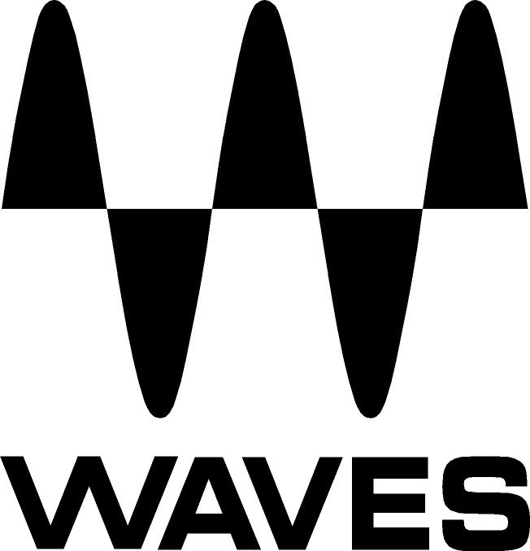

PRESS RELEASE
Contact: Clyne Media, Inc.
Tel: (615) 662-1616
Fax: (615) 662-1636

FOR IMMEDIATE RELEASE

Waves Audio and Abbey Road Studios Unveil RS56 Plugin

— Plugin faithfully recreates the RS56 Universal Tone Control, used for years at Abbey Road Studios and put to use on a multitude of classic recordings —

TEL AVIV, ISRAEL, June 11, 2013 — Waves Audio, a leading provider of audio DSP solutions for professional, broadcast and consumer electronics markets, and long-term collaborators, London’s legendary Abbey Road Studios, are proud to introduce the new RS56 Passive EQ plugin, based on the original RS56 Universal Tone Control, utilized on a multitude of classic recordings.

A passive equalizer with powerful sound-shaping capabilities, the RS56 Universal Tone Control was originally introduced in the early 1950s and used at Abbey Road Studios to prepare recordings for the record-lathe, as part of the process we now know as “mastering.” Later, Abbey Road’s pop engineers began using the RS56 for studio recordings because of its abilities to dramatically manipulate sound – unlike the basic treble and bass EQs found on the mixing consoles at the time. This earned it the nickname “The Curve Bender.”

Waves and Abbey Road Studios have faithfully recreated the unique magic of the RS56, using advanced circuit modeling techniques based on the original schematics. Like its hardware predecessor, the Waves Abbey Road RS56 passive EQ plugin features three bands with four selectable center frequencies for each and six different filter types, plus independent or linked control over the left and right channels. The result is an extraordinary equalizer that is as effective today as it was when it was created over half a century ago.

Abbey Road Studios’ Director of Engineering Peter Cobbin said, “The RS56 plugin has already joined the ranks of my go-to list, as it delivers an inviting sonic character along with a logical functionality. I would encourage any engineer to get creative with some lovely old-time curve bending, and tap into this fabulous piece of Abbey Road heritage.”

Features:
- Based on the legendary RS56 Universal Tone Control passive EQ
- Three bands with four selectable center frequencies for each
- Six different filter types
- Independent or linkable left/right controls
- Developed in association with Abbey Road Studios

Controls:
- Bass Decibels sets the amount of low frequency boost or cut
- Bass Width sets the shape of the filter
- Bass Frequency sets the low frequency cutoff point
- Bass On/Off deactivates low frequency processing
- Treble Decibels sets the amount of midrange frequency boost or cut
- Treble Width sets the shape of the filter
- Treble Frequency sets the midrange frequency cutoff point
- Top On/Off deactivates high frequency processing
- Output Level:
  - In Stereo and Duo modes: Controls the left and right channel levels
  - In MS mode: The left knob controls the Mid channel; the right knob controls the Sides channel level.
- Phase inverts the phase of the signal
- EQ Mode selects stereo processing mode (stereo component only)
  - Stereo relatively links the channels and applies the same processing to both.
  - Duo unlinks the channels and offers the option of applying different processing to each.
  - MS applies an MS encoding matrix on the input to the plugin
- Graph Range sets the range of the EQ graph
- VU Meters display output VU readings
- VU Level Calibration sets the dBFS level which appears as 0 VU.

The Waves: Abbey Road RS56 Passive EQ plugin is Native and SoundGrid® compatible. It is not included in any Waves bundle; it is only available separately. It is now available with a U.S. MSRP of Native $200, with a special introductory price of $99, and SoundGrid $300, with a special introductory price of $149. Visit www.waves.com for more information.

Abbey Road Studios, Curve Bender and RS and their associated logos are trademarks of EMI (IP) Limited.

About the RS56
The RS56 is a passive EQ, meaning no amplification of any kind is used to create its filters. In fact, it can’t even be plugged into a power socket. Passive EQs use high value capacitors and inductors to achieve the desired filtering. This lack of amplification means passive equalizers can only attenuate the signal, not boost it. Therefore, boost-like frequency-shaping is achieved by attenuating the entire signal except the specified frequency. For example, to achieve a 6 dB “boost” at 1 kHz, a passive EQ attenuates the entire signal by 6 dB apart from 1 kHz. The entire input signal is attenuated by the sum total amount of possible boost; in the case of the RS56 hardware, with three bands that can boost up to 10 dB each, the overall signal attenuation is 30 dB. In most cases, make-up gain is applied post-processing to bring the signal back up; at Abbey Road Studios, make-up gain was applied using V72 amplifiers, as found in the REDD.17 and REDD.37 consoles.

Created in the early 1950s by EMI engineer Mike Batchelor, the monophonic Universal Tone Control Type RS56 was the most flexible equalizer of its time, and an influence on EQ designs for years to come. Later, the stereo RS56-S was introduced, which offered independent linkable controls for left and right channels. The RS56 is one of those rare, mythical pieces of equipment that only the most hardcore gear aficionados even know about. The original RS56 featured three bands (Bass, Treble and Top) with four selectable center frequencies for each and six different filter types, providing +/- 10 dB of cut/boost in 2 dB increments; the Waves: Abbey Road RS56 plugin offers +/- 20 dB of cut/boost, in 0/1 dB increments. The RS56 is an extremely musical-sounding EQ; the center frequencies of its Bass and Treble bands are exactly one octave apart and, in the Top range, half an octave apart.

The RS56 was used in Abbey Road Studios from 1951-1970 to put the finishing touches on recordings prior to disc-cutting. Due to the RS56’s ability to dramatically transform the sound of input source material (as well as EMI’s dedication to “True Fidelity”), its studio use was initially restricted to fixing externally-recorded materials; the RS56 was deemed unnecessary for recordings made at Abbey Road. However, as time went on and experimentation in the recording studio became more acceptable, The Beatles’ engineers were the first to be granted permission to use the RS56 for recording and mixing.
...ends 988 words

Photo files: RS56_ScreenShot1.JPG, RS56_ScreenShot2.JPG

About Waves Ltd.:
From its start in the early '90s with the introduction of the Q10 equalizer plugin, Waves, the world’s leading developer of audio DSP solutions for professional, broadcast, and consumer electronics audio markets, has gone on to develop a comprehensive line of over 130 audio plugins including industry standards like the L1 and L2 Ultramaximizers, popular vintage console models, and innovative mixing tools like Vocal Rider and the Artist Signature Series. For its accomplishments, in 2011 Waves received a Technical GRAMMY® award, and the Q10 was selected as an inductee into the TECnology Hall of Fame. Waves technologies are now used to improve sound quality in virtually every sector of the audio market, from recording, mixing, mastering and post-production to broadcast, live sound, and consumer electronics. Waves has over 20 years of expertise in the development of psycho-acoustic signal processing algorithms that leverage knowledge on the human perception of hearing to radically improve perceived sound quality. Waves’ award-winning processors are utilized to improve sound quality in the creation of hit records, major motion pictures, and top-selling video games worldwide. Waves offers computer software solutions, as well as hardware-plus-software solutions, for the professional and broadcast markets. Under its Maxx brand, Waves offers semiconductor and licensable algorithms for consumer electronics applications. Waves Maxx technologies dramatically enhance audio performance and are used by industry leaders such as Dell, ASUS, Sony, JVC and many others.

All other product names and trademarks are the property of their respective owners, which are in no way associated or affiliated with Waves.

About Abbey Road Studios:
Abbey Road Studios are the most famous recording studios in the world and an iconic symbol of British music. They have been home to countless landmark recordings and pioneering advances in recording technology. Opened in November 1931, Abbey Road Studios were the world’s first purpose built recording studios. The hallowed building has a phenomenal 80 year history working with many of the world’s most famous artists including The Beatles, Pink Floyd, The Hollies, Kate Bush, Oasis, Florence and the Machine, Adele and Lady Gaga. Also one of the world’s premiere locations for movie scoring, since the 1980s films such as Raiders of the Lost Ark, the Lord of The Rings Trilogy, Braveheart and The King’s Speech have been recorded there. The list continues with many other major titles, including Shrek, Prometheus, Harry Potter, Skyfall and The Hobbit. www.AbbeyRoad.com

Waves Contacts:
North America Offices:
Waves, Inc., 2800 Merchants Drive, Knoxville, TN 37912;
Tel: 865-909-9200, Fax: 865-909-9245, Email: info@waves.com, Web: http://www.waves.com

Corporate Headquarters Israel:
Waves Ltd., Azrieli Center, The Triangle Tower, 32nd Floor
Tel Aviv 67023, Israel; Tel: 972-3-608-4000, Fax: 972-3-608-4056, Email: info@waves.com,
Web: http://www.waves.com

Waves Public Relations:
Clyne Media, Inc., 169-B Belle Forest Circle, Nashville, TN 37221;
Tel: 615-662-1616, Fax: 615-662-1636, Email: robert@clynemedia.com,
Web: http://www.clynemedia.com

