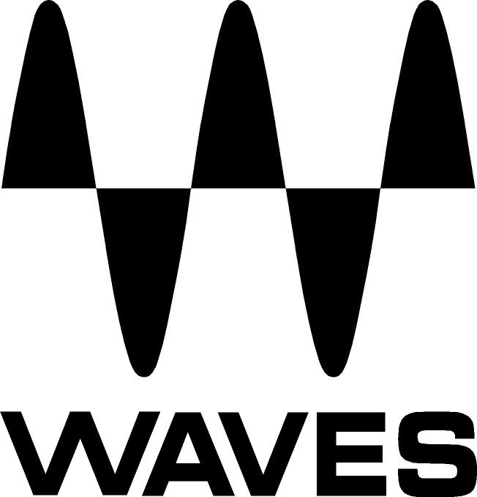
PRESS RELEASE
Contact: Clyne Media, Inc.
Tel: (615) 662-1616
Fax: (615) 662-1636

FOR IMMEDIATE RELEASE

David Cain Mixes with Waves Nx – Virtual Mix Room over Headphones and Waves Nx Head Tracker for Headphones

KNOXVILLE, TN, June 20, 2019 — Composer, performer, engineer, producer and filmmaker David Cain (Wertico Cain and Gray) mixes using Waves Nx – Virtual Mix Room over Headphones and Waves Nx Head Tracker for Headphones.

Cain comments, “I use Waves Nx – Virtual Mix Room over Headphones and Waves Nx Head Tracker for Headphones to mix albums for my trio, Wertico Cain and Gray (featuring seven-time GRAMMY® winner Paul Wertico from the Pat Metheny Group). Our most recent project, Without Compromise, is a live studio session of improvised music compositions which we recorded using vintage mics (including a U47 that belonged to John Lennon). We also captured an 8k VR 360 video of the session to put the viewer/listener in the middle of the studio, exactly seven feet from Paul, Larry and myself. With Waves Nx, I was able to move confidently into the ‘Wild West’ of surround, in that Nx enables hearing stereo, surround and ambisonic experiences. It’s a very powerful way to expand my workflow.”

He adds, “My studio reference monitors are an essential element in my work, but I love working on my Shure 1840 headphones because I can get immersed in the sonic experience and minimize outside interruptions or room noises. I like the perceptual and proximity effect of the Nx’s flow to experiment and embrace new ideas and technologies. With Waves’ Nx, I’m able to get into stereo and 3D space with my trusty Shure 1840s, and I like to use these headphones to fine-tune my mixes. I have always loved to experiment and embrace new ideas and technologies. Producers and engineers such as George Martin (Beatles) and Teo Macero (Miles Davis) pushed the envelope in amazing ways with the technology of the day. I’m trying to do the same with my music, mixes, videos, and Waves plugins. Nx puts me in the room(s) of my choice: stereo, surround or ambisonic. I think that we’re on the cusp of a listening revolution that will open up new ways of experiencing sonic magic. In addition, it is essential to have multiple ways of referencing and examining mixes, especially with the crazy number of listening possibilities currently available. Nx provides great mix reference points and helps me see and hear my mixes from all angles.”

Powered by Waves’ groundbreaking Nx technology, Waves Nx Virtual Mix Room is a virtual monitoring plugin that delivers immersive 3D audio on headphones – the same three-dimensional depth and panoramic stereo image you would be hearing from speakers in an acoustically treated room. This plugin recreates the acoustics of a high-end studio inside your headphones, so you can make great mixing decisions anytime, anywhere. In addition, you can mix for 7.1, 5.1 or 5.0 surround on your regular stereo headphones – all this without coloring your sound or introducing any artifacts. What you hear is your mix, exactly the way you want it to sound – only now you have a more accurate way to monitor it on headphones. It includes a Headphone EQ calibration feature, allowing you to select a correction EQ curve for specific headphone models. Taking advantage of your computer’s camera, or the Waves Nx Head Tracker for Headphones, you have real-time head tracking and enjoy the enhanced realism of being in the Virtual Mix Room, anywhere and everywhere you go. This small Bluetooth® device latches on to your headphones and tracks your head movements in order to augment the immersive 3D audio experience created by Nx technology. Use the Nx Head Tracker along with the Nx Virtual Mix Room plugin in order to recreate on headphones the ideal spatial acoustics of a high-end room, improving your headphone mixing, recording and an end to headphone-ear fatigue.

Cain continues, “I’ve just started mixing the soundtrack for a new movie project, The Luckiest People, using Waves Nx, which is really helpful in keeping my workflow simple and clean. I don’t want to be bogged down with ‘stuff’ or ‘tech’ while I’m working. And again, with Nx I can work anywhere. When I’m in sunny California, I like to work outside at a coffee shop on a beautiful day, listening and mixing with Nx while people-watching. The point is – I can work anywhere. I think that Nx is best enjoyed near a beach by an ocean.”

He adds, “Another clear benefit of using Nx is that when using various means to listen and mix at various volume levels, it really helps to minimize ear fatigue. Nx is another tool to minimize sonic overload from headphones or monitors, with constant sound pressure levels.” About using the Waves Nx Head Tracker for Headphones, he notes, “I primarily use the Nx plugin with the Nx Head Tracker, since I find this combination to be a great workflow for mixing. I can work on a mix and experience the perceptual reality of any listening environment, be it stereo, surround or ambisonic.”

Cain sums it up, “Waves Nx is an integral part of my mixing process, for stereo and surround sound sculpting. In my opinion, sound spatial design is an advanced form of orchestration. I studied music composition and orchestration with composer Roque Cordero, from the revolutionary 2nd Viennese school (Schoenberg, Webern), and I try to imagine what they might have done with these modern tools! Not only can I create new instruments for my music and projects, with Nx I can orchestrate sounds and performances in 3D and 360 worlds. Waves audio tools are amazing, reliable, and essential to my creative workflow. I love my headphones as much as my studio reference monitor systems. Having the flexibility to be able to work anywhere (hotel room, airport) with Nx is cool, and I can share in-progress mixes and ideas with my collaborator and co-producer Paul Wertico, anywhere, anytime!”

…ends 950 words

Photo file 1: Nx_Cain.JPG
Photo caption 1: Composer, performer, engineer, producer and filmmaker David Cain

Photo file 2: nx-virtual-mix-room.jpg
Photo caption 2: Waves Nx – Virtual Mix Room over Headphones

About Waves Audio Ltd.:
Waves is the world’s leading developer of audio DSP solutions for the professional, broadcast, and consumer electronics audio markets. Since its start in the early '90s with the introduction of the Q10 equalizer plugin, Waves has gone on to develop a comprehensive line of over 150 audio plugins, including industry standards like the L1 and L2 Ultramaximizers, popular vintage console models, and innovative mixing tools like Vocal Rider and the Artist Signature Series. For its accomplishments, Waves received a Technical GRAMMY® Award in 2011, and the Q10 was selected as an inductee into the TECnology Hall of Fame. In 2016, Waves released the eMotion LV1 mixer, a revolutionary live digital mixing console that provides real-time audio mixing for front-of-house, monitor, studio and broadcast engineers. Waves technologies are now used to improve sound quality in virtually every sector of the audio market, from recording, mixing, mastering and post-production to broadcast, live sound, and consumer electronics. Waves has over 25 years of expertise in the development of psychoacoustic signal processing algorithms that leverage knowledge of human auditory perception to radically improve perceived sound quality. Waves’ award-winning processors are utilized to improve sound quality in the creation of hit records, major motion pictures, and top-selling video games worldwide. Waves offers computer software and hardware-plus-software solutions for the professional and broadcast markets. The company’s WavesLive division is a market leader in all live sound sectors, spearheading the development of solutions for all live platforms. Under its Maxx brand, Waves offers semiconductor and licensable algorithms for consumer electronics applications. Waves technologies dramatically enhance audio performance and are used by industry leaders such as Dell, Google, Fitbit, Acer, Asus, Hisense and more.

North America Offices:
Waves, Inc., 2800 Merchants Drive, Knoxville, TN 37912;
Tel: 865-909-9200, Fax: 865-909-9245, Email: info@waves.com,
Web: http://www.waves.com

Corporate Headquarters Israel:
Waves Ltd., Azrieli Center, The Triangle Tower, 32nd Floor, Tel Aviv 67023, Israel;
Tel: 972-3-608-4000, Fax: 972-3-608-4056, Email: info@waves.com,
Web: http://www.waves.com

Waves Public Relations:
Clyne Media, Inc., 169-B Belle Forest Circle, Nashville, TN 37221;
Tel: 615-662-1616, Fax: 615-662-1636, Email: robert@clynemedia.com,
Web: http://www.clynemedia.com

