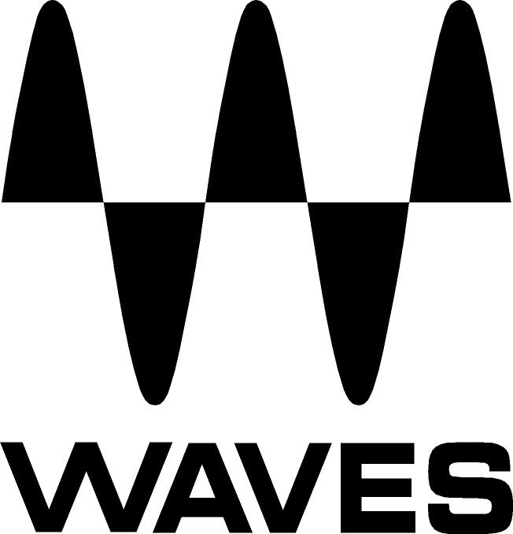

PRESS RELEASE
Contact: Clyne Media, Inc.
Tel: (615) 662-1616
Fax: (615) 662-1636

FOR IMMEDIATE RELEASE

Waves Audio Offers Waves B360 Ambisonics Encoder, Waves Nx Ambisonics and Waves 360° Ambisonics Tools

NAB Show, Las Vegas, NV, April 8, 2019 — Waves Audio (booth C1147), a leading provider of processing solutions, offers a combo of tools for Ambisonics, the most popular technique for mixing audio in a full spherical 360-degree sound field. Using these tools is the easiest way to mix and monitor Ambisonics B-format audio for 360° or VR projects on your existing system – no dedicated 360° playback system required.

Ambisonics B-format is the industry standard for recording, mixing and playing back audio in a full spherical 360-degree soundfield. It is the audio format most widely used in VR/AR and in Facebook and YouTube 360° videos.

With the tools in this combo, you can convert stereo and surround to Ambisonics B-format, mix B-format audio, and monitor it in high fidelity on your regular stereo headphones, all as part of your intuitive workflow. The combo includes:
- B360 Ambisonics Encoder: Use this plugin to easily convert mono, stereo and surround tracks to Ambisonics B-format for 360° playback and mixing. You can either insert B360 on your entire mix to convert it to B-format; or open the plugin on each individual track in order to pan it in your 360° mix.
- Nx Virtual Mix Room: Use this plugin to monitor your B-format mix on any pair of standard stereo headphones, with professional audio quality that doesn’t color your sound. Simply insert the plugin’s Nx Ambisonics component on the buss you wish to monitor, and send it to your regular headphones.
- Nx Head Tracker: This small Bluetooth device enhances the 360° realism of the Nx plugin by tracking your head movements with full precision.
Combined, these tools give you the most intuitive, user-friendly way to handle Ambisonics B-format audio for your 360° or VR/AR projects.

For more information, please visit www.waves.com.
…ends 287 words

Photo file: B360_AmbisonicsTools.JPG
Photo caption: Waves 360° Ambisonics Tools

About Waves Audio Ltd.:
Waves is the world’s leading developer of audio DSP solutions for the professional, broadcast, and consumer electronics audio markets. Since its start in the early '90s with the introduction of the Q10 equalizer plugin, Waves has gone on to develop a comprehensive line of over 150 audio plugins, including industry standards like the L1 and L2 Ultramaximizers, popular vintage console models, and innovative mixing tools like Vocal Rider and the Artist Signature Series. For its accomplishments, Waves received a Technical GRAMMY® Award in 2011, and the Q10 was selected as an inductee into the TECnology Hall of Fame. In 2016, Waves released the eMotion LV1 mixer, a revolutionary live digital mixing console that provides real-time audio mixing for front-of-house, monitor, studio and broadcast engineers. Waves technologies are now used to improve sound quality in virtually every sector of the audio market, from recording, mixing, mastering and post-production to broadcast, live sound, and consumer electronics. Waves has over 25 years of expertise in the development of psychoacoustic signal processing algorithms that leverage knowledge of human auditory perception to radically improve perceived sound quality. Waves’ award-winning processors are utilized to improve sound quality in the creation of hit records, major motion pictures, and top-selling video games worldwide. Waves offers computer software and hardware-plus-software solutions for the professional and broadcast markets. The company’s WavesLive division is a market leader in all live sound sectors, spearheading the development of solutions for all live platforms. Under its Maxx brand, Waves offers semiconductor and licensable algorithms for consumer electronics applications. Waves technologies dramatically enhance audio performance and are used by industry leaders such as Dell, Google, Fitbit, Acer, Asus, Hisense and more.

All other product names and trademarks are the property of their respective owners, which are in no way associated or affiliated with Waves.

North America Offices:
Waves, Inc., 2800 Merchants Drive, Knoxville, TN 37912;
Tel: 865-909-9200, Fax: 865-909-9245, Email: info@waves.com,
Web: http://www.waves.com

Corporate Headquarters Israel:
Waves Ltd., Azrieli Center, The Triangle Tower, 32nd Floor, Tel Aviv 67023, Israel;
Tel: 972-3-608-4000, Fax: 972-3-608-4056, Email: info@waves.com,
Web: http://www.waves.com

Waves Public Relations:
Clyne Media, Inc., 169-B Belle Forest Circle, Nashville, TN 37221;
Tel: 615-662-1616, Fax: 615-662-1636, Email: robert@clynemedia.com,
Web: http://www.clynemedia.com

Waves Audio is exhibiting at booth C1147 at the 2019 NAB Show in Las Vegas, NV.

