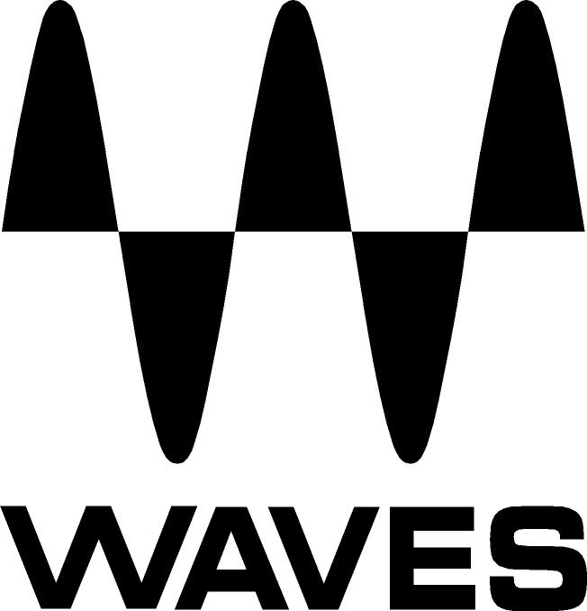

PRESS RELEASE
Contact: Clyne Media, Inc.
Tel: (615) 662-1616
Fax: (615) 662-1636

FOR IMMEDIATE RELEASE

Waves Offers eMotion LV1 Live Mixer

NAB SHOW, LAS VEGAS, NV, April 18, 2016 — The Waves (booth C2451) eMotion LV1 is a revolutionary digital mixing console for front-of-house, monitor and broadcast engineers. Based on Waves SoundGrid® technology, this software mixer delivers the superior sound quality for which Waves is renowned, as well as a quick workflow needed in demanding environments.

It gives users unprecedented control over every aspect sound. Each of the mixer’s channels has its own plugin rack capable of running up to eight Waves and third-party plugins, meaning users can mix live with hundreds of their favorite plugins—all running inside the mixer itself. All plugin presets and chains saved in eMotion LV1 can be shared with the Waves MultiRack and StudioRack plugin hosts, enabling users to move seamlessly between live and studio environments.

The mixer’s channel strip—its standard EQ, filters and dynamics processing—is provided by Waves eMo plugins: eMo D5 Dynamics, eMo F2 Filter and eMo Q4 Equalizer, designed for maximum clarity and efficiency in a live environment.

Users can control eMotion LV1 with industry-standard hardware controllers, multi-touch screens and diverse portable devices, from four touchscreens to a single laptop or tablet. Whichever device is being used, the LV1 has the same intuitive workflow, with a user interface built for flexibility and speed.

Waves eMotion LV1 features:
- 64 stereo/mono input channels, 36 buss/return channels
- Run 8 SoundGrid-compatible plugins directly on each channel
- Standard channel processing provided by Waves eMo plugins
- 16 auxes, 8 audio groups (stereo/mono), L/R/C/Mono, 8 matrixes
- 16 DCA faders, 8 mute groups, 8 user-assignable shortcut keys
- 32-bit floating point mix engine; up to 96 kHz sample rate
- Compatible with industry-standard control surfaces
- Connect to diverse SoundGrid I/Os & drivers and to multiple DAWs
- Windows/Mac 64 bit-compatible

…ends 280 words

Photo file: LV1.JPG
Photo caption: Waves eMotion LV1 Live Mixer

About Waves Audio Ltd.:
Waves is the world’s leading developer of audio DSP solutions for the professional, broadcast, and consumer electronics audio markets. Since its start in the early '90s with the introduction of the Q10 equalizer plugin, Waves has gone on to develop a comprehensive line of over 200 audio plugins, including industry standards like the L1 and L2 Ultramaximizers, popular vintage console models, and innovative mixing tools like Vocal Rider and the Artist Signature Series. For its accomplishments, Waves received a Technical GRAMMY® Award in 2011, and the Q10 was selected as an inductee into the TECnology Hall of Fame. In 2016, Waves released the eMotion LV1 mixer, a revolutionary live digital mixing console that provides real-time audio mixing for front-of-house, monitor, studio and broadcast engineers. Waves technologies are now used to improve sound quality in virtually every sector of the audio market, from recording, mixing, mastering and post-production to broadcast, live sound, and consumer electronics. Waves has over 20 years of expertise in the development of psychoacoustic signal processing algorithms that leverage knowledge of human auditory perception to radically improve perceived sound quality. Waves’ award-winning processors are utilized to improve sound quality in the creation of hit records, major motion pictures, and top-selling video games worldwide. Waves offers computer software and hardware-plus-software solutions for the professional and broadcast markets. The company’s WavesLive division is a market leader in all live sound sectors, spearheading the development of solutions for all live platforms. Under its Maxx brand, Waves offers semiconductor and licensable algorithms for consumer electronics applications. Waves Maxx technologies dramatically enhance audio performance and are used by industry leaders such as Dell, LG, TCL, Lenovo, Asus, Denon and more.

All other product names and trademarks are the property of their respective owners, which are in no way associated or affiliated with Waves.

North America Offices:
Waves, Inc., 2800 Merchants Drive, Knoxville, TN 37912;
Tel: 865-909-9200, Fax: 865-909-9245, Email: info@waves.com, Web: http://www.waves.com

Corporate Headquarters Israel:
Waves Ltd., Azrieli Center, The Triangle Tower, 32nd Floor
Tel Aviv 67023, Israel; Tel: 972-3-608-4000, Fax: 972-3-608-4056, Email: info@waves.com,
Web: http://www.waves.com

Waves Public Relations:
Clyne Media, Inc., 169-B Belle Forest Circle, Nashville, TN 37221;
Tel: 615-662-1616, Fax: 615-662-1636, Email: robert@clynemedia.com,
Web: http://www.clynemedia.com

Waves Audio is exhibiting at booth C2451 at the 2016 NAB Show in Las Vegas, NV.

