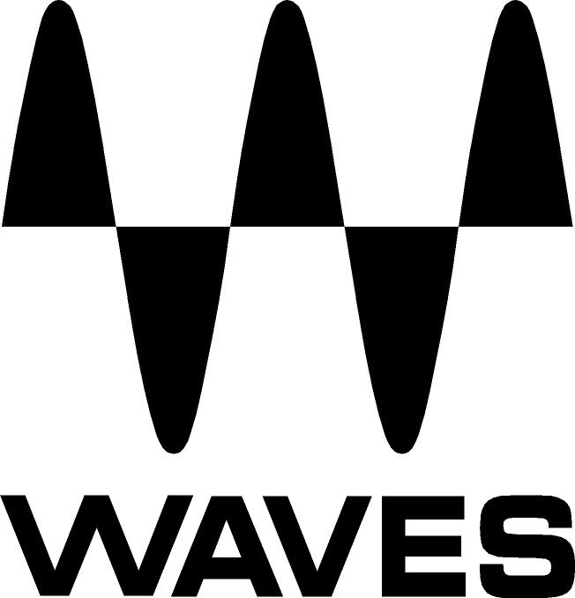
PRESS RELEASE
Contact: Clyne Media, Inc.
Tel: (615) 662-1616
Fax: (615) 662-1636

FOR IMMEDIATE RELEASE

Waves Audio Now Shipping MyMon – a Personal Monitor Mixing App for the eMotion LV1 Live Mixer

Knoxville, TN, December 4, 2019 — Waves Audio, the world’s leading developer of professional audio signal processing technologies and leading maker of audio plugins for mixing, music production, mastering, sound design, broadcast, post-production and live sound, introduces MyMon – a Personal Monitor Mixing App for the Waves eMotion LV1 Live Mixer.

This iOS/Android app for the Waves eMotion LV1 Live Mixer gives musicians on stage direct control of their monitor mix: Adjust input levels, mute, pan, apply post-mix EQ, and link channels to custom single-fader groups.

As a stage musician, your monitor mix is an important part of your performance. No one knows how your mix sounds better than you! A bad monitor mix can ruin an entire show—and when your mix is bad, it can be difficult to perform at your best. Waves’ MyMon makes it easy to adjust your mix directly from your iOS or Android mobile device. Instead of trying to tell someone else what you need to hear, with MyMon, you get real-time customizable control of your own mix anywhere, anytime, so you can hear exactly what you need every time you play.

Even if you have little to no technical knowledge about mixing, MyMon‘s app interface is musician-friendly and intuitive enough for you to easily build the perfect mix for yourself. Self-manage input channel levels, mute, pan, link multiple channels to a single fader, and customize your sound even further with the built-in master bus EQ.

For live sound engineers, it’s a priority to make the band not only sound great in the house but feel great on stage. The better the band can hear, the better the performance will be. Waves’ MyMon provides a streamlined personal monitor experience. No more mysterious hand gestures, no more musicians randomly pointing at their instruments. Every member of the band can customize their mix at any given time—without affecting the house mix, and without competing for your attention at FOH.

With simple setup and easy navigation, MyMon makes the live experience more enjoyable for live sound engineers and musicians alike.

Features:
- Personal monitor mixing app for Android and iOS (iPhone®, iPad®, iPod touch®) devices
- Designed exclusively for the eMotion LV1 Live Mixer
- Connect up to 16 mobile devices simultaneously to eMotion LV1
- Musician-friendly app interface: Easy swipe navigation, double-tap reset
- Landscape and Portrait screen modes
- Control individual channel pan, mute and volume levels
- Control groups and FX returns (LV1 64/32-channel configurations only)
- Control post-mix (master bus) monitor EQ
- Assign any combination of channels to four LINK masters, each with volume and mute toggles
- Create unique names for Links
- Save and store Link names and assignments per session
- Lock individual devices for security

To learn more, visit www.waves.com/mixers-racks/mymon-personal-monitor-mixing-app.

Video:
Introducing Waves MyMon: Personal Monitor Mixing App for Mobile Devices: https://youtu.be/I-njvpAqZq0

…ends 456 words

Photo file: Lv1_MyMon.JPG
Photo caption: Waves Audio is now shipping MyMon – a personal monitor mixing app for the eMotion LV1 Live Mixer

About Waves Audio Ltd.:
Waves is the world’s leading developer of audio DSP solutions for the professional, broadcast, and consumer electronics audio markets. Since its start in the early '90s with the introduction of the Q10 equalizer plugin, Waves has gone on to develop a comprehensive line of over 150 audio plugins, including industry standards like the L1 and L2 Ultramaximizers, popular vintage console models, and innovative mixing tools like Vocal Rider and the Artist Signature Series. For its accomplishments, Waves received a Technical GRAMMY® Award in 2011, and the Q10 was selected as an inductee into the TECnology Hall of Fame. In 2016, Waves released the eMotion LV1 mixer, a revolutionary live digital mixing console that provides real-time audio mixing for front-of-house, monitor, studio and broadcast engineers. Waves technologies are now used to improve sound quality in virtually every sector of the audio market, from recording, mixing, mastering and post-production to broadcast, live sound, and consumer electronics. Waves has over 25 years of expertise in the development of psychoacoustic signal processing algorithms that leverage knowledge of human auditory perception to radically improve perceived sound quality. Waves’ award-winning processors are utilized to improve sound quality in the creation of hit records, major motion pictures, and top-selling video games worldwide. Waves offers computer software and hardware-plus-software solutions for the professional and broadcast markets. The company’s WavesLive division is a market leader in all live sound sectors, spearheading the development of solutions for all live platforms. Under its Maxx brand, Waves offers semiconductor and licensable algorithms for consumer electronics applications. Waves technologies dramatically enhance audio performance and are used by industry leaders such as Dell, Google, Fitbit, Acer, Asus, Hisense and more.

North America Offices:
Waves, Inc., 2800 Merchants Drive, Knoxville, TN 37912;
Tel: 865-909-9200, Fax: 865-909-9245, Email: info@waves.com,
Web: http://www.waves.com

Corporate Headquarters Israel:
Waves Ltd., Azrieli Center, The Triangle Tower, 32nd Floor, Tel Aviv 67023, Israel;
Tel: 972-3-608-4000, Fax: 972-3-608-4056, Email: info@waves.com,
Web: http://www.waves.com

Waves Public Relations:
Clyne Media, Inc., 169-B Belle Forest Circle, Nashville, TN 37221;
Tel: 615-662-1616, Fax: 615-662-1636, Email: robert@clynemedia.com,
Web: http://www.clynemedia.com

