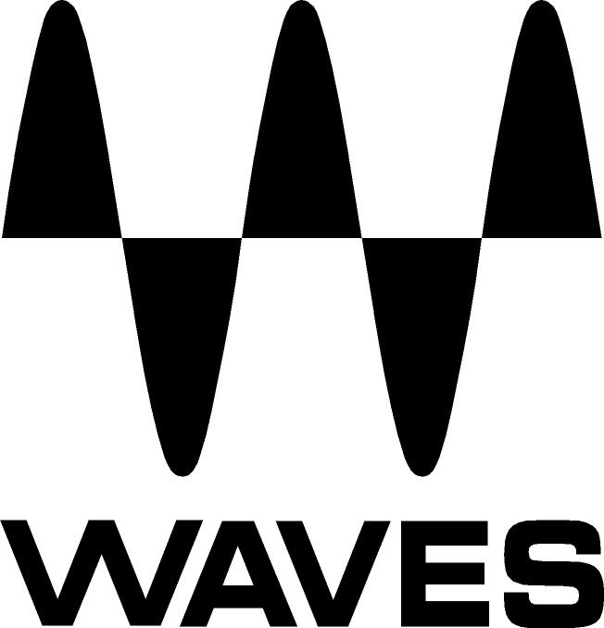
PRESS RELEASE
Contact: Clyne Media, Inc.
Tel: (615) 662-1616
Fax: (615) 662-1636

FOR IMMEDIATE RELEASE

Music Mix Mobile Employs Waves SuperRack and Waves Plugins for the Broadcast Mix of the Bud Light Super Bowl Music Fest

Knoxville, TN, March 4, 2020 — Music Mix Mobile (M3), the New Jersey-based remote facilities company that combines the talents of award-winning production professionals and state-of-the-art audio solutions, recently captured performances at the Bud Light Super Bowl Music Fest, held January 30 through February 1. The three-night festival leading up to Super Bowl LIV gave football fans and the city of Miami an opportunity to enjoy some of the top names in the music industry, including DJ Khaled, Maroon 5, DaBaby, Guns N’ Roses, Snoop Dogg, and Dan + Shay. Held at Miami’s American Airlines Arena, with highlights from the festival airing on the Fox network on Saturday, February 1, the event was captured onsite by M3 with their Eclipse truck, which was driven directly from the GRAMMY® Awards to Miami.

The Eclipse truck features a LAWO mixing console, M&K Speakers, and signal processing from Waves, including an extensive selection of Waves plugins and the new Waves SuperRack SoundGrid—a cutting-edge plugin rack that lets live sound and broadcast engineers run up to 128 audio channels through multiple instances of Waves’ plugins, with near-zero latency and endless workflow customization options. M3 was responsible for the broadcast music mix. Their use of Waves products, they say, kept things running smoothly in the high-stress, high-stakes environment of live event broadcast audio.

M3 co-founder and Chief Engineer Joel Singer notes, “Our lead mixer Jay Vicari chose Waves for effects, reverbs, delays, and specialized processing. The F6 Floating-Band Dynamic EQ in particular is essential to our vocal processing. The F6 is on all main vocal channels, along with a Renaissance DeEsser. Jay has become really comfortable using it: he uses the F6 alongside the console EQ and dynamics to get a vocal to work very nicely—without nearly as much console EQ as he’s used before. We now use minimal amounts of EQ, instead of having to EQ something drastically in order to try to get the vocal to sit. With F6 you’re able to find the trouble spot in the vocal, and just focus on that to make the vocal sit in the mix.”

The Bud Light Super Bowl Music Fest was M3’s first live use of the Waves SuperRack. Singer says, “We had been testing it for a month or so, and we finally put it to use in this show in our Eclipse truck. We took advantage of SuperRack’s new floating window option, which let us place the F6 at the top of the screen, while also being able to see the other plugins being used and control different plugins simultaneously. The overall layout in SuperRack is very helpful and practical: You can see a lot more of what’s going on. You can see your input, your output, and you can see them on a lot of channels simultaneously. The interface is just so user-friendly—very cool.”

When asked about the challenges of a show like the Bud Light Super Bowl Music Fest, Singer says, “We worked something like 45 hours in three days. Having the right tools helped us achieve a sound that was extremely uniform. Waves made the show sound really good, and it gave Jay the tools and the ability to hone the sound quickly. Waves has been a key component of our sound and workflow for years—and now with SuperRack it’s taken the interface to a new level of ease.”
…ends 558 words

Photo file 1: M3_BudLightSuperBowl_Photo1.JPG
Photo caption 1: M3 lead mixer Jay Vicari, pictured in the Eclipse truck, at the Bud Light Super Bowl Music Fest, held January 30 through February 1. Pictured onscreen is Waves SuperRack.

Photo file 2: M3_BudLightSuperBowl_Photo2.JPG
Photo caption 2: M3 lead mixer Jay Vicari, pictured in the Eclipse truck, at the Bud Light Super Bowl Music Fest, held January 30 through February 1. Pictured onscreen is Waves F6 Floating-Band Dynamic EQ.

About Waves Audio Ltd.:
Waves is the world’s leading developer of audio DSP solutions for the professional, broadcast, and consumer electronics audio markets. Since its start in the early '90s with the introduction of the Q10 equalizer plugin, Waves has gone on to develop a comprehensive line of over 150 audio plugins, including industry standards like the L1 and L2 Ultramaximizers, popular vintage console models, and innovative mixing tools like Vocal Rider and the Artist Signature Series. For its accomplishments, Waves received a Technical GRAMMY® Award in 2011, and the Q10 was selected as an inductee into the TECnology Hall of Fame. In 2016, Waves released the eMotion LV1 mixer, a revolutionary live digital mixing console that provides real-time audio mixing for front-of-house, monitor, studio and broadcast engineers. Waves technologies are now used to improve sound quality in virtually every sector of the audio market, from recording, mixing, mastering and post-production to broadcast, live sound, and consumer electronics. Waves has over 25 years of expertise in the development of psychoacoustic signal processing algorithms that leverage knowledge of human auditory perception to radically improve perceived sound quality. Waves’ award-winning processors are utilized to improve sound quality in the creation of hit records, major motion pictures, and top-selling video games worldwide. Waves offers computer software and hardware-plus-software solutions for the professional and broadcast markets. The company’s WavesLive division is a market leader in all live sound sectors, spearheading the development of solutions for all live platforms. Under its Maxx brand, Waves offers semiconductor and licensable algorithms for consumer electronics applications. Waves technologies dramatically enhance audio performance and are used by industry leaders such as Dell, Google, Fitbit, Acer, Asus, Hisense and more.

North America Offices:
Waves, Inc., 2800 Merchants Drive, Knoxville, TN 37912;
Tel: 865-909-9200, Fax: 865-909-9245, Email: info@waves.com,
Web: http://www.waves.com

Corporate Headquarters Israel:
Waves Ltd., Azrieli Center, The Triangle Tower, 32nd Floor, Tel Aviv 67023, Israel;
Tel: 972-3-608-4000, Fax: 972-3-608-4056, Email: info@waves.com,
Web: http://www.waves.com

Waves Public Relations:
Clyne Media, Inc., 169-B Belle Forest Circle, Nashville, TN 37221;
Tel: 615-662-1616, Fax: 615-662-1636, Email: robert@clynemedia.com,
Web: http://www.clynemedia.com

