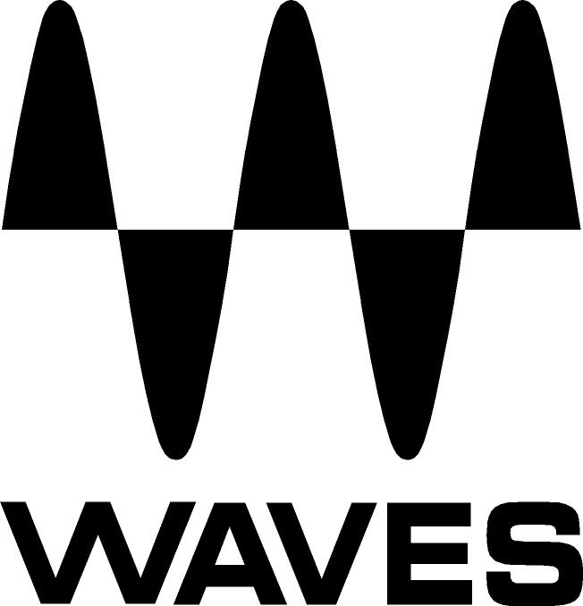

PRESS RELEASE
Contact: Clyne Media, Inc.
Tel: (615) 662-1616
Fax: (615) 662-1636

FOR IMMEDIATE RELEASE

Waves Audio Offers Offers MultiRack

InfoComm, Las Vegas, NV, June 6, 2018 — Waves Audio (booth C852), a leading provider of processing solutions, offers Waves MultiRack, a software host that lets FOH and monitor engineers run multiple, simultaneous instances of the same award-winning Waves plugins used in recording studios and mixing rooms the world over. The world’s best-sounding reverbs, equalizers, compressors, limiters and delays are at your fingertips, without the limitations of hardware and at a fraction of the cost.

MultiRack application is ideal for live sound, broadcast, post-production facilities and more. With easy setup and advanced preset capabilities, MultiRack delivers all the flexibility and portability of software, with sound quality and convenience that beats hardware.
- Take studio sound to the stage and back again
- Quick and simple setup
- A fraction of the cost of hardware
- Full recall, full control
- Set and save presets, snapshots and Hot plugins per song and song sections
- Advanced side-chaining capabilities
- Windows- and OS X-compatible
- Run plugins live in real time and low latency (MultiRack SoundGrid only)
- Simultaneous processing and recording capabilities (MultiRack SoundGrid only)
- Plugin chain presets saved on MultiRack can be loaded in StudioRack, and vice versa
- Supports 5.1 and 7.1 Surround plugins and plugin components (NEW)
- Hot Plugin Panel with individual gain reduction meters for each plugin (NEW)

For more information, please visit https://www.waves.com/mixers-racks/multirack#introduction-to-multirack.
…ends 209 words

Photo file: multirack-soundgrid.JPG
Photo caption: Waves MultiRack SoundGrid® user interface

About Waves Audio Ltd.:
Waves is the world’s leading developer of audio DSP solutions for the professional, broadcast, and consumer electronics audio markets. Since its start in the early '90s with the introduction of the Q10 equalizer plugin, Waves has gone on to develop a comprehensive line of over 150 audio plugins, including industry standards like the L1 and L2 Ultramaximizers, popular vintage console models, and innovative mixing tools like Vocal Rider and the Artist Signature Series. For its accomplishments, Waves received a Technical GRAMMY® Award in 2011, and the Q10 was selected as an inductee into the TECnology Hall of Fame. In 2016, Waves released the eMotion LV1 mixer, a revolutionary live digital mixing console that provides real-time audio mixing for front-of-house, monitor, studio and broadcast engineers. Waves technologies are now used to improve sound quality in virtually every sector of the audio market, from recording, mixing, mastering and post-production to broadcast, live sound, and consumer electronics. Waves has over 25 years of expertise in the development of psychoacoustic signal processing algorithms that leverage knowledge of human auditory perception to radically improve perceived sound quality. Waves’ award-winning processors are utilized to improve sound quality in the creation of hit records, major motion pictures, and top-selling video games worldwide. Waves offers computer software and hardware-plus-software solutions for the professional and broadcast markets. The company’s WavesLive division is a market leader in all live sound sectors, spearheading the development of solutions for all live platforms. Under its Maxx brand, Waves offers semiconductor and licensable algorithms for consumer electronics applications. Waves technologies dramatically enhance audio performance and are used by industry leaders such as Dell, Google, Fitbit, Acer, Asus, Hisense and more.

All other product names and trademarks are the property of their respective owners, which are in no way associated or affiliated with Waves.

North America Offices:
Waves, Inc., 2800 Merchants Drive, Knoxville, TN 37912;
Tel: 865-909-9200, Fax: 865-909-9245, Email: info@waves.com,
Web: http://www.waves.com

Corporate Headquarters Israel:
Waves Ltd., Azrieli Center, The Triangle Tower, 32nd Floor, Tel Aviv 67023, Israel;
Tel: 972-3-608-4000, Fax: 972-3-608-4056, Email: info@waves.com,
Web: http://www.waves.com

Waves Public Relations:
Clyne Media, Inc., 169-B Belle Forest Circle, Nashville, TN 37221;
Tel: 615-662-1616, Fax: 615-662-1636, Email: robert@clynemedia.com,
Web: http://www.clynemedia.com

Waves Audio is exhibiting at booth C852 at the 2018 InfoComm Show in Las Vegas, NV.

