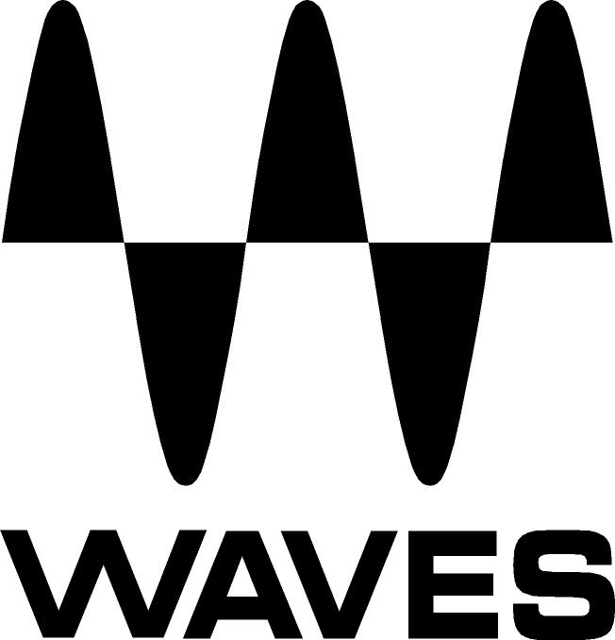

PRESS RELEASE
Contact: Clyne Media, Inc.
Tel: (615) 662-1616
Fax: (615) 662-1636

FOR IMMEDIATE RELEASE

Waves Audio Offers eMotion™ Mixer for SoundGrid®

INFOCOMM, ORLANDO, FL, June 12, 2013 — Waves Audio (booth 762) offers its eMotion™ Mixer for SoundGrid® systems. The line’s first products were recently introduced: the eMotion LV1 for live sound front-of-house and monitor applications, and eMotion Studio, for recording, mixing and post production facilities. Designed to integrate seamlessly with Waves SoundGrid-compatible I/Os, eMotion is poised to revolutionize the world of mixing.

The eMotion Mixer engine is powered by low-latency Intel-based Waves SoundGrid DSP Servers. Features include low-latency Waves plugin processing on every channel; support for multiple mixers, I/O boxes and SoundGrid DSP servers over a single network; hardware scalability using standard network components; compatibility with standard control surfaces; Multi-Touch support; Windows and Mac compatibility; and preset sharing across consoles and platforms.

The LV1, the first product in the eMotion series, features two new integrated plugins: EMO-D5 Dynamics Processor and EMO-Q4 Equalizer.

LV1 Software Mixer Product Features
- 64 input channels (mono/stereo)
- 32 stereo busses + return channels
- L/R, center, mono main busses + master channels
- 8 DCA faders, 8 mute groups, 8 user-assignable function controls
- Cue/SIP and talk-back
- EMO-Q4 Equalizer: 4-band EQ with HP and LP per channel
- EMO-D5 Dynamics Processor: Comp/Gate/Expander/DeEsser/Limiter/Leveler per channel
- Up to 6 plug-ins per channel
- Connect to multiple DAWs for recording and playback
- Save and transmit sessions and snapshots from any DAW to eMotion
- Connect and share SoundGrid I/O devices, drivers and applications
- Up to 1000 Scenes/Snapshots
- Up to 96 kHz sample rate
- Automatic plugin delay compensation
- Mackie HUI control surface support, including iPad HUI emulators

Visit www.waves.com and www.waveslive.com for more information.
...ends 253 words

Photo File: eMotion.JPG

About Waves Ltd.:
From its start in the early '90s with the introduction of the Q10 equalizer plugin, Waves, the world’s leading developer of audio DSP solutions for professional, broadcast, and consumer electronics audio markets, has gone on to develop a comprehensive line of over 130 audio plugins including industry standards like the L1 and L2 Ultramaximizers, popular vintage console models, and innovative mixing tools like Vocal Rider and the Artist Signature Series. For its accomplishments, in 2011 Waves received a Technical GRAMMY® award, and the Q10 was selected as an inductee into the TECnology Hall of Fame. Waves technologies are now used to improve sound quality in virtually every sector of the audio market, from recording, mixing, mastering and post-production to broadcast, live sound, and consumer electronics. Waves has over 20 years of expertise in the development of psycho-acoustic signal processing algorithms that leverage knowledge on the human perception of hearing to radically improve perceived sound quality. Waves’ award-winning processors are utilized to improve sound quality in the creation of hit records, major motion pictures, and top-selling video games worldwide. Waves offers computer software solutions, as well as hardware-plus-software solutions, for the professional and broadcast markets. Under its Maxx brand, Waves offers semiconductor and licensable algorithms for consumer electronics applications. Waves Maxx technologies dramatically enhance audio performance and are used by industry leaders such as Dell, ASUS, Sony, JVC and many others.

All other product names and trademarks are the property of their respective owners, which are in no way associated or affiliated with Waves.

Waves Contacts:
North America Offices:
Waves, Inc., 2800 Merchants Drive, Knoxville, TN 37912;
Tel: 865-909-9200, Fax: 865-909-9245, Email: info@waves.com, Web: http://www.waves.com

Corporate Headquarters Israel:
Waves Ltd., Azrieli Center, The Triangle Tower, 32nd Floor
Tel Aviv 67023, Israel; Tel: 972-3-608-4000, Fax: 972-3-608-4056, Email: info@waves.com,
Web: http://www.waves.com

Waves Public Relations:
Clyne Media, Inc., 169-B Belle Forest Circle, Nashville, TN 37221;
Tel: 615-662-1616, Fax: 615-662-1636, Email: robert@clynemedia.com,
Web: http://www.clynemedia.com

Waves Audio is exhibiting at booth 762 at the 2013 InfoComm Show in Orlando, Florida.

