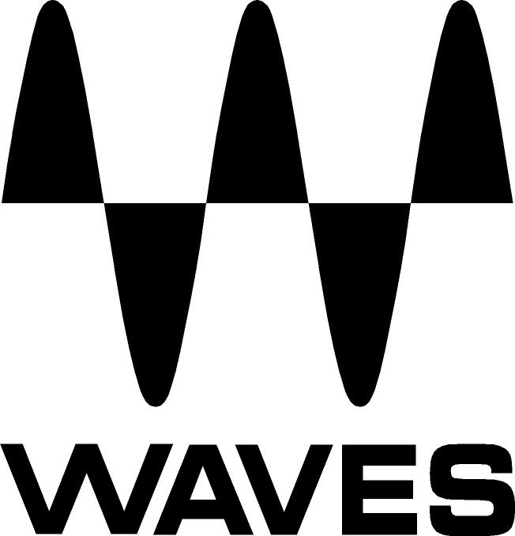

PRESS RELEASE
Contact: Clyne Media, Inc.
Tel: (615) 662-1616
Fax: (615) 662-1636

FOR IMMEDIATE RELEASE

Waves Audio Offers Manny Marroquin Signature Series Collection

INFOCOMM, ORLANDO, FL, June 12, 2013 — Waves Audio (booth 762) is displaying the Manny Marroquin Signature Series Collection, custom plugins developed in collaboration with renowned mixing engineer Manny Marroquin (Bruno Mars, Alicia Keys, Rihanna, Maroon 5, Shakira). Five-time GRAMMY® award-winner Marroquin takes the Waves Signature Series to a new level with six hybrid plugins that bring his unique workflow to users’ studios. Alongside his personalized versions of tried-and-true favorites like EQ, reverb, delay and distortion, Manny introduces the innovative new Tone Shaper and Triple D plugins, which are destined to become mixing essentials as well. Combining inspiration from his impressive collection of unique and boutique hardware, together with the fruits of his imagination, the Manny Marroquin Signature Series gives users direct access to the same tools Manny uses to mix hit after hit after hit.

“For my Signature Series, our goal was to create a set of high-quality professional plugins that were innovative, effective and easy to use,” said Manny Marroquin.

About the Waves Signature Series
The only tools of their kind, the Waves Signature Series is an exclusive line of customized plugins, created in collaboration with the world’s top producers and mixing engineers. Each and every Signature Series plugin has been precision-crafted to capture the artist’s distinct sound and production style, using custom multi-effect processing chains designed by the artists themselves. For experienced and aspiring audio professionals alike, the Waves Signature Series streamlines the mixing process, delivering high-quality results, instantly. The Waves Signature Series currently includes plugin collections developed with Eddie Kramer and GRAMMY® award-winners Chris Lord-Alge, Jack Joseph Puig, and Tony Maserati.

The Waves Manny Marroquin Signature Series Collection is now available with U.S. MSRP: $500. Introductory price: $299. Visit: http://www.waves.com/content.aspx?id=12132 for more information.
...ends 279 words

Photo Files: marroquin-delay.jpg, marroquin-distortion.jpg, marroquin-eq.jpg, marroquin-reverb.jpg, marroquin-tone-shaper.jpg, marroquin-triple-d.jpg

About Waves Ltd.:
From its start in the early '90s with the introduction of the Q10 equalizer plugin, Waves, the world’s leading developer of audio DSP solutions for professional, broadcast, and consumer electronics audio markets, has gone on to develop a comprehensive line of over 130 audio plugins including industry standards like the L1 and L2 Ultramaximizers, popular vintage console models, and innovative mixing tools like Vocal Rider and the Artist Signature Series. For its accomplishments, in 2011 Waves received a Technical GRAMMY® award, and the Q10 was selected as an inductee into the TECnology Hall of Fame. Waves technologies are now used to improve sound quality in virtually every sector of the audio market, from recording, mixing, mastering and post-production to broadcast, live sound, and consumer electronics. Waves has over 20 years of expertise in the development of psycho-acoustic signal processing algorithms that leverage knowledge on the human perception of hearing to radically improve perceived sound quality. Waves’ award-winning processors are utilized to improve sound quality in the creation of hit records, major motion pictures, and top-selling video games worldwide. Waves offers computer software solutions, as well as hardware-plus-software solutions, for the professional and broadcast markets. Under its Maxx brand, Waves offers semiconductor and licensable algorithms for consumer electronics applications. Waves Maxx technologies dramatically enhance audio performance and are used by industry leaders such as Dell, ASUS, Sony, JVC and many others.

All other product names and trademarks are the property of their respective owners, which are in no way associated or affiliated with Waves.

Waves Contacts:
North America Offices:
Waves, Inc., 2800 Merchants Drive, Knoxville, TN 37912;
Tel: 865-909-9200, Fax: 865-909-9245, Email: info@waves.com, Web: http://www.waves.com

Corporate Headquarters Israel:
Waves Ltd., Azrieli Center, The Triangle Tower, 32nd Floor
Tel Aviv 67023, Israel; Tel: 972-3-608-4000, Fax: 972-3-608-4056, Email: info@waves.com,
Web: http://www.waves.com

Waves Public Relations:
Clyne Media, Inc., 169-B Belle Forest Circle, Nashville, TN 37221;
Tel: 615-662-1616, Fax: 615-662-1636, Email: robert@clynemedia.com,
Web: http://www.clynemedia.com

Waves Audio is exhibiting at booth 762 at the 2013 InfoComm Show in Orlando, Florida.

