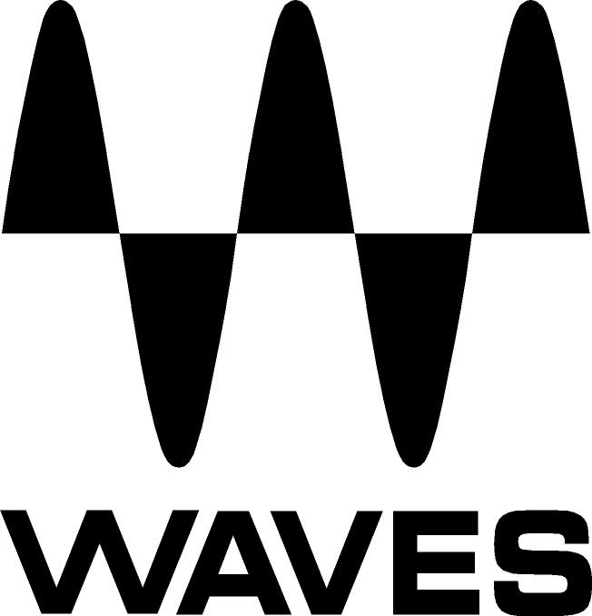

PRESS RELEASE
Contact: Clyne Media, Inc.
Tel: (615) 662-1616
Fax: (615) 662-1636

FOR IMMEDIATE RELEASE

Waves Audio Releases GEQ Graphic Equalizer Plugin

INFOCOMM, ORLANDO, FL, June 12, 2013 — Waves Audio (booth 762) has just released its GEQ graphic equalizer plugin. Developed primarily for live users (but sure to find a home in the studio as well), Waves GEQ is a full-featured graphic equalizer plugin with both Classic and Modern mono and stereo components, featuring 30 ISO bands plus high and low pass filters, a high precision floating parametric EQ bell filter, and a real-time analyzer.

GEQ Classic components use traditional proportional Q filters inspired by the renowned DN series 1/3 octave equalizers, which narrow the filter width as you increase a band’s gain; GEQ Modern components utilize special Flat-Top filters, which eliminate the artifacts associated with band interaction, and provide perfect plateau and stair-stepped responses. Users can set band gains one-by-one, or draw their curve via touch-screen or mouse. Finally, GEQ’s integrated real-time analyzer lets users compare the difference between two sources.

Features:
- 30 ISO bands with selectable 6, 12 & 18 dB scales
- Independent HPF, LPF and parametric bells per side
- Classic component with Proportional Q filters
- Modern component with non-interactive Flat-Top filters
- Real-time analyzer
- Zero latency
The GEQ Graphic Equalizer Plugin is now available with a U.S. MSRP of $200.00, with a special introductory price of $99.00. Visit www.waves.com and www.waveslive.com for more information.
...ends 524 words

Photo Files: GEQ_GraphicEqualizer_Classic.JPG, GEQ_GraphicEqualizer_Modern.JPG

About Waves Ltd.:
From its start in the early '90s with the introduction of the Q10 equalizer plugin, Waves, the world’s leading developer of audio DSP solutions for professional, broadcast, and consumer electronics audio markets, has gone on to develop a comprehensive line of over 130 audio plugins including industry standards like the L1 and L2 Ultramaximizers, popular vintage console models, and innovative mixing tools like Vocal Rider and the Artist Signature Series. For its accomplishments, in 2011 Waves received a Technical GRAMMY® award, and the Q10 was selected as an inductee into the TECnology Hall of Fame. Waves technologies are now used to improve sound quality in virtually every sector of the audio market, from recording, mixing, mastering and post-production to broadcast, live sound, and consumer electronics. Waves has over 20 years of expertise in the development of psycho-acoustic signal processing algorithms that leverage knowledge on the human perception of hearing to radically improve perceived sound quality. Waves’ award-winning processors are utilized to improve sound quality in the creation of hit records, major motion pictures, and top-selling video games worldwide. Waves offers computer software solutions, as well as hardware-plus-software solutions, for the professional and broadcast markets. Under its Maxx brand, Waves offers semiconductor and licensable algorithms for consumer electronics applications. Waves Maxx technologies dramatically enhance audio performance and are used by industry leaders such as Dell, ASUS, Sony, JVC and many others.

All other product names and trademarks are the property of their respective owners, which are in no way associated or affiliated with Waves.

Waves Contacts:
North America Offices:
Waves, Inc., 2800 Merchants Drive, Knoxville, TN 37912;
Tel: 865-909-9200, Fax: 865-909-9245, Email: info@waves.com, Web: http://www.waves.com

Corporate Headquarters Israel:
Waves Ltd., Azrieli Center, The Triangle Tower, 32nd Floor
Tel Aviv 67023, Israel; Tel: 972-3-608-4000, Fax: 972-3-608-4056, Email: info@waves.com,
Web: http://www.waves.com

Waves Public Relations:
Clyne Media, Inc., 169-B Belle Forest Circle, Nashville, TN 37221;
Tel: 615-662-1616, Fax: 615-662-1636, Email: robert@clynemedia.com,
Web: http://www.clynemedia.com

Waves Audio is exhibiting at booth 762 at the 2013 InfoComm Show in Orlando, Florida.

