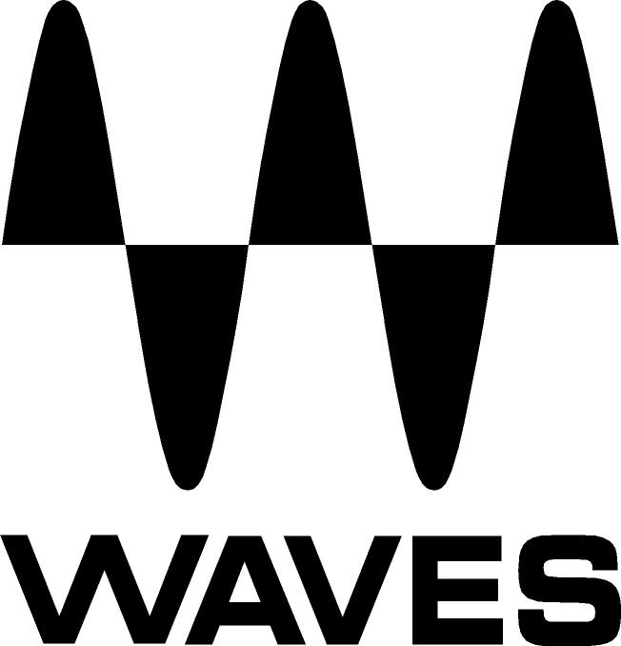

PRESS RELEASE
Contact: Clyne Media, Inc.
Tel: (615) 662-1616
Fax: (615) 662-1636

FOR IMMEDIATE RELEASE

Waves Audio Works Closely with AVnu Alliance

INFOCOMM, ORLANDO, FL, June 12, 2013 — Waves Audio (booth 762), the industry-leading developer of professional audio digital signal processing technologies, is currently working closely with AVnu Alliance, an industry forum dedicated to the advancement and certification of Audio/Video Bridging (AVB) devices. As part of its collaborative efforts, Waves is actively encouraging industry adoption of AVnu’s standards campaigns. Other industry leaders working with AVnu include Avid™, Cisco™, Dolby®, Gibson®, GM™, Harman, Intel®, Meyer Sound®, Sennheiser, Texas Instruments, Yamaha and many more.

AVnu promotes the adoption of the IEEE 802.1 Audio/Video Bridging (AVB), and the related IEEE 1722 and IEEE 1733, standards over various networking link-layers. The organization works to create compliance test procedures and processes that ensure AVB interoperability of networked A/V devices, helping to provide the highest quality streaming A/V experience. The Alliance will promote awareness of the benefits of AVB technologies and is collaborating with other organizations and entities to make use of this work in their respective efforts to provide a better end-user A/V experience. The Alliance is focused on applications of these technologies in the Automotive, Professional and Consumer Electronics markets.

Among its promotional efforts in collaboration with AVnu, Waves is increasing its presence at industry trade shows; participating in AVnu’s flagship “Plug Fest” events; encouraging AVB adoption by crossing platform boundaries (when Waves SoundGrid technology runs AVB, it is immediately available to all SoundGrid users); and more.

“AVnu Alliance is pleased that Waves is a member,” said Lee Minich, marketing chair for the AVnu Alliance. “Waves hardware and software signal processing solutions span the studio, live sound and broadcast markets, all of which will benefit from the adoption of standards-based, truly interoperable networked audio solutions.”

“We at Waves strongly support AVnu’s goals to provide the practical means to identify equipment conformity and test interoperability, and to educate our customers as to the values and benefits of AVB-based networked systems,” stated Gilad Keren, Waves CEO and Co-Founder. “Waves is dedicated to non-proprietary and standardized interoperability between systems, allowing our customers the freedom to use their plugin products anywhere and everywhere.”

Visit www.waves.com and www.waveslive.com for more information.
...ends 344 words

About Waves Ltd.:
From its start in the early '90s with the introduction of the Q10 equalizer plugin, Waves, the world’s leading developer of audio DSP solutions for professional, broadcast, and consumer electronics audio markets, has gone on to develop a comprehensive line of over 130 audio plugins including industry standards like the L1 and L2 Ultramaximizers, popular vintage console models, and innovative mixing tools like Vocal Rider and the Artist Signature Series. For its accomplishments, in 2011 Waves received a Technical GRAMMY® award, and the Q10 was selected as an inductee into the TECnology Hall of Fame. Waves technologies are now used to improve sound quality in virtually every sector of the audio market, from recording, mixing, mastering and post-production to broadcast, live sound, and consumer electronics. Waves has over 20 years of expertise in the development of psycho-acoustic signal processing algorithms that leverage knowledge on the human perception of hearing to radically improve perceived sound quality. Waves’ award-winning processors are utilized to improve sound quality in the creation of hit records, major motion pictures, and top-selling video games worldwide. Waves offers computer software solutions, as well as hardware-plus-software solutions, for the professional and broadcast markets. Under its Maxx brand, Waves offers semiconductor and licensable algorithms for consumer electronics applications. Waves Maxx technologies dramatically enhance audio performance and are used by industry leaders such as Dell, ASUS, Sony, JVC and many others.

All other product names and trademarks are the property of their respective owners, which are in no way associated or affiliated with Waves.

Waves Contacts:
North America Offices:
Waves, Inc., 2800 Merchants Drive, Knoxville, TN 37912;
Tel: 865-909-9200, Fax: 865-909-9245, Email: info@waves.com, Web: http://www.waves.com

Corporate Headquarters Israel:
Waves Ltd., Azrieli Center, The Triangle Tower, 32nd Floor
Tel Aviv 67023, Israel; Tel: 972-3-608-4000, Fax: 972-3-608-4056, Email: info@waves.com,
Web: http://www.waves.com

Waves Public Relations:
Clyne Media, Inc., 169-B Belle Forest Circle, Nashville, TN 37221;
Tel: 615-662-1616, Fax: 615-662-1636, Email: robert@clynemedia.com,
Web: http://www.clynemedia.com

Waves Audio is exhibiting at booth 762 at the 2013 InfoComm Show in Orlando, Florida.

