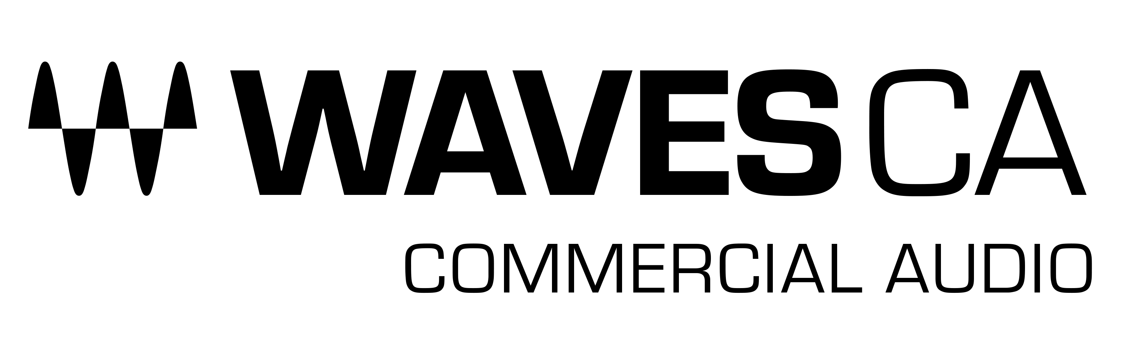

PRESS RELEASE
Contact: Clyne Media, Inc.
Tel: (615) 662-1616

FOR IMMEDIATE RELEASE

Waves Audio Adopts NDI® for Cloud-Based Media Productions with the Waves Cloud MX Audio Mixer

InfoComm, Las Vegas, NV, June 8, 2022 — Waves Audio (booth W1912), the world’s leading developer of professional audio signal processing technologies and plugins, announces support for NDI® (the globally standardized video-over-IP technology) with the Waves Cloud MX Audio Mixer, a cloud-based audio mixer with superior sound quality for broadcast professionals.

The move to cloud-based broadcasting has accelerated rapidly over the past two years. Leading-edge broadcasting and media companies have been able to migrate many production tools to cloud environments. Though the deployment of video production technology moved quickly to software-driven workflows, until now, the true pro audio component has been lacking. Subsequently, as broadcast production workflows evolve from entire on-premises control rooms to remote integration (REMI), hybrid or completely cloud-based environments, there is a crucial and urgent need for efficient cloud-based audio mixing. Processing, mixing and routing the production audio directly in the cloud complete this new-generation workflow from source ingest to program distribution.

One key technology that has helped facilitate this transition is NDI (Network Device Interface), a high-performance network protocol for transporting media streams over Ethernet. NDI, part of the Vizrt Group, is a royalty-free technology that allows video and audio sources to be shared bi-directionally across a network, eliminating the need for costly direct connections, expensive cable runs, and infrastructure upgrades while turning every source into a destination instantly available anywhere on the network.

Broadcast and media production teams can now add Waves’ Cloud MX Audio Mixer directly in the cloud workflow with easy routing of audio inputs and outputs via NDI.

“We adopted NDI technology, as it is a proven system for professional cloud production environments,” says Mick Olesh, Waves Managing Director and EVP of Sales. “The ability to process, mix and route all audio streams in the cloud, and without converting protocols, simplifies the workflow so that production teams can now focus on delivering a superior sounding program feed to the audience.”

Using the Cloud MX Audio Mixer ensures an enhanced, professional final production mix. Broadcasters and media organizations can now add state-of-the-art audio mixing and processing to their flexible professional cloud-based workflows, thanks to Cloud MX Audio Mixer’s crystal-clear double-precision 32-bit-float mixing engine, augmented by Waves’ industry-leading arsenal of cloud-licensed audio plugins.

Waves’ Cloud MX Audio Mixer is NDI-compatible, fitting easily into NDI-based environments, with easy patching and routing of NDI audio streams.

“The cloud is revolutionizing live production and creative workflows; broadcasters and creators need professional audio tools to manage audio streams seamlessly over the cloud. With Waves Audio adopting NDI, the Cloud MX Audio Mixer now offers mixing, processing, and routing without the need for converting or transcoding, thanks to NDI and its wide adoption.” says Suso Carrillo, NDI Marketing Lead at Vizrt Group.

Waves Cloud MX Audio Mixer is easily deployed on AWS, making integration with new or existing cloud production systems a breeze. Cloud MX Audio Mixer also makes it easy to scale productions with any number of audio mixers, without the operational costs involved in shipping, maintaining or scheduling on-premises gear and personnel.

All Waves Cloud MX Audio Mixer packages come with the powerful cloud-licensed Waves eMo plugins (eMo D5 Dynamics, eMo F2 Filter, and eMo Q4 Equalizer), which form the mixer’s channel strip for a fast, efficient workflow. You can expand your audio capabilities even further, by upgrading to Cloud MX Audio Mixer Plus, with 11 extra cloud-licensed plugins such as the Primary Source Expander for automatic mic bleed elimination, the legendary Renaissance Vox vocal compressor, the surgical F6 Floating-Band Dynamic EQ, MaxxBass, the L2 UltraMaximizer and more; or to Cloud MX Audio Mixer Premium, which adds over 150 cloud-licensed plugins covering every audio need, including the Dugan Speech plugin for real-time automatic mixing of multiple mics. Each of these packages are available as 1-month or 1-year licenses. The Plus and Premium tiers present an arsenal of cloud-licensed audio plugins, covering every broadcast audio need from multi-mic auto-mixing to noise reduction, audio restoration, and beyond.”

The support for NDI technology with Waves’ Cloud MX Audio Mixer enables broadcast and media production teams to bring a new level of audio fidelity, flexibility, and control to your program content—with easy deployment and superior uncompromising sound quality.

To learn more, click here.

…ends 693 words

About Waves Audio Ltd.:
Waves is the world’s leading developer of audio DSP solutions for music production, recording, mixing, mastering, sound design, post-production, live sound, broadcast, commercial and consumer electronics audio markets. Since its start in the early '90s, Waves has developed a comprehensive line of over 250 audio plugins and numerous hardware devices. For its accomplishments, Waves received a Technical GRAMMY® Award in 2011, and its early flagship plugin, the Q10 equalizer, was selected as an inductee into the TECnology Hall of Fame.

Increasingly leveraging pioneering techniques in artificial intelligence, neural networks and machine learning, as well as the company’s three decades of accumulated expertise in psychoacoustics, Waves technologies are being used to improve sound quality in a growing number of market sectors. Around the world, Waves’ award-winning plugins are utilized in the creation of hit records, major motion pictures, and top-selling video games. Additionally, Waves now offers hardware-plus-software solutions (including the revolutionary Cloud MX Audio Mixer) for professional audio markets. The company’s WavesLive division is a leader in the live sound sector, spearheading the development of solutions for all live platforms. Products from Waves Commercial Audio enable A/V system integrators and installers to deliver superior sound quality for corporate, commercial, government, educational, entertainment, sports and house-of-worship applications. Under its Maxx brand, Waves offers semiconductor and licensable algorithms for consumer electronics applications, used in laptops, smartphones, smart speakers, gaming headsets, TVs and more from industry leaders such as Dell, Google, Fitbit, Acer, Asus, Hisense and others.

North America Offices:
Waves, Inc., 2800 Merchants Drive, Knoxville, TN 37912;
Tel: 865-909-9200, Fax: 865-909-9245, Email: info@waves.com,
Web: http://www.waves.com

Corporate Headquarters Israel:
Waves Ltd., Azrieli Center, The Triangle Tower, 32nd Floor, Tel Aviv 67023, Israel;
Tel: 972-3-608-4000, Fax: 972-3-608-4056, Email: info@waves.com,
Web: http://www.waves.com

Waves Public Relations:
Clyne Media, Inc., 169-B Belle Forest Circle, Nashville, TN 37221;
Tel: 615-662-1616, Email: robert@clynemedia.com,
Web: http://www.clynemedia.com

Waves Audio is exhibiting at booth W1912 at the 2022 InfoComm Show in Las Vegas, NV.

