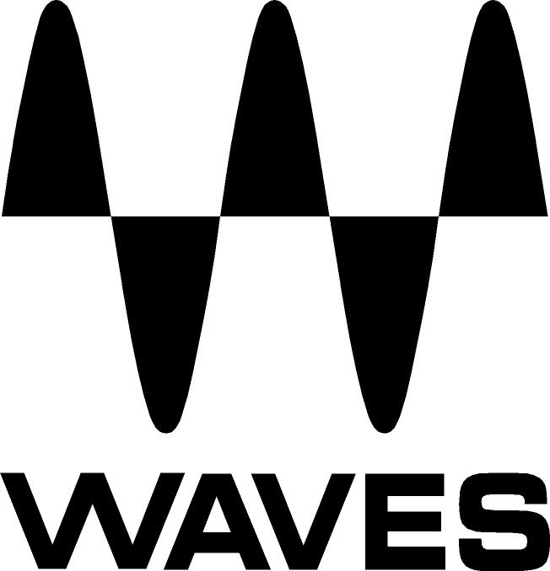

PRESS RELEASE
Contact: Clyne Media, Inc.
Tel: (615) 662-1616
Fax: (615) 662-1636

FOR IMMEDIATE RELEASE

Waves Audio Now Shipping the H-Reverb Plugin

TEL AVIV, ISRAEL, May 11, 2015 — Waves Audio is now shipping the Waves H-Reverb plugin, a pioneering reverb based on innovative algorithmic FIR (Finite Impulse Response) reverberation technology, providing richer, deeper reverb tails that sit beautifully in the mix while breathing crisp air into your tracks.

The FIR engine that powers H-Reverb lets you shape and customize the reverb decay envelope beyond the standard linear forms, resulting in perfectly gated, real reverse, and dense reverb tails that don’t muddy up the mix. Taking things one step further, H-Reverb incorporates Waves’ advanced analog modeling along with a drive control, offering signal behavior that until now was found exclusively in high-end hardware reverb devices. This unique design also enables input drive, a technique favored by many top engineers.

To top it off, H-Reverb includes an impressive library of artist presets from the industry’s leading mixing engineers (including Toni Maserati, Brad Divens, Daniel Green, Dave Darlington, Dave Stagl, James Ebdon, Ken “Pooch” Van Druten, Kevin Madigan, Pete Keppler, Ross Hogarth and Yoad Nevo, to name just a few). Their personal settings may be the perfect space you’re looking for, or simply the perfect point to start from.

By fusing classic reverb concepts with forward-thinking features that break new ground in digital reverb processing, H-Reverb provides uncompromising sound quality and boundless creative control.

Additional features include:
- Impulse-variable resonant filtering for creating unfamiliar and advanced reverb effects
- EQ and dynamics module for compression, ducking and de-essing
- ADA analog modeling and drive control for input clipping
- Full buildup timing and shaping
- Pre-delay BPM sync
- Artist presets from the industry’s leading mixing engineers
- Support for full 5.1-channel surround setups

Mick Olesh, Waves EVP of Sales & Marketing, states, “Waves is extremely excited about releasing the H-Reverb. We went to great lengths to make this the most comprehensive and best-sounding reverb plugin possible, incorporating invaluable input from industry-leading mixing engineers.”
Top industry professionals have been praising H-Reverb. Here is what a few of them have been saying:

Ken “Pooch” Van Druten (Linkin Park, Kid Rock, Kiss): “H-Reverb is the ultimate customizable reverb! It’s my new go-to. It just sounds amazing. What makes high-end hardware units sound so great is the reverb tail. The very end of the reverb in most plugins has bad breakup. H-Reverb has a very smooth reverb tail, as smooth as the best hardware units out there. I think most people would be hard-pressed to tell the difference.”

Jim Ebdon (Aerosmith, Maroon 5, Annie Lennox): “From subtle to in-ya-face, H-Reverb has it all. Very easy to navigate and edit, with fantastic quality. This is an essential plugin for me now.”

Dave Darlington (Bob Sinclar, Digable Planets, Sting, Oz): “Waves’ new H-Reverb is a masterful combination of rich vibrant tone and beautiful spacious texture. I predict it will become the gold standard of reverbs for mixers worldwide.”

Donal Hodgson (The Police, Sting, Jeff Beck): “It’s very simple – H-Reverb is now my default reverb plugin. It’s one of the best-sounding plugins I’ve heard in a long time. H-Reverb is the new yardstick in high-quality reverberation.”

Dave Stagl (North Point Community Church): “It’s been a long time since I’ve stopped using high-end hardware reverbs and made the decision to go all ‘in-the-box,’ so the best reverbs I’ve been using have been convolution reverbs using impulses of legendary outboard gear and spaces. I’ve been comparing those impulses to H-Reverb, and I don’t think I’ll be using much convolution reverb going forward. H-Reverb easily stands up against the best stuff I’ve got, and offers much more flexibility for adjustment than most convolution reverbs.”

Gil Norton (Foo Fighters, Pixies, Echo & the Bunnymen): “H-Reverb is different from the usual reverbs I use. The inclusion of distortion and bit-rate reduction, plus the advanced levels of tailoring for decay and delay, allow me to create unique reverbs that I could not achieve with anything else. H-Reverb also enables me to emulate some of my favorite patches from early digital reverbs.

Stephen Bailey (Matt Redman, Charlie Hall, Kristian Stanfill, Passion Conferences): “H-Reverb is the most technologically advanced and arguably the best-sounding reverb plugin ever made. The attention to detail is spectacular. If we put H-Reverb up to a listening test with the best hardware units available, I honestly think I wouldn't be able to tell the difference between the plugin and the hardware.”

Zito (One Republic, Backstreet Boys, Kenny “Babyface” Edmonds): “H-Reverb from Waves is going to become my new favorite verb. I was blown away at the controls and features this verb has to offer. I kept finding myself saying, ‘Wow, I can do that too?!’ High-end hardware reverb units just took a death blow the day H-Reverb was released. Goodbye!”

Brad Divens (HIM, Garbage, Linkin Park, Jane’s Addiction): “The Waves H-Reverb plugin is now my go-to reverb. It is very simple to use and the results are sonically superb. It sounds as if I'm using a top-dollar hardware piece. H-Reverb is different from other reverb plugins. There are more parameters to control, which gives you the ability to really create something unique. Also, the design of the GUI makes it easy to use. I think it sounds great. Finally, this is a reverb plugin that sounds like the high-end hardware units.”

Miles Walker (Beyoncé, Usher, Sia, Icona Pop): “The most impressive thing about H-Reverb compared to other reverb plugins is the variation on space within each setting. As a sound is preformed into it, you can hear how the different parameters provide variance in the sound of the room, just like a real performance changing slightly with its own dynamics and energy. It follows the sound’s natural arch, breathing with it and working in tandem for an amazing spatial experience. I have several Lexicon hardware units that I always go to for mixes — a few particular patches that I'm always drawn to because they aren’t just following an impulse response but are creating variety and randomness as a sound goes into them. That's something I always thought was very challenging for plugin reverbs because of the huge amount of computing required. Somehow Waves has managed to do just that, and now I can get from H-Reverb the same great feeling of a hardware unit, with all the ease of plugin controls and automation — so cool!”

Ross Hogarth (Van Halen, Ziggy Marley, Keb' Mo', R.E.M.): “After digging into H-Reverb, I realized the depth and versatility of the plugin. I think H-Reverb can do just about anything, from weird lo-fi effects, to smooth small rooms, to long open spaces. With the right programing, H-Reverb can sound like just about any hardware box.”

Pete Keppler (Nine Inch Nails, Katy Perry, David Byrne & St. Vincent): “H-Reverb is quite simply the best software reverb I’ve laid ears on, and as good as or better than most hardware units I've ever used. No one has made anything else like it. Open it up and you have a great reverb without touching a single control. If you want to tailor it a little, the main controls — Pre-Delay, Build-Up and Size — combined with the various ER choices (one of the highlights for me) and the Reverb Time will give you practically anything you need. And you also get a Reverse button! H-Reverb sounds amazing and is super-easy to use straight ‘out of the box.’ Dig in a little and you'll start getting sounds you didn't know were possible from a software-based reverb. Well done, Waves!”

H-Reverb video links:
Waves H-Reverb Promo Video: https://www.youtube.com/watch?v=titnuqQ1W0c
Waves H-Reverb Plugin Tutorial: https://www.youtube.com/watch?v=sfSYseNmVU0
Exploring the H-Reverb Plugin with Yoad Nevo: https://www.youtube.com/watch?v=Hp1AuSMIZOg

To learn more: http://www.waves.com/plugins/h-reverb-hybrid-reverb
...ends 1245 words

Photo File: HReverb.JPG
Photo Caption: The interface for Waves’ new H-Reverb plugin.

About Waves Audio Ltd.:
Waves is the world’s leading developer of audio DSP solutions for the professional, broadcast, and consumer electronics audio markets. Since its start in the early '90s with the introduction of the Q10 equalizer plugin, Waves has gone on to develop a comprehensive line of over 200 audio plugins, including industry standards like the L1 and L2 Ultramaximizers, popular vintage console models, and innovative mixing tools like Vocal Rider and the Artist Signature Series. For its accomplishments, Waves received a Technical GRAMMY® Award in 2011, and the Q10 was selected as an inductee into the TECnology Hall of Fame. Waves technologies are now used to improve sound quality in virtually every sector of the audio market, from recording, mixing, mastering and post-production to broadcast, live sound, and consumer electronics. Waves has over 20 years of expertise in the development of psychoacoustic signal processing algorithms that leverage knowledge of human auditory perception to radically improve perceived sound quality. Waves’ award-winning processors are utilized to improve sound quality in the creation of hit records, major motion pictures, and top-selling video games worldwide. Waves offers computer software and hardware-plus-software solutions for the professional and broadcast markets. The company’s WavesLive division is a market leader in all live sound sectors, spearheading the development of solutions for all live platforms. Under its Maxx brand, Waves offers semiconductor and licensable algorithms for consumer electronics applications. Waves Maxx technologies dramatically enhance audio performance and are used by industry leaders such as Dell, Lenovo, ASUS, LG, Oppo, JVC, Denon and many others.

All other product names and trademarks are the property of their respective owners, which are in no way associated or affiliated with Waves.

North America Offices:
Waves, Inc., 2800 Merchants Drive, Knoxville, TN 37912;
Tel: 865-909-9200, Fax: 865-909-9245, Email: info@waves.com, Web: http://www.waves.com

Corporate Headquarters Israel:
Waves Ltd., Azrieli Center, The Triangle Tower, 32nd Floor
Tel Aviv 67023, Israel; Tel: 972-3-608-4000, Fax: 972-3-608-4056, Email: info@waves.com,
Web: http://www.waves.com

Waves Public Relations:
Clyne Media, Inc., 169-B Belle Forest Circle, Nashville, TN 37221;
Tel: 615-662-1616, Fax: 615-662-1636, Email: robert@clynemedia.com,
Web: http://www.clynemedia.com

