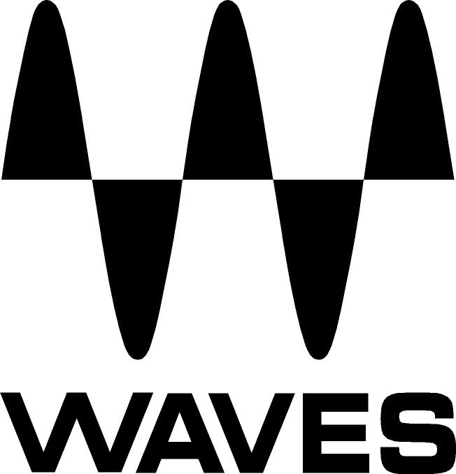

PRESS RELEASE
Contact: Clyne Media, Inc.
Tel: (615) 662-1616
Fax: (615) 662-1636

FOR IMMEDIATE RELEASE

Waves Flex Introduces Extended Rent-to-own Plugin Plan

KNOXVILLE, TN, May 29, 2019 — Waves Audio, the world’s leading developer of professional audio signal processing technologies and leading maker of audio plugins for mixing, music production, mastering, sound design, broadcast, post-production and live sound, has added new plans to its popular Flex rent-to-own plugin plan. With 120 plugins to choose from, and plans starting at $9.99, Waves Flex is the largest and most affordable rent-to-own plugin plan currently on the market.

With Flex, you can choose from a vast catalog of Waves’ award-winning plugins, including the world’s largest selection of EQs, compressors, effects, mastering tools and more. Waves Flex enables maximum flexibility as you can pick the plugins you want, with easy and affordable monthly payments. There is no commitment – plan subscribers can cancel at any time – and unlike other known plugin subscription plans, Waves Flex allows subscribers to fully own their plugins at the end of a 24-month rent-to-own period.

Waves is offering three Flex plans:
- Flex Starter at $9.99 a month: Choose 5 plugins + 1 FREE plugin from a selection of 40 plugins.
- Flex at $19.99 a month: Choose 10 plugins + 3 FREE plugins from a selection of 85 plugins.
- Flex Pro at $29.99 a month: Choose 20 plugins + 4 FREE plugins from a selection of 120 plugins

Waves Flex is currently the largest and most versatile rent-to-own pro-audio plugin plan available. With Flex, musicians, engineers and producers can now experience a flexible, affordable, simple and easy entry point into the industry’s largest selection of renowned professional tools and choose precisely the plugins they need, without having to pay extra funds for tools they may not be interested in acquiring. Whether you’re starting out or are an experienced producer, Waves Flex is an affordable option with a fitting plan for you.

To learn more, visit https://www.waves.com/bundles/flex.

… ends 297 words

Photo file: Flex-logo.JPG
Photo caption: Waves Audio has added new plans to its popular Flex rent-to-own plugin plan.

About Waves Audio Ltd.:
Waves is the world’s leading developer of audio DSP solutions for the professional, broadcast, and consumer electronics audio markets. Since its start in the early '90s with the introduction of the Q10 equalizer plugin, Waves has gone on to develop a comprehensive line of over 150 audio plugins, including industry standards like the L1 and L2 Ultramaximizers, popular vintage console models, and innovative mixing tools like Vocal Rider and the Artist Signature Series. For its accomplishments, Waves received a Technical GRAMMY® Award in 2011, and the Q10 was selected as an inductee into the TECnology Hall of Fame. In 2016, Waves released the eMotion LV1 mixer, a revolutionary live digital mixing console that provides real-time audio mixing for front-of-house, monitor, studio and broadcast engineers. Waves technologies are now used to improve sound quality in virtually every sector of the audio market, from recording, mixing, mastering and post-production to broadcast, live sound, and consumer electronics. Waves has over 25 years of expertise in the development of psychoacoustic signal processing algorithms that leverage knowledge of human auditory perception to radically improve perceived sound quality. Waves’ award-winning processors are utilized to improve sound quality in the creation of hit records, major motion pictures, and top-selling video games worldwide. Waves offers computer software and hardware-plus-software solutions for the professional and broadcast markets. The company’s WavesLive division is a market leader in all live sound sectors, spearheading the development of solutions for all live platforms. Under its Maxx brand, Waves offers semiconductor and licensable algorithms for consumer electronics applications. Waves technologies dramatically enhance audio performance and are used by industry leaders such as Dell, Google, Fitbit, Acer, Asus, Hisense and more.

All other product names and trademarks are the property of their respective owners, which are in no way associated or affiliated with Waves.

North America Offices:
Waves, Inc., 2800 Merchants Drive, Knoxville, TN 37912;
Tel: 865-909-9200, Fax: 865-909-9245, Email: info@waves.com,
Web: http://www.waves.com

Corporate Headquarters Israel:
Waves Ltd., Azrieli Center, The Triangle Tower, 32nd Floor, Tel Aviv 67023, Israel;
Tel: 972-3-608-4000, Fax: 972-3-608-4056, Email: info@waves.com,
Web: http://www.waves.com

Waves Public Relations:
Clyne Media, Inc., 169-B Belle Forest Circle, Nashville, TN 37221;
Tel: 615-662-1616, Fax: 615-662-1636, Email: robert@clynemedia.com,
Web: http://www.clynemedia.com

