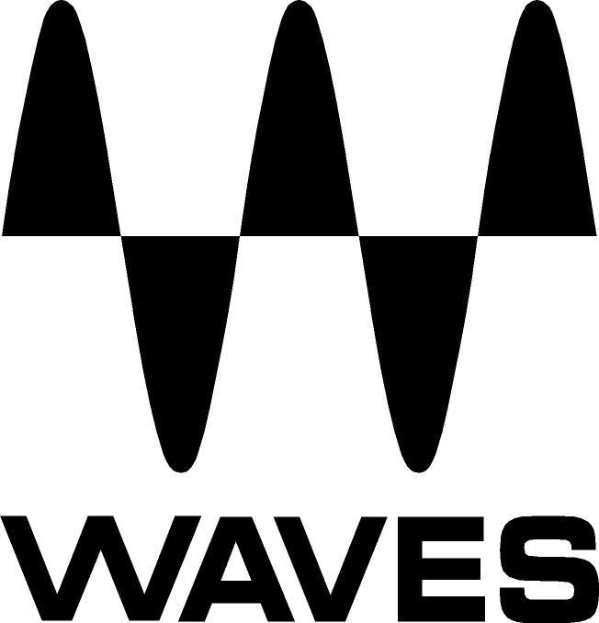

PRESS RELEASE
Contact: Clyne Media, Inc.
Tel: (615) 662-1616
Fax: (615) 662-1636

FOR IMMEDIATE RELEASE

Technical Director David Levin Chooses Waves eMotion LV1 Live Mixer for Brooklyn Music Venue Elsewhere

KNOXVILLE, TN, May 29, 2018 — David Levin, Technical Director for the Bushwick (Brooklyn, NYC) venue Elsewhere, a live music venue, nightclub and arts space, housed in a 24,000+-square-foot converted warehouse, chooses Waves eMotion LV1 Live Mixer for Zone One at Elsewhere. Levin has worked as front-of-house engineer for such acts as Blood Orange, Nelly Furtado, Tove Lo, Sofi Tukker and Icona Pop.

Levin comments, “The main goals in choosing a desk for Zone One were sound quality, ease of use and enough flexibility that the engineers won’t get bored! When I was first introduced to the LV1, it took about three minutes to learn the basic functionality of the desk, and under 30 minutes to feel like I had a deep grasp of all the more in-depth functions. The layout at first is very familiar and user-friendly, and coming from other major consoles, extremely intuitive.”

“Since Zone One is a rather small 250-capacity room,” Levin says, “and considering its price point, the Waves LV1 was easily the best solution. It has accomplished our goals very nicely and has given our in-house engineers the ability to hone their skills to a much greater degree than any other console in its class. I needed a console that young engineers could operate, but also grow and learn with. By having the ability to use powerful modern tools like the Waves F6 Floating-Band Dynamic EQ, C6 Multiband Compressor, and the Scheps Parallel Particles, along with Waves’ vintage vibe plugs like Abbey Road Reverb Plates, Scheps 73, and the CLA Classic Compressors bundle, our engineers can choose from a huge sound palette that no other small frame console can provide.”

He adds, “At Zone One, we are doing nine shows and 27+ artists per week! We get a lot of touring guest engineers coming through with their bands, so the console needs to be easy enough for them to become accustomed to – quickly. The LV1 has proven successful in this department, since the GUI is familiar enough that touring engineers can learn the basic workflow by the end of their first sound check on the system.”

About using Waves plugins, Levin comments, “The variety of acts from night to night is something that makes Elsewhere special. Genres range from Indie Rock to Techno, to Underground Hip-Hop. The Waves LV1 has all the tools we need to achieve consistently excellent sound. For the retro bands, it is great to have vintage vibe tools like the Waves Abbey Road Reverb Plates, API 2500 on drums and CLA-76 Compressor/Limiter for vocals, along with the F6 to control problem frequencies. For Live Electronic bands, we use the Waves L3-LL Multimaximizer and Smack Attack plugins to fit live drums into the drum loops or playback, and it is better than in any other live mixing situation I’ve been in. Zone One has many performing underground Techno DJ’s, and having tools like Waves’ Smack Attack, Scheps Parallel Particles, and F6, allows us to do real-time mastering for the performers and make DJ tracks of varying quality sound more consistently polished. With the LV1, doing sound for DJs isn’t just watching left and right meters anymore, because the LV1 has such an arsenal of tools available.”

Levin comments about the LV1’s workflow: “The experience of using LV1 has been outstanding. With most consoles in small venues, there are few options, and you can run out of fun things to experiment with. This console has provided our staff with many ways to be creative with their mixing. It has enabled us to hire some phenomenal engineers who can really go deep into a live mix in a way that you never could with other small-format consoles. Using deeper functions on the LV1 is pretty straight forward, such as parallel bussing, or setting up different monitor specific channels. Also, the Zone One at Elsewhere is a monitor-from-FOH situation, and the LV1 has enough channels that we can dedicate some channels specifically to monitors. This is particularly handy for things like vocals, where monitors call for a simple EQ with minimal processing time, while the channel to the main PA could have well over four inserts. Being able to route channels either from the top of the channel or from the patch window is really awesome. In addition, the ability to multitrack a show in-house has been really great. The engineers are able to practice their skills with virtual sound check and really dig deep into all of the mixing options that the LV1 offers.”

Levin summarizes, “The Waves eMotion LV1 sounds insanely good. The preamps are clean, and the summing is at the top of any class of console. This allows the engineer to choose the vibe he or she wants to achieve. On any given day, you can choose to challenge yourself by mixing with a completely different set of plugins to explore all the flavor variations. If it is a hard rock band, maybe you’ll go hard on Waves API and SSL plugins, and then the next day, with an indie band, the Scheps 73, and the following day, with an electronic pop group, use only the F6 and the eMo D5 Dynamics plugins.”

To learn more about Elsewhere: https://www.elsewherebrooklyn.com/

…ends 863 words

Photo file: DavidLevin.JPG
Photo caption: David Levin (photo credit: Luis Nieto Dickens / Elsewhere in-house photographer)

About Waves Audio Ltd.:
Waves is the world’s leading developer of audio DSP solutions for the professional, broadcast, and consumer electronics audio markets. Since its start in the early '90s with the introduction of the Q10 equalizer plugin, Waves has gone on to develop a comprehensive line of over 150 audio plugins, including industry standards like the L1 and L2 Ultramaximizers, popular vintage console models, and innovative mixing tools like Vocal Rider and the Artist Signature Series. For its accomplishments, Waves received a Technical GRAMMY® Award in 2011, and the Q10 was selected as an inductee into the TECnology Hall of Fame. In 2016, Waves released the eMotion LV1 mixer, a revolutionary live digital mixing console that provides real-time audio mixing for front-of-house, monitor, studio and broadcast engineers. Waves technologies are now used to improve sound quality in virtually every sector of the audio market, from recording, mixing, mastering and post-production to broadcast, live sound, and consumer electronics. Waves has over 25 years of expertise in the development of psychoacoustic signal processing algorithms that leverage knowledge of human auditory perception to radically improve perceived sound quality. Waves’ award-winning processors are utilized to improve sound quality in the creation of hit records, major motion pictures, and top-selling video games worldwide. Waves offers computer software and hardware-plus-software solutions for the professional and broadcast markets. The company’s WavesLive division is a market leader in all live sound sectors, spearheading the development of solutions for all live platforms. Under its Maxx brand, Waves offers semiconductor and licensable algorithms for consumer electronics applications. Waves technologies dramatically enhance audio performance and are used by industry leaders such as Dell, Google, Fitbit, Acer, Asus, Hisense and more.

All other product names and trademarks are the property of their respective owners, which are in no way associated or affiliated with Waves.

North America Offices:
Waves, Inc., 2800 Merchants Drive, Knoxville, TN 37912;
Tel: 865-909-9200, Fax: 865-909-9245, Email: info@waves.com,
Web: http://www.waves.com

Corporate Headquarters Israel:
Waves Ltd., Azrieli Center, The Triangle Tower, 32nd Floor, Tel Aviv 67023, Israel;
Tel: 972-3-608-4000, Fax: 972-3-608-4056, Email: info@waves.com,
Web: http://www.waves.com

Waves Public Relations:
Clyne Media, Inc., 169-B Belle Forest Circle, Nashville, TN 37221;
Tel: 615-662-1616, Fax: 615-662-1636, Email: robert@clynemedia.com,
Web: http://www.clynemedia.com

