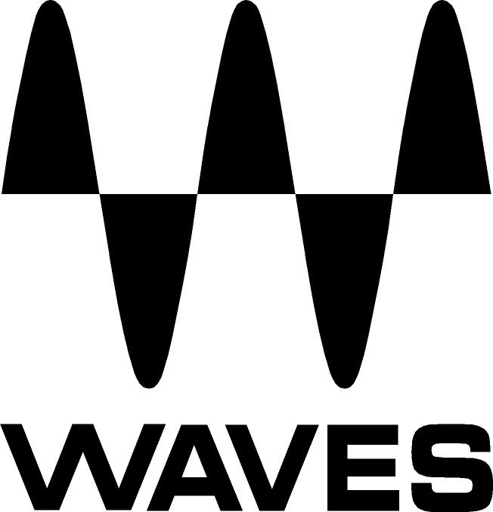

PRESS RELEASE
Contact: Clyne Media, Inc.
Tel: (615) 662-1616
Fax: (615) 662-1636

FOR IMMEDIATE RELEASE

Waves Audio Now Shipping the Element 2.0 Virtual Analog Synth

KNOXVILLE, TN, December 21, 2015 — Waves Audio, a leading provider of digital signal processing solutions, is now shipping the Element 2.0 Virtual Analog Synth, an analog-style polyphonic instrument designed to deliver the fat, warm sounds of classic analog synths, with all the precision, flexibility and control of a cutting-edge software instrument.

The first synthesizer to take advantage of the next generation of Waves’ Virtual Voltage technology, Element 2.0 includes a vast array of convenient features and functions, including five integrated effects, a 16-step sequencer, MIDI learn for all controls, and a massive, fully tweakable preset library.

All Element 2.0 parameters are laid out right there in front of you—so when inspiration strikes, there’s no need to scroll through page after page in order to customize your sounds. Searing leads, gritty basses, lush pads, electro-percussion, sequential motions, mind-blowing FX and lots more—Element 2.0 has it all. Perfect for the studio and for live performances.

Waves Element 2.0 features:
- High resolution oscillators and analog envelope behavior
- Filters with zero-delay feedback
- Effects include delay, reverb, distortion, chorus and two distinct crushers
- Keep the legacy: choose between Element 1 and Element 2 modes at the click of a button
- 16-step sequencer with Hold and Retrigger modes that can be used as a modulation source
- Use as a plugin or as a standalone application

For more information, please visit http://www.waves.com/plugins/element.
…ends 222 words

Photo file: Element2-0.JPG
Photo caption: The graphic user interface of the Waves Element 2.0 Virtual Analog Synth.

About Waves Audio Ltd.:
Waves is the world’s leading developer of audio DSP solutions for the professional, broadcast, and consumer electronics audio markets. Since its start in the early '90s with the introduction of the Q10 equalizer plugin, Waves has gone on to develop a comprehensive line of over 200 audio plugins, including industry standards like the L1 and L2 Ultramaximizers, popular vintage console models, and innovative mixing tools like Vocal Rider and the Artist Signature Series. For its accomplishments, Waves received a Technical GRAMMY® Award in 2011, and the Q10 was selected as an inductee into the TECnology Hall of Fame. Waves technologies are now used to improve sound quality in virtually every sector of the audio market, from recording, mixing, mastering and post-production to broadcast, live sound, and consumer electronics. Waves has over 20 years of expertise in the development of psychoacoustic signal processing algorithms that leverage knowledge of human auditory perception to radically improve perceived sound quality. Waves’ award-winning processors are utilized to improve sound quality in the creation of hit records, major motion pictures, and top-selling video games worldwide. Waves offers computer software and hardware-plus-software solutions for the professional and broadcast markets. The company’s WavesLive division is a market leader in all live sound sectors, spearheading the development of solutions for all live platforms. Under its Maxx brand, Waves offers semiconductor and licensable algorithms for consumer electronics applications. Waves Maxx technologies dramatically enhance audio performance and are used by industry leaders such as Dell, Lenovo, ASUS, LG, Oppo, JVC, Denon and many others.

All other product names and trademarks are the property of their respective owners, which are in no way associated or affiliated with Waves.

North America Offices:
Waves, Inc., 2800 Merchants Drive, Knoxville, TN 37912;
Tel: 865-909-9200, Fax: 865-909-9245, Email: info@waves.com, Web: http://www.waves.com

Corporate Headquarters Israel:
Waves Ltd., Azrieli Center, The Triangle Tower, 32nd Floor
Tel Aviv 67023, Israel; Tel: 972-3-608-4000, Fax: 972-3-608-4056, Email: info@waves.com,
Web: http://www.waves.com

Waves Public Relations:
Clyne Media, Inc., 169-B Belle Forest Circle, Nashville, TN 37221;
Tel: 615-662-1616, Fax: 615-662-1636, Email: robert@clynemedia.com,
Web: http://www.clynemedia.com

