

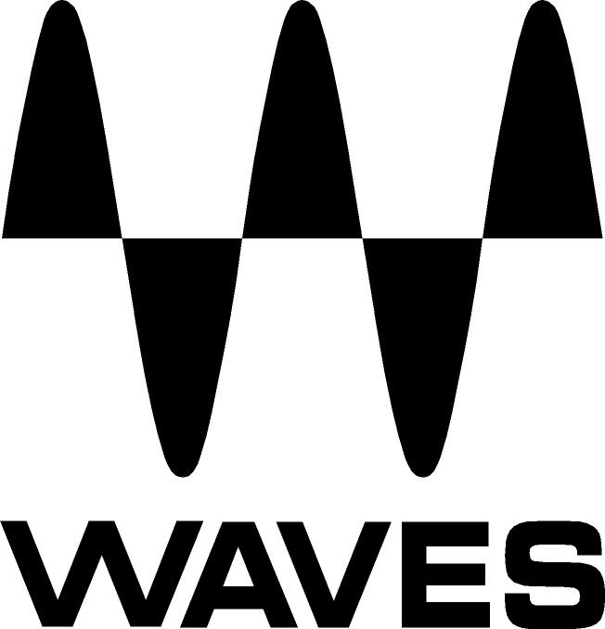

PRESS RELEASE
Contact: Clyne Media, Inc.
Tel: (615) 662-1616
Fax: (615) 662-1636

FOR IMMEDIATE RELEASE

Waves Audio Introduces the Morgan Page EMP Toolbox

TEL AVIV, ISRAEL, January 16, 2014 — Waves EMP, the electronic music production division of Waves Audio, announces the availability of the Morgan Page EMP Toolbox plugin collection. Created in collaboration with highly acclaimed DJ/Producer Morgan Page, this is the second bundle in a series in Waves’ new EMP product line.

Whether he’s remixing for superstars, or putting out his own GRAMMY®-nominated singles, Morgan Page balances electronic dance beats and pop sensibilities like few other artists can. From chart-topping powerhouses like Katy Perry and Madonna, to industry darlings Tegan & Sara and La Roux, Morgan Page has been called upon by every brand of hit-maker to paint their songs with new colors and sounds for the club scene.

As with any medium, an electronic musician needs a palette to work from that can deliver equal parts creative inspiration and technical refinement. That’s why Morgan Page relies on Waves EQs, dynamics and effects as his primary set of production tools. Hand-picked by Page himself, the Morgan Page EMP Toolbox contains eight powerful Waves audio processors that he uses most in his mixing and mastering sessions, ideal for electronic music producers of every shade of the spectrum.

Page notes, ”Waves plugins are the single most important group of plugins in my setup because they allow me to work quickly. It's crucial for me to get a great vocal chain with a minimal amount of clicks. I need my plugins to be intuitive and versatile, because I use them for so many different tasks, including writing, remixing, tracking, sound design, mixing, and mastering.”

The Morgan Page EMP Toolbox includes the following Waves plugins: Maserati VX1 Vocal Enhancer, Vocal Rider, TrueVerb, SoundShifter, NLS Non-Linear Summer, H-Delay Hybrid Delay, L3-LL Multimaximizer, and H-EQ Hybrid Equalizer.

* Morgan Page also uses the Waves SSL 4000 Collection.

The Morgan Page EMP Toolbox is now available with a U.S. MSRP of $599 and a special introductory price of $449. Visit www.waves.com or http://www.waves.com/electronic-music-production for more information.
...ends 323 words

Photo File: MorganPageToolbox.JPG

About Waves Ltd.:
From its start in the early '90s with the introduction of the Q10 equalizer plugin, Waves, the world’s leading developer of audio DSP solutions for professional, broadcast, and consumer electronics audio markets, has gone on to develop a comprehensive line of over 130 audio plugins including industry standards like the L1 and L2 Ultramaximizers, popular vintage console models, and innovative mixing tools like Vocal Rider and the Artist Signature Series. For its accomplishments, in 2011 Waves received a Technical GRAMMY® award, and the Q10 was selected as an inductee into the TECnology Hall of Fame. Waves technologies are now used to improve sound quality in virtually every sector of the audio market, from recording, mixing, mastering and post-production to broadcast, live sound, and consumer electronics. Waves has over 20 years of expertise in the development of psycho-acoustic signal processing algorithms that leverage knowledge on the human perception of hearing to radically improve perceived sound quality. Waves’ award-winning processors are utilized to improve sound quality in the creation of hit records, major motion pictures, and top-selling video games worldwide. Waves offers computer software solutions, as well as hardware-plus-software solutions, for the professional and broadcast markets. Under its Maxx brand, Waves offers semiconductor and licensable algorithms for consumer electronics applications. Waves Maxx technologies dramatically enhance audio performance and are used by industry leaders such as Dell, ASUS, JVC and many others.

All other product names and trademarks are the property of their respective owners, which are in no way associated or affiliated with Waves.

North America Offices:
Waves, Inc., 2800 Merchants Drive, Knoxville, TN 37912;
Tel: 865-909-9200, Fax: 865-909-9245, Email: info@waves.com, Web: http://www.waves.com

Corporate Headquarters Israel:
Waves Ltd., Azrieli Center, The Triangle Tower, 32nd Floor
Tel Aviv 67023, Israel; Tel: 972-3-608-4000, Fax: 972-3-608-4056, Email: info@waves.com,
Web: http://www.waves.com

Waves Public Relations:
Clyne Media, Inc., 169-B Belle Forest Circle, Nashville, TN 37221;
Tel: 615-662-1616, Fax: 615-662-1636, Email: robert@clynemedia.com,
Web: http://www.clynemedia.com

Waves Audio is exhibiting at booth 6824 at the 2014 NAMM Show in Anaheim, California.

