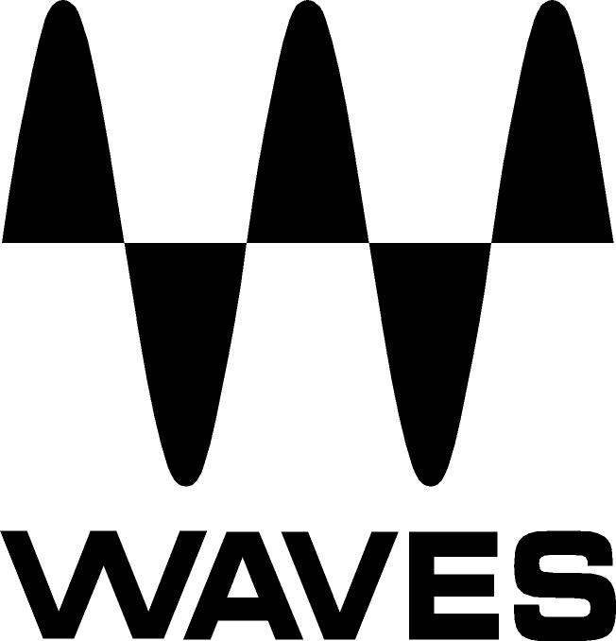
PRESS RELEASE
Contact: Clyne Media, Inc.
Tel: (615) 662-1616

FOR IMMEDIATE RELEASE

Della Leaders Club in India Chooses the Waves eMotion LV1 for Its Della Towers Broadcast Studio

Knoxville, TN, March 3, 2022 — India-based Della Leaders Club (DLC), a global community of entrepreneurs, professionals and young leaders that “brings people together to positively impact the world,” has chosen the Waves eMotion LV1 Live Mixer for its Della Towers Broadcast studio. The facility, located at Della Towers in Mumbai, is a state-of-the-art digital broadcasting studio responsible for developing recorded and live content for the DLC community, including masterclasses, interviews, fireside chats, and seminars by global leaders in their respective fields. DLC’s objective was to build a studio that can handle live shows and broadcast the feed to a global digital audience.

“The Waves eMotion LV1 was impressive and perfect for the job,” says Sai Prem, Della Leaders Club’s mix engineer. “The LV1 is incredibly transparent, the preamps sound great and the mixer is incredibly powerful. The layout and UI of the board is very intuitive, which helps the mix engineer control the show more easily and achieve better overall sound."

“Choosing the eMotion LV1 enabled us to customize the solution to our specific needs,” says Vicky Pereira, Application Engineer for VMT (India's largest professional audio retail store). “The system is built on a scalable foundation that can easily be upgraded to grow with the studio. We chose the 16-channel version of the LV1, running on a Waves Axis Proton host computer, with a Waves Proton Server handling the audio processing and an STG-1608 SoundGrid audio interface with 16 inputs and 8 outputs. We also added a Waves FIT Controller for eMotion LV1 to retain the tactile feel of a fader, while using ViewSonic touch screens to control the LV1’s mixer and plugin pages.”

“Using the eMotion LV1 as an end-to-end broadcast solution for our streaming studio has made our entire setup process so much easier,” adds mix engineer Sai Prem. “The setup is extremely straightforward now and doesn’t involve the usual mess of too many different cables having different purposes and connections. Instead, everything is simplified by using Cat6 cables and a switch between all the devices. Routing audio in the console is also pretty simple, straightforward and convenient, with all the different modes of patching and routing available through the LV1. Furthermore, the SoundGrid network facilitates smoother recording.”

“The game-changer with LV1,” Prem remarks, “is the ability to load studio plugins within the live mixer with near-zero latency. The Waves Platinum bundle installed with our LV1 at Della allows me to mix effectively. The Waves Q10 Equalizer, Vitamin Sonic Enhancer, C4 Multiband Compressor and H-Reverb have become staple plugins at the Della Towers Broadcast studio. Additional must-haves in my shows include the Waves eMo F2 Filter – an extremely simple plugin with a very basic function of either choosing a high-pass filter or low-pass filter on the input channels. This plugin is a staple on all of my microphones, since it rolls off the lows on them with a smooth high-pass filter. Also, the eMo D5 Dynamics is an all-in-one solution for anyone looking for a gate/expander, compressor with sidechain, leveler, de-esser and limiter. I also use this plugin on all the microphones, since all of them need to be gated and compressed while being sent on the stream.”

Prem continues, “The C4 Multiband Compressor helps in improving an overall balance of the dynamics of the mix and individual inputs as well. I use it on the AV input channels to balance out the mix from the AVs. I use the C4 on the master as well in order to achieve an overall balance in the mix. The Vitamin Sonic Enhancer is another dynamic equalizer plugin that enhances the overall mix. I insert it on playback channels as well as on the master and other matrix outputs. The L3-LL Ultramaximizer plugin works wonders on the mix and increases the overall dynamic of the playback sources, by making the highs crisp and the lows smooth. Finally, the Waves Playlist Rider is another wonder of a plugin, in that it helps in volume leveling for the playback devices that might have tracks that may be of different volume levels. It smoothens out the volume to a chosen decibel level and lets you avoid riding the fader manually to achieve the same result.”

Jeff Mandot, VMT Enterprise National Sales Manager, summarizes, “The brief from Della was simple: they wanted a studio that was on par with the best broadcasting studios. We were able to create a great synergy with the eMotion LV1 and Waves plugins to achieve the desired level of quality.”
…ends 745 words

Photo file 1: DLC_PR_photo.JPG
Photo caption 1: Sai Prem, Mix Engineer – Online Studio, Della Leaders Club

About Vardhaman Megatech Pvt. Ltd.
Vardhaman Megatech Pvt. Ltd. is the exclusive distributor for the Waves LV1 systems in India and is the professional audio division of the 200-year-old family owned Vardhaman Group (Established in 1807). The 3 Divisions within VMT are VMT Retail, VMT Enter- prise & VMT Distribution.

VMT Retail runs the online store vmt.in along with 13 physical stores in India where the customers can choose from leading Professional Audio Brands such as Harman, Bose, QSC, Shure, Sennheiser, Allen & Heath and more. Each of the 13 stores hosts an auditorium that hosts regular training, service and launch events for the local customers.

VMT Enterprise is the projects division of VMT and has developed a network of systems integrators and consultants across India. With a strong portfolio of over 1500 projects in 36 months – we have some of India’s most prestigious projects executed under this division including the Oneness Fields, Digha Convention Centre, Lucknow Railway Station, Embassy of Sweden and H&M Stores to name a few.

VMT Distribution is the newly formed division that undertakes representation of the World’s Leading Brands for the B2B and B2C segments. Currently, we distribute Martin Audio for our loudspeaker portfolio and Waves for our digital mixing portfolio under this division.

VMT HQ.
Vardhaman Megatech Pvt. Ltd.
Vardhaman House, DL Road, Kalachowki, Mumbai 400 033.
T | +91 022 4343 2222
E| info@vmt.in

For Waves
Contact Person – Kekul Sheth.
M | +91 8657864922
E | kekul@vmt.in

About Waves Audio Ltd.:
Waves is the world’s leading developer of audio DSP solutions for music production, recording, mixing, mastering, sound design, post-production, live sound, broadcast, commercial and consumer electronics audio markets. Since its start in the early '90s, Waves has developed a comprehensive line of over 250 audio plugins and numerous hardware devices. For its accomplishments, Waves received a Technical GRAMMY® Award in 2011, and its early flagship plugin, the Q10 equalizer, was selected as an inductee into the TECnology Hall of Fame.

Increasingly leveraging pioneering techniques in artificial intelligence, neural networks and machine learning, as well as the company’s three decades of accumulated expertise in psychoacoustics, Waves technologies are being used to improve sound quality in a growing number of market sectors. Around the world, Waves’ award-winning plugins are utilized in the creation of hit records, major motion pictures, and top-selling video games. Additionally, Waves now offers hardware-plus-software solutions (including the revolutionary eMotion LV1 mixer) for professional audio markets. The company’s WavesLive division is a leader in the live sound sector, spearheading the development of solutions for all live platforms. Products from Waves Commercial Audio enable A/V system integrators and installers to deliver superior sound quality for corporate, commercial, government, educational, entertainment, sports and house-of-worship applications. Under its Maxx brand, Waves offers semiconductor and licensable algorithms for consumer electronics applications, used in laptops, smartphones, smart speakers, gaming headsets, TVs and more from industry leaders such as Dell, Google, Fitbit, Acer, Asus, Hisense and others.

North America Offices:
Waves, Inc., 2800 Merchants Drive, Knoxville, TN 37912;
Tel: 865-909-9200, Fax: 865-909-9245, Email: info@waves.com,
Web: http://www.waves.com

Corporate Headquarters Israel:
Waves Ltd., Azrieli Center, The Triangle Tower, 32nd Floor, Tel Aviv 67023, Israel;
Tel: 972-3-608-4000, Fax: 972-3-608-4056, Email: info@waves.com,
Web: http://www.waves.com

Waves Public Relations:
Clyne Media, Inc., 169-B Belle Forest Circle, Nashville, TN 37221;
Tel: 615-662-1616, Email: robert@clynemedia.com,
Web: http://www.clynemedia.com

