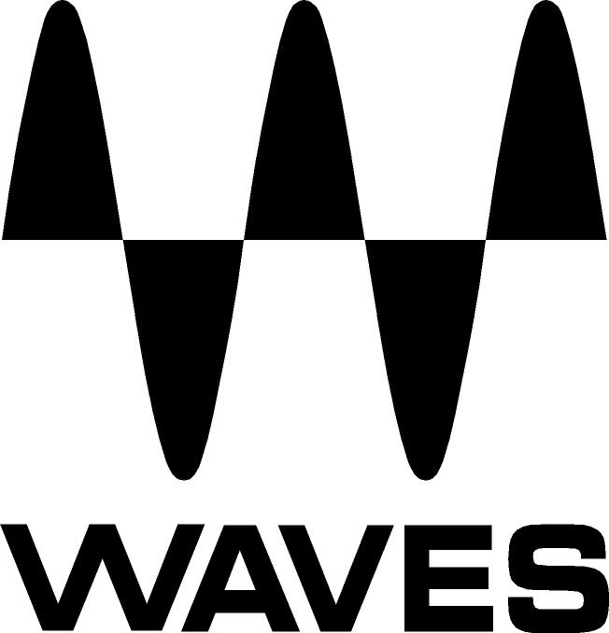

PRESS RELEASE
Contact: Clyne Media, Inc.
Tel: (615) 662-1616
Fax: (615) 662-1636

FOR IMMEDIATE RELEASE

Waves Audio Now Shipping the Waves Clavinet

KNOXVILLE, TN, August 7, 2017 — Waves Audio, a leading provider of digital signal processing solutions and digital music production tools, is now shipping the Waves Clavinet, an addition to its expanding line of virtual instruments.

The original Clav has always held a special appeal in funk, fusion, rock and soul music for its unique percussive playability and sonic versatility, from brilliant, vibrant, nitty and gritty to soft, rich, mellow tones. Waves has now accurately sampled one of the funkiest keyboards in existence: the iconic D6 model Clavinet, made famous by Stevie Wonder, Led Zeppelin, Sly & the Family Stone and many more.

Recreating all the dynamic control, feel and expression of the original funkified icon, Waves has meticulously sampled every texture, articulation and hammer tip string-striking mechanic of the authentic D6 Clavinet in both the muted and unmuted modes.

Using only a few controls, you can achieve an array of deep sonic textures, capturing the distinctive timbre of the Clav’s unique single-coil pickups. Choose from the selection of factory presets, featuring patches modeled after Stevie Wonder’s “Superstition,” Billy Preston’s “Outta Space” and other classic songs; or shape your own tones using the built-in auto-wah, amp overdrive and other effects.

Waves Clavinet features:
- Sampled from the original D6 model Clavinet
- Built-in FX section including advanced auto-wah, phaser, chorus, reverb
- Full velocity response mix control with key up and mechanics features
- Customizable EQ section for further tone shaping
- Mute slider control for decayed staccato or mellow sustain
- Amp overdrive control with tube condenser and dynamic microphone selectors
- Global tune control; MIDI assignable
- 32-bit & 64-bit
- NKS-ready for NI Komplete Kontrol and Maschine
- HD and SD sample libraries
- Can be used as a plugin or as a standalone instrument
- Powered by the Waves Sampler Engine (WSE)

For more information, please visit www.waves.com/plugins/clavinet.

Video: Presenting the Waves Clavinet Virtual Instrument Plugin: https://youtu.be/Rxioxlq1NtI.

…ends 303 words

Photo file: Clavinet_GUI.JPG
Photo caption: The graphic user interface for Waves Clavinet.

About Waves Audio Ltd.:
Waves is the world’s leading developer of audio DSP solutions for the professional, broadcast, and consumer electronics audio markets. Since its start in the early '90s with the introduction of the Q10 equalizer plugin, Waves has gone on to develop a comprehensive line of over 200 audio plugins, including industry standards like the L1 and L2 Ultramaximizers, popular vintage console models, and innovative mixing tools like Vocal Rider and the Artist Signature Series. For its accomplishments, Waves received a Technical GRAMMY® Award in 2011, and the Q10 was selected as an inductee into the TECnology Hall of Fame. In 2016, Waves released the eMotion LV1 mixer, a revolutionary live digital mixing console that provides real-time audio mixing for front-of-house, monitor, studio and broadcast engineers. Waves technologies are now used to improve sound quality in virtually every sector of the audio market, from recording, mixing, mastering and post-production to broadcast, live sound, and consumer electronics. Waves has over 20 years of expertise in the development of psychoacoustic signal processing algorithms that leverage knowledge of human auditory perception to radically improve perceived sound quality. Waves’ award-winning processors are utilized to improve sound quality in the creation of hit records, major motion pictures, and top-selling video games worldwide. Waves offers computer software and hardware-plus-software solutions for the professional and broadcast markets. The company’s WavesLive division is a market leader in all live sound sectors, spearheading the development of solutions for all live platforms. Under its Maxx brand, Waves offers semiconductor and licensable algorithms for consumer electronics applications. Waves Maxx technologies dramatically enhance audio performance and are used by industry leaders such as Dell, LG, TCL, Lenovo, Asus, Denon and more.

All other product names and trademarks are the property of their respective owners, which are in no way associated or affiliated with Waves.

North America Offices:
Waves, Inc., 2800 Merchants Drive, Knoxville, TN 37912;
Tel: 865-909-9200, Fax: 865-909-9245, Email: info@waves.com,
Web: http://www.waves.com

Corporate Headquarters Israel:
Waves Ltd., Azrieli Center, The Triangle Tower, 32nd Floor, Tel Aviv 67023, Israel;
Tel: 972-3-608-4000, Fax: 972-3-608-4056, Email: info@waves.com,
Web: http://www.waves.com

Waves Public Relations:
Clyne Media, Inc., 169-B Belle Forest Circle, Nashville, TN 37221;
Tel: 615-662-1616, Fax: 615-662-1636, Email: robert@clynemedia.com,
Web: http://www.clynemedia.com

