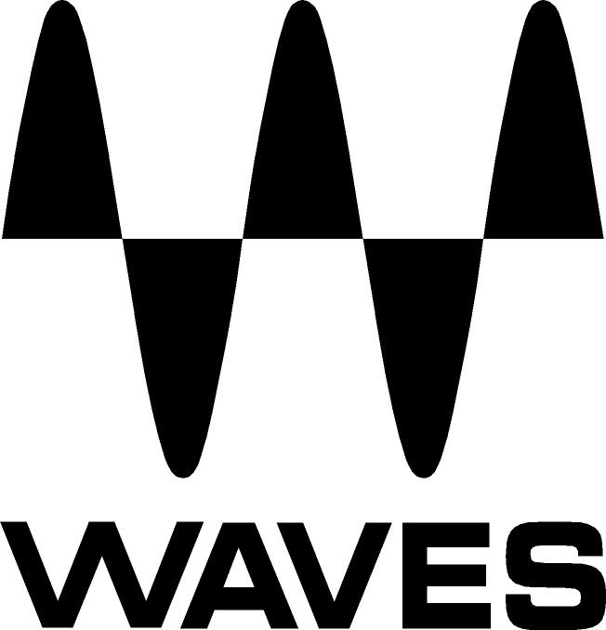

PRESS RELEASE
Contact: Clyne Media, Inc.
Tel: (615) 662-1616
Fax: (615) 662-1636

FOR IMMEDIATE RELEASE

Waves Audio to Hold Mixing Workshop in Camarillo, CA, on May 22

— Taking place at CSU Channel Islands, this masterclass will feature Waves specialists Josiah Eckhart and Michael Pearson-Adams and acclaimed live sound engineer Sean “Sully” Sullivan (Red Hot Chili Peppers, Rihanna, Beck, Beastie Boys, Sheryl Crow and most recently Shania Twain), along with the audio team from Rat Sound —

KNOXVILLE, TN, May 14, 2018 — Waves Audio, a leading provider of audio processing solutions, will be hosting a mixing workshop masterclass at CSU Channel Islands (Grand Salon, One University Dr) in Camarillo, CA, on May 22. Taking place from 7:30-10pm PDT, the session will feature Waves specialists Josiah Eckhart and Michael Pearson-Adams and acclaimed live sound engineer Sean “Sully” Sullivan (Red Hot Chili Peppers, Rihanna, Beck, Beastie Boys, Sheryl Crow and most recently Shania Twain), along with the audio team from Rat Sound. Visit here to register for this event.

The evening will start with an overview of SoundGrid® technology, the Waves MultiRack plugin host and the Waves eMotion LV1 live mixer, followed by an in-depth mixing seminar and Q&A session. Pre-event drinks/snacks mixer begins at 7pm.

A SoundGrid Certification training session will take place earlier that day, in the morning, in the same location, from 10am-12pm (snacks and coffee served from 9:30am). Attendees can register separately for that session. (Please note: SoundGrid 101 is a pre-requisite for taking the SoundGrid 201 Certification that will be held on that day.)

WHEN: May 22, 2018
WHERE: CSU Channel Islands (Grand Salon, One University Dr, Camarillo, CA 93012). Once on campus, please follow directional signage to the appropriate parking and walking signage to the Grand Salon.

…ends 204 words

About Waves Audio Ltd.:
Waves is the world’s leading developer of audio DSP solutions for the professional, broadcast, and consumer electronics audio markets. Since its start in the early '90s with the introduction of the Q10 equalizer plugin, Waves has gone on to develop a comprehensive line of over 150 audio plugins, including industry standards like the L1 and L2 Ultramaximizers, popular vintage console models, and innovative mixing tools like Vocal Rider and the Artist Signature Series. For its accomplishments, Waves received a Technical GRAMMY® Award in 2011, and the Q10 was selected as an inductee into the TECnology Hall of Fame. In 2016, Waves released the eMotion LV1 mixer, a revolutionary live digital mixing console that provides real-time audio mixing for front-of-house, monitor, studio and broadcast engineers. Waves technologies are now used to improve sound quality in virtually every sector of the audio market, from recording, mixing, mastering and post-production to broadcast, live sound, and consumer electronics. Waves has over 25 years of expertise in the development of psychoacoustic signal processing algorithms that leverage knowledge of human auditory perception to radically improve perceived sound quality. Waves’ award-winning processors are utilized to improve sound quality in the creation of hit records, major motion pictures, and top-selling video games worldwide. Waves offers computer software and hardware-plus-software solutions for the professional and broadcast markets. The company’s WavesLive division is a market leader in all live sound sectors, spearheading the development of solutions for all live platforms. Under its Maxx brand, Waves offers semiconductor and licensable algorithms for consumer electronics applications. Waves technologies dramatically enhance audio performance and are used by industry leaders such as Dell, Google, Fitbit, Acer, Asus, Hisense and more.

All other product names and trademarks are the property of their respective owners, which are in no way associated or affiliated with Waves.

North America Offices:
Waves, Inc., 2800 Merchants Drive, Knoxville, TN 37912;
Tel: 865-909-9200, Fax: 865-909-9245, Email: info@waves.com,
Web: http://www.waves.com

Corporate Headquarters Israel:
Waves Ltd., Azrieli Center, The Triangle Tower, 32nd Floor, Tel Aviv 67023, Israel;
Tel: 972-3-608-4000, Fax: 972-3-608-4056, Email: info@waves.com,
Web: http://www.waves.com

Waves Public Relations:
Clyne Media, Inc., 169-B Belle Forest Circle, Nashville, TN 37221;
Tel: 615-662-1616, Fax: 615-662-1636, Email: robert@clynemedia.com,
Web: http://www.clynemedia.com

