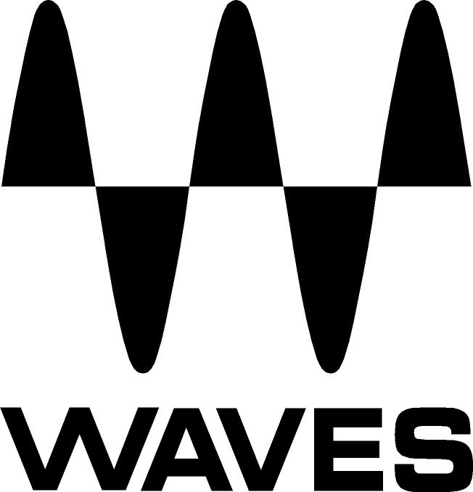
PRESS RELEASE
Contact: Clyne Media, Inc.
Tel: (615) 662-1616
Fax: (615) 662-1636

FOR IMMEDIATE RELEASE

Waves Now Shipping the CLA Epic Plugin

Knoxville, TN, November 30, 2020 — Waves Audio, the world’s leading developer of professional audio signal processing technologies and leading maker of audio plugins for mixing, music production, mastering, sound design, broadcast, post-production and live sound, is now shipping the CLA Epic plugin, designed with legendary GRAMMY® Award-winning mix engineer Chris Lord-Alge (Green Day, Muse, Bruce Springsteen).

Chris Lord-Alge is renowned as a master at creating epic depth and dimension in every song he mixes. Now, with the Waves CLA Epic plugin, he is giving you the key to that depth: his complete suite of reverbs and delays, all in one plugin.

Waves CLA Epic features Chris’s four go-to delays (Slap, Throw, Tape, Crowd) and four go-to reverbs (Plate, Room, Hall, Space). These modules are each based on Chris’s favorite studio gear, which he uses in various combinations in every one of his mixes. Whether used on vocals, drums or other instruments, CLA Epic opens the gate to more depth in your mixes and productions.

One of the keys to Chris’s depth of sound is the way he blends effects creatively – sending multiple delays to multiple reverbs on each track, and controlling the exact blend with his console faders. Waves CLA Epic lets you blend CLA’s reverbs and delays in the same creative manner. There’s no need for you to open different effect plugins to get a rich landscape of sound: You can activate any or all of CLA Epic’s eight effect modules, and blend them easily using the plugin’s console-type faders.

To make things even easier, CLA Epic always loads with Chris’s default settings for each effect. You can go deeper and tweak all the familiar parameters (as well as some surprising ones) – but by simply loading the plugin and blending in the different effects, you’ll hear CLA magic in action.

Chris Lord-Alge has an extra secret for mixing with depth: he sends his delays to his reverbs, so that the delays become part of the overall sonic landscape. CLA Epic lets you easily send any delay to any reverb, in addition to the option of running the effects in parallel. With the click of a button, you can choose to send each delay only to the Output, only to any or all of the reverbs, or to everything at once. Effects routing that would take hours in your DAW now takes seconds.

Waves’ CLA Epic comes packed with 50 powerful presets crafted by Chris himself – for your vocals, drums, guitars and keyboards. CLA Epic also includes over 300 presets by GRAMMY winners Greg Wells, Michael Brauer, and dozens more top producers and engineers.

Owners of CLA Epic also receive the CLA EchoSphere slap delay & plate reverb plugin as a complementary bonus.

Chris Lord-Alge comments, “CLA Epic gives you my way of mixing with depth. You can layer reverbs, you can layer delays, and you can mix them all together in one easy-to-use plugin. You can break new ground and create new dimension in your music that you didn’t think was possible.”

Waves CLA Epic features:
- Reverb and delay super-suite designed with Chris Lord-Alge
- Based on CLA’s favorite classic studio gear
- Add epic depth, dimension and space to your mixes & productions
- Four delay modules: Slap, Throw, Tape, Crowd
- Four reverb modules: Plate, Room, Hall, Space (Non-Lin)
- Blend the eight effects easily on any track
- Send any delay to any reverb with the click of a button
- Modulation control per module to add texture and spread
- CPU-friendly
- 50 powerful presets by Chris Lord-Alge
- Over 300 additional presets by Greg Wells, Michael Brauer and more

CLA Epic is included in Waves’ Mercury, Pro Show and SD7 Pro Show bundles.

For more information, visit https://www.waves.com/plugins/cla-epic.

Videos:

CLA Epic – Complete Reverbs & Delays by Chris Lord-Alge: https://youtu.be/5VsTFRHO04c

CLA Epic Plugin Tutorial with Chris Lord-Alge – Mixing with Depth: https://youtu.be/tBNcPUBngSE

CLA Epic Reverbs & Delays – Chris Lord-Alge Preset Tour: https://youtu.be/dQ4wJpm1sIs

…ends 641 words

Photo file 1: CLA_Epic_GUI.JPG
Photo caption 1: Waves CLA Epic user interface

About Waves Audio Ltd.:
Waves is the world’s leading developer of audio DSP solutions for the professional, broadcast, and consumer electronics audio markets. Since its start in the early '90s with the introduction of the Q10 equalizer plugin, Waves has gone on to develop a comprehensive line of over 150 audio plugins, including industry standards like the L1 and L2 Ultramaximizers, popular vintage console models, and innovative mixing tools like Vocal Rider and the Artist Signature Series. For its accomplishments, Waves received a Technical GRAMMY® Award in 2011, and the Q10 was selected as an inductee into the TECnology Hall of Fame. In 2016, Waves released the eMotion LV1 mixer, a revolutionary live digital mixing console that provides real-time audio mixing for front-of-house, monitor, studio and broadcast engineers. Waves technologies are now used to improve sound quality in virtually every sector of the audio market, from recording, mixing, mastering and post-production to broadcast, live sound, and consumer electronics. Waves has over 25 years of expertise in the development of psychoacoustic signal processing algorithms that leverage knowledge of human auditory perception to radically improve perceived sound quality. Waves’ award-winning processors are utilized to improve sound quality in the creation of hit records, major motion pictures, and top-selling video games worldwide. Waves offers computer software and hardware-plus-software solutions for the professional and broadcast markets. The company’s WavesLive division is a market leader in all live sound sectors, spearheading the development of solutions for all live platforms. Under its Maxx brand, Waves offers semiconductor and licensable algorithms for consumer electronics applications. Waves technologies dramatically enhance audio performance and are used by industry leaders such as Dell, Google, Fitbit, Acer, Asus, Hisense and more.

North America Offices:
Waves, Inc., 2800 Merchants Drive, Knoxville, TN 37912;
Tel: 865-909-9200, Fax: 865-909-9245, Email: info@waves.com,
Web: http://www.waves.com

Corporate Headquarters Israel:
Waves Ltd., Azrieli Center, The Triangle Tower, 32nd Floor, Tel Aviv 67023, Israel;
Tel: 972-3-608-4000, Fax: 972-3-608-4056, Email: info@waves.com,
Web: http://www.waves.com

Waves Public Relations:
Clyne Media, Inc., 169-B Belle Forest Circle, Nashville, TN 37221;
Tel: 615-662-1616, Fax: 615-662-1636, Email: robert@clynemedia.com,
Web: http://www.clynemedia.com

