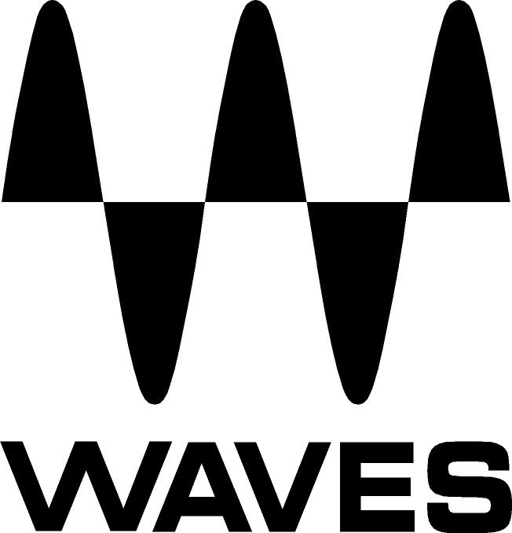

PRESS RELEASE
Contact: Clyne Media, Inc.
Tel: (615) 662-1616
Fax: (615) 662-1636

FOR IMMEDIATE RELEASE

Brian Yaskulka Mixes “Elton John – Farewell Yellow Brick Road: The Legacy (VR360)” with Waves Nx – Virtual Mix Room over Headphones

KNOXVILLE, TN, April 4, 2018 — GRAMMY®-winning mix engineer Brian Yaskulka (Lisa Loeb, Andy Summers) was recently tasked with mixing “Elton John - Farewell Yellow Brick Road: The Legacy (VR360),” a career-retrospective 360/VR project for music legend Sir Elton John and part of the artist’s ongoing career-farewell endeavors. Finding himself temporarily without a traditional 360-degree mix environment but nonetheless working within tight deadlines, Yaskulka found the right mixing solution with Waves Nx – Virtual Mix Room over Headphones.

Yaskulka comments, “The original plan was for me to do all the mixing for the Elton John project in the theater room at Spinifex. But due to some scheduling conflicts and timeline acceleration, it became necessary to work on the production at my own studio; however, I had just recently relocated my studio to the iconic Sound City facility in Van Nuys, California, and I was waiting for the new studio to be completed, so I was basically working out of boxes, and I didn’t have my usual 5.1 setup available!”

He notes, “I had heard good things about Waves Nx technology for 3D audio on headphones, so I thought I’d give it a try – nothing to lose. I had no viable monitoring facility, so I went ahead and used a pair of AKG K702 reference headphones, with the Nx Virtual Mix Room plugin and the Nx Head Tracker attached to the headphones. I ended up mixing 90% of the project on headphones. The remaining 10% was done in the Spinifex theater, and I was amazed, as it sounded almost exactly the same in that acoustically magnificent theater as it did on my headphones with Nx. Everything – the localization, the spaciousness – matched, and I ended up just making a few tweaks here and there, mainly to be able to work with the producers, in order to dial in sound design elements.”

Yaskulka adds, about the uniqueness of mixing this project: “The idea was for the viewer to experience inside, pivotal moments in Elton John’s career – his first show at Hollywood’s Troubadour Club in 1970 and the famous 1975 Dodgers Stadium concert – and place you right there on stage alongside Elton. The creators at Spinifex Group recreated digital versions of a younger Elton using CGI, motion-capture technology tracking Elton’s face, and even a professional Elton impersonator to reproduce his ‘70s dance moves! The point of the audio mix was to put you right there with Elton and feel the excitement of these events, as well as to create some moments of pure fantasy. So, for some scenes, I needed to create a feeling of total immersion in a live concert; for others, I needed an extra sense of space and depth.”

On using Waves plugins, he remarks, “This was a project aimed at celebrating Elton John’s music, not reinventing it, so I researched the original recording process of all these songs and what technology was used at that time, and I applied the right plugins to recreate the sounds I was looking for. For example, on the vocal for ‘Your Song’ I used the Waves C4 Multiband Compressor, the CLA-2A Compressor and the Waves DeEsser. On the piano, I used the Waves MV2, the Scheps 73 EQ and the PS22 Stereo Maker. For the vocals on ‘Saturday Night’s Alright (for Fighting)’ I used the SSL G-Equalizer and the CLA-76 Compressor. On the vocals of ‘Rocket Man’ and ‘Goodbye Yellow Brick Road’ I used the F6 Dynamic EQ to dynamically control the vocal track, and again the CLA-2A. Also, when we matched the audio and the visuals in the theater room, everything worked flawlessly. But once the tech team did a run-through test with some of the VR headsets, they found they were having sync issues. That’s where the Waves SoundShifter plugin came in. It was a split-second fix that needed to be made on the spot: we had to time-stretch the first scene by 100 ms. SoundShifter did it perfectly, no glitches, no artifacts. I used a set of Waves 5.1 surround plugins to pull off the balance and the spread in the surround sound design – the R360 Surround Reverb, the C360 Surround Compressor, the L360 Surround Limiter and the M360 Surround Manager & Mixdown.“

He sums up his experience: “Basically, I’m just glad Waves Nx was there to help me solve this particular one!”

To learn more: https://www.waves.com/plugins/nx#introducing-nx-virtual-mix-room

Video: https://youtu.be/0zXZIgnub6w
…ends 721 words

Photo file: Waves_BrianYaskulka_EltonJohnNx.JPG
Photo caption: Brian Yaskulka works on the mix for “Elton John - Farewell Yellow Brick Road: The Legacy (VR360)” using Waves Nx – Virtual Mix Room over Headphones.

About Waves Audio Ltd.:
Waves is the world’s leading developer of audio DSP solutions for the professional, broadcast, and consumer electronics audio markets. Since its start in the early '90s with the introduction of the Q10 equalizer plugin, Waves has gone on to develop a comprehensive line of over 150 audio plugins, including industry standards like the L1 and L2 Ultramaximizers, popular vintage console models, and innovative mixing tools like Vocal Rider and the Artist Signature Series. For its accomplishments, Waves received a Technical GRAMMY® Award in 2011, and the Q10 was selected as an inductee into the TECnology Hall of Fame. In 2016, Waves released the eMotion LV1 mixer, a revolutionary live digital mixing console that provides real-time audio mixing for front-of-house, monitor, studio and broadcast engineers. Waves technologies are now used to improve sound quality in virtually every sector of the audio market, from recording, mixing, mastering and post-production to broadcast, live sound, and consumer electronics. Waves has over 25 years of expertise in the development of psychoacoustic signal processing algorithms that leverage knowledge of human auditory perception to radically improve perceived sound quality. Waves’ award-winning processors are utilized to improve sound quality in the creation of hit records, major motion pictures, and top-selling video games worldwide. Waves offers computer software and hardware-plus-software solutions for the professional and broadcast markets. The company’s WavesLive division is a market leader in all live sound sectors, spearheading the development of solutions for all live platforms. Under its Maxx brand, Waves offers semiconductor and licensable algorithms for consumer electronics applications. Waves technologies dramatically enhance audio performance and are used by industry leaders such as Dell, Google, Fitbit, Acer, Asus, Hisense and more.

All other product names and trademarks are the property of their respective owners, which are in no way associated or affiliated with Waves.

North America Offices:
Waves, Inc., 2800 Merchants Drive, Knoxville, TN 37912;
Tel: 865-909-9200, Fax: 865-909-9245, Email: info@waves.com,
Web: http://www.waves.com

Corporate Headquarters Israel:
Waves Ltd., Azrieli Center, The Triangle Tower, 32nd Floor, Tel Aviv 67023, Israel;
Tel: 972-3-608-4000, Fax: 972-3-608-4056, Email: info@waves.com,
Web: http://www.waves.com

Waves Public Relations:
Clyne Media, Inc., 169-B Belle Forest Circle, Nashville, TN 37221;
Tel: 615-662-1616, Fax: 615-662-1636, Email: robert@clynemedia.com,
Web: http://www.clynemedia.com

