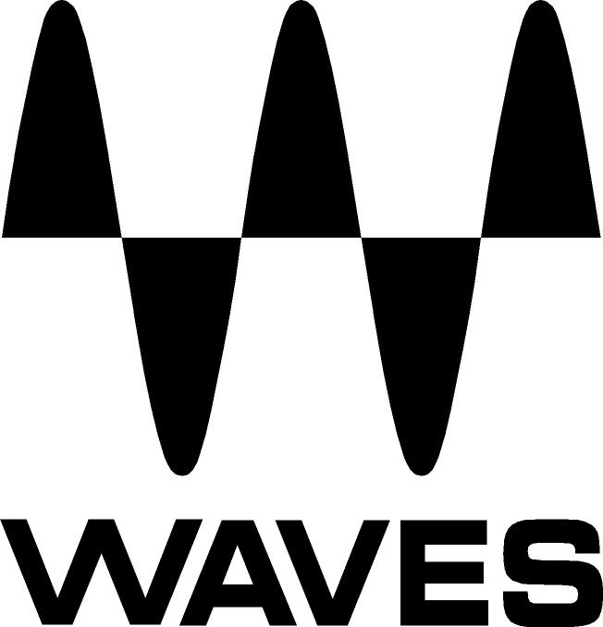
PRESS RELEASE
Contact: Clyne Media, Inc.
Tel: (615) 662-1616
Fax: (615) 662-1636

FOR IMMEDIATE RELEASE

Waves Audio to Hold “In the Studio with Dave Audé” Event on September 24 in Asheville, NC

KNOXVILLE, TN, September 13, 2019 — On Tuesday, September 24, 2019 (07:00 pm–09:30 pm EDT), Waves Audio will be hosting “Waves in the Studio with Dave Audé” at Echo Mountain Recording in Asheville, NC (175 Patton Avenue, Asheville, NC 28801). Waves invites you to join the GRAMMY®-winning mix engineer and producer Dave Audé (Sting, Mark Ronson, Bruno Mars) in person, as he explains his approach to mixing and walks you through his mix workflow and how he uses Waves plugins. This is a unique opportunity to meet Dave as he opens a mix, shares his mixing methodology, and in the process, helps you learn from his many years mixing, so your mixes will be better too.

Also in this evening, Waves’ own studio product specialist Jeremiah Clever will take you through how to get the most out of Waves’ audio-over-Ethernet protocol, SoundGrid®, and how it can add to your creative workflow in the studio, as well as some plugin tips and tricks.
In this special free event, you will also enjoy Q&A time with Dave, Jeremiah and the owners of this amazing studio facility, so you can learn an incredible amount in this unique evening.

The event is free, but space is limited, so RSVP to reserve your ticket here: Waves in the Studio with Dave Audé

When
Tuesday, September 24, 2019
07:00 pm–09:30 pm EDT (Refreshments from 6:30 pm)

Where
Echo Mountain Recording
175 Patton Avenue
Asheville, NC 28801

Contact Waves about this event
…ends 241 words

Photo file: september-2019-dave-Aude-asheville-masterclass.JPG
Photo caption: On Tuesday, September 24, 2019 (07:00 pm–09:30 pm EDT), Waves Audio will be hosting “Waves in the Studio with Dave Audé” at Echo Mountain Recording in Asheville, NC.

About Waves Audio Ltd.:
Waves is the world’s leading developer of audio DSP solutions for the professional, broadcast, and consumer electronics audio markets. Since its start in the early '90s with the introduction of the Q10 equalizer plugin, Waves has gone on to develop a comprehensive line of over 150 audio plugins, including industry standards like the L1 and L2 Ultramaximizers, popular vintage console models, and innovative mixing tools like Vocal Rider and the Artist Signature Series. For its accomplishments, Waves received a Technical GRAMMY® Award in 2011, and the Q10 was selected as an inductee into the TECnology Hall of Fame. In 2016, Waves released the eMotion LV1 mixer, a revolutionary live digital mixing console that provides real-time audio mixing for front-of-house, monitor, studio and broadcast engineers. Waves technologies are now used to improve sound quality in virtually every sector of the audio market, from recording, mixing, mastering and post-production to broadcast, live sound, and consumer electronics. Waves has over 25 years of expertise in the development of psychoacoustic signal processing algorithms that leverage knowledge of human auditory perception to radically improve perceived sound quality. Waves’ award-winning processors are utilized to improve sound quality in the creation of hit records, major motion pictures, and top-selling video games worldwide. Waves offers computer software and hardware-plus-software solutions for the professional and broadcast markets. The company’s WavesLive division is a market leader in all live sound sectors, spearheading the development of solutions for all live platforms. Under its Maxx brand, Waves offers semiconductor and licensable algorithms for consumer electronics applications. Waves technologies dramatically enhance audio performance and are used by industry leaders such as Dell, Google, Fitbit, Acer, Asus, Hisense and more.

North America Offices:
Waves, Inc., 2800 Merchants Drive, Knoxville, TN 37912;
Tel: 865-909-9200, Fax: 865-909-9245, Email: info@waves.com,
Web: http://www.waves.com

Corporate Headquarters Israel:
Waves Ltd., Azrieli Center, The Triangle Tower, 32nd Floor, Tel Aviv 67023, Israel;
Tel: 972-3-608-4000, Fax: 972-3-608-4056, Email: info@waves.com,
Web: http://www.waves.com

Waves Public Relations:
Clyne Media, Inc., 169-B Belle Forest Circle, Nashville, TN 37221;
Tel: 615-662-1616, Fax: 615-662-1636, Email: robert@clynemedia.com,
Web: http://www.clynemedia.com

