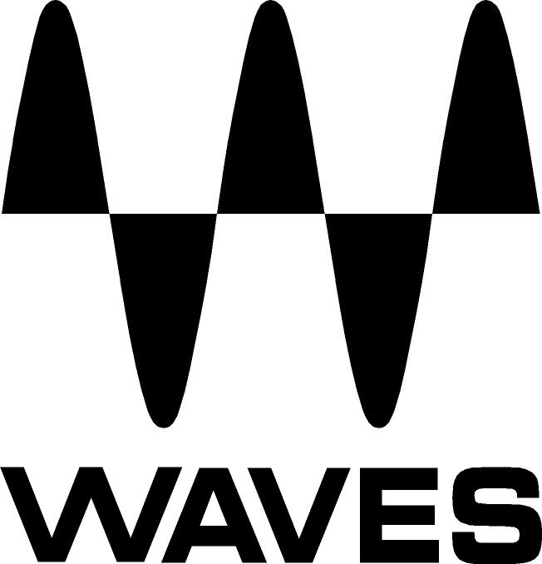

PRESS RELEASE
Contact: Clyne Media, Inc.
Tel: (615) 662-1616
Fax: (615) 662-1636

FOR IMMEDIATE RELEASE

Waves Audio Introduces the Waves Abbey Road Collection

— Expanding on their highly successful series of collaborations with Abbey Road Studios, Waves has assembled the Abbey Road Collection, featuring five modeled plugins —

TEL AVIV, ISRAEL, May 21, 2014 — Waves Audio, a leading provider of digital signal processing software and hardware solutions, introduces the Waves Abbey Road Collection. Developed in association with Abbey Road Studios, the Waves Abbey Road Collection features a lineup of exquisite plugins that meticulously model the fabled studios’ legendary microphones, consoles, tape machines and signature effects, as heard on countless historic recordings and pop masterpieces.

The Waves Abbey Road Collection includes the acclaimed REDD consoles, the RS56 Passive EQ (‘the Curve Bender’) and the J37 Tape, as well as the vintage King’s Microphones and the pioneering Reel ADT. All of these plugins are carefully modeled on the original, rare and often exclusive Abbey Road Studios hardware, providing users with legendary sound in the studio or live on stage.

Mick Olesh, Waves EVP Sales & Marketing, stated, “Abbey Road Studios is undoubtedly the most celebrated recording complex in the world. We are excited to be able to continue our collaboration with Abbey Road on this exceptional collection of audio plugins.”

Mirek Stiles, Head of Audio Products, Abbey Road Studios, stated, “Abbey Road Studios is proud to work closely with the talented team at Waves, creating the ultimate collection of plugins based on Abbey Road’s cherished classic recording equipment and techniques. These beautiful-sounding plugins encapsulate the hardware and expertise that contribute to the ‘Abbey Road sound’, as heard on the many landmark recordings made at the studios throughout its 80 plus year history. It’s good to know that current and future generations of musicians, engineers and producers working across all genres of music can add a little piece of Abbey Road Studios magic to their music.”

The Waves Abbey Road Collection is Native- and SoundGrid®-compatible. It is now available with a U.S. MSRP of Native $600 (with a special introductory price of $480) and SoundGrid $900 (with a special introductory price $720).

View a product video feature here: http://youtu.be/QPX_VFH0wlc. Read more at http://www.waves.com/bundles/abbey-road-collection. Visit www.waves.com for more information.

Abbey Road Studios, REDD, Curve Bender, RS and their associated logos are trademarks of EMI (IP) Limited.
...ends 338 words

Photo File: AbbeyRoadCollection.JPG

About Abbey Road Studios:
Abbey Road Studios are the most famous recording studios in the world and an iconic symbol of British music. They have been home to countless landmark recordings and pioneering advances in recording technology. Opened in November 1931, Abbey Road Studios were the world’s first purpose-built recording studios. The hallowed building has a phenomenal history spanning over 80 years, working with many of the world’s most famous artists including The Beatles, Pink Floyd, The Hollies, Kate Bush, Oasis, Florence and the Machine, Adele and Lady Gaga. Also one of the world’s premiere locations for movie scoring, since the 1980s films such as Raiders of the Lost Ark, the Lord of The Rings Trilogy, Braveheart and The King’s Speech have been recorded there. The list continues with many other major titles, including Shrek, Prometheus, Harry Potter, Skyfall and The Hobbit. http://www.AbbeyRoad.com

About Waves Ltd.:
Since its start in the early '90s with the introduction of the Q10 equalizer plugin, Waves, the world’s leading developer of DSP audio solutions for professional, broadcast, and consumer electronics audio markets, has gone on to develop a comprehensive line of over 130 audio plugins, including industry standards like the L1 and L2 Ultramaximizers, popular vintage console models, and innovative mixing tools like Vocal Rider and the Artist Signature Series. For its accomplishments, Waves received a Technical GRAMMY® Award in 2011, and the Q10 was selected as an inductee into the TECnology Hall of Fame. Waves technologies are now used to improve sound quality in virtually every sector of the audio market, from recording, mixing, mastering and post-production to broadcast, live sound, and consumer electronics. Waves has over 20 years of expertise in the development of psychoacoustic signal processing algorithms that leverage knowledge of human auditory perception to radically improve perceived sound quality. Waves’ award-winning processors are utilized to improve sound quality in the creation of hit records, major motion pictures, and top-selling video games worldwide. Waves offers computer software as well as hardware-plus-software solutions for the professional and broadcast markets. Under its Maxx brand, Waves offers semiconductor and licensable algorithms for consumer electronics applications. Waves Maxx technologies dramatically enhance audio performance and are used by industry leaders such as Dell, ASUS, JVC, and many others.

All other product names and trademarks are the property of their respective owners, which are in no way associated or affiliated with Waves.

North America Offices:
Waves, Inc., 2800 Merchants Drive, Knoxville, TN 37912;
Tel: 865-909-9200, Fax: 865-909-9245, Email: info@waves.com, Web: http://www.waves.com

Corporate Headquarters Israel:
Waves Ltd., Azrieli Center, The Triangle Tower, 32nd Floor
Tel Aviv 67023, Israel; Tel: 972-3-608-4000, Fax: 972-3-608-4056, Email: info@waves.com,
Web: http://www.waves.com

Waves Public Relations:
Clyne Media, Inc., 169-B Belle Forest Circle, Nashville, TN 37221;
Tel: 615-662-1616, Fax: 615-662-1636, Email: robert@clynemedia.com,
Web: http://www.clynemedia.com

