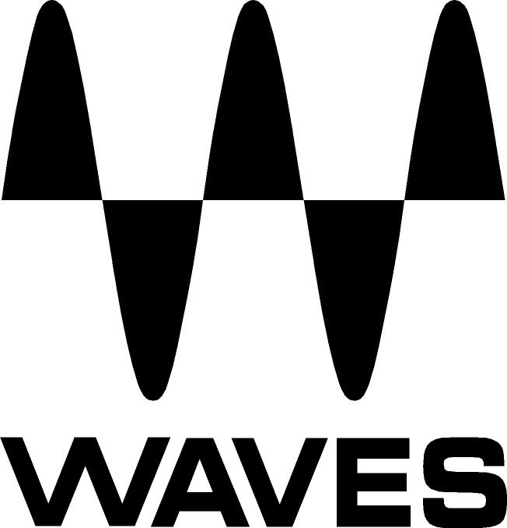
PRESS RELEASE
Contact: Clyne Media, Inc.
Tel: (615) 662-1616
Fax: (615) 662-1636

FOR IMMEDIATE RELEASE

PT. ASIIS Indonesia Chooses the Waves eMotion LV1 for Broadcast Streaming the Unlimited Fire Conference – Power 2020

Knoxville, TN, September 21, 2020 — Andy Mulya Sutikno, Production Director/ Mixing Engineer and Owner and Director of PT. ASIIS Indonesia, chooses the Waves eMotion LV1 Live Mixer and Waves plugins for the broadcast streaming of the Unlimited Fire Conference – Power 2020.

The Unlimited Fire Conference is an interdenominational youth network in Indonesia connecting various churches, businesses, governments and communities and building relationships and networks with youth leaders. The conference, which was based this year in Solo City (Surakarta), featured the Unlimited Fire band, consisting of five vocalists, four musicians, a pastor and two hosts.

ASIIS (Acoustic, Sound, Image, Integrated, Solution), a high-end audio provider based in Indonesia, provided the internet system, broadcast system, tracking and mixing for the Unlimited Fire band’s main worship sessions.

“Our setup’s function is centered on direct-from-stage to the eMotion LV1 Stageboxes,” says Andy. “We used two SoundStudio STG 2412 Stageboxes for the stage, and one STG-1608 for monitor mixing and an additional one for broadcast mixing, feeding our nearfield AMPHION One18 monitors. When working with the SoundStudio Stageboxes, we are able to get VERY clean and controlled high frequencies, solid and tight low frequencies, and warm yet articulated mid and mid-low to get the Hi-Fi feel of a live mix. We supported the venue’s existing backline via a Waves SoundGrid network that connects the broadcast mixer with the monitor mixer – with gain sharing from the various Stageboxes in the SoundGrid network.”
He continues, “The whole conference was broken down into nine sessions that involved a chat, a music video, hosts, worship and sermon. The chat was recorded elsewhere, and I recorded and mixed the worship and sermon. The music video was shot separately by the church. The church’s media team took the worship and pastor sessions that I mixed and then combined it with the other bits and streamed it. We used the eMotion LV1 for tracking and direct mastering for sermons that go direct to a multimedia team for video editing. So, we had materials that were recorded at the moment, together with materials to be sent direct, mixed and mastered, minus sound editing.”

He goes on: “The sessions were recorded beforehand with the Waves eMotion LV1 live mixer, and we then supplied the band’s six sessions for the playback tracks using a Waves SoundGrid Driver to send data over a Cat6 Ethernet cable. We received their prerecorded tracks and prerecorded multitracks which included bass synths, 808s, claps, pads, synths, brass, strings, backing vocals, effects, clicks and guiding vocals – less than 20 hours before they are supposed to be on air! There were about 30+ channel sequencer tracks that we had to manually arrange in time, together with the existing tracks that we already recorded.”

On choosing the LV1, Andy comments, “Simply speaking, Waves’ eMotion LV1 is the most effective and efficient system that exists today. More often than not, we are not familiar with the venue that we are going to work at. We only receive photos of the room, which is usually very small, and it is almost impossible to bring our other huge consoles into such a room. The eMotion LV1 fits really well in terms of size and power.”

Using Waves’ plugins is an integral part of Andy’s workflow: “I constantly used the Scheps Parallel Particles to optimize the bass sound, which originally lacks presence and tends to be too boomy, and EQing does not really help. This plugin enhances the harmonic distortion causing the bass to stand out through the complex mix, and it also adds a thick bite. Using this plugin, you can shape the body in a very controlled way, yet it sounds as if the bass had on it an expensive pick up, went through expensive preamps and an expensive DI. I used Waves’ Smack Attack and Torque plugins for kick and toms, since the acoustic drum kits tend to lack accurate tuning and they sound quite hollow. Smack Attack adds the much-needed attack and also the precise transient needed for fast-paced/upbeat songs to give it more dynamics and excitement. The Torque plugin enables precise tuning and provides added body to the kits, making them sound bigger and richer. In this production, the $800 drum sounded like a $5000 one after using these plugins! I insert the F6 Floating-Band Dynamic on almost all channels. We like to do EQing and Dynamic EQing all in one window. With most vocal microphones, the F6 helps to reduce the mid-low and low proximity effects by using dynamic EQ, especially when the singer suddenly gets too close to the mic; or alternatively, when they sing quite distant from the mic and the dynamic EQ processing does not trigger, the F6 ensures a full-bodied vocal. I also inserted the F6 for the whole vocal group, particularly when they hit on the same threshold, specifically on the 250hz when they sing together. It can sound muffled and at 3000hz-4500hz it successfully reduces the harshness of the vocals. An additional benefit is that it also helps in reducing ear fatigue during those times where they tend to shout. Overall, the Waves F6 helps the whole signal to glue them together and create a balanced and pleasant vocal sound.”

He continues, “For the Bass and Drum Group I put on the Waves Abbey Road TG Mastering Chain to first bring forth a very pleasant low saturation and warmth, something which we normally don’t hear so much in a pure clean digital recording. Also, the TG somehow just glues the drum and bass together. And again, the F6 also comes in handy here, to trigger the side chain of the Dynamic EQ for Kick and Bass, to safeguard that they don’t close each other and to guarantee that they sound balanced throughout the songs. For me, the Waves L2 Ultramaximizer is a must for the Master Bus, to enrich and make the mix sound much more revealing on the mid-high, and it adds more transient impact on the mid-low and low. I prefer to add clarity to the mid for these new modern mixes, considering that most people listen to mixes in Hi-Fi system or a Lo-Fi one as well. The L2 makes sure that the mix never crosses the line of 0dBu and adding a little dynamic EQ after that makes the mix sound as what we intended it to be and at a loudness level that we expect.”

He sums it up: “The Waves eMotion LV1 enables smooth tracking, mixing and mastering on the fly in a very effective and efficient way. We are able to get the sound we desire effectively, with not only a correct tonal balance, but a correct tone and proper color for each instrument, including a proportional image size with certain harmonic acoustic characteristics. And equally important, using the LV1 helps us make sure that all the instrumentalists, worship leaders and singers are comfortable.”
…ends 1141 words

Photo file 1: AndyMulyaSutikno.JPG
Photo caption 1: Andy Mulya Sutikno, Production Director / Mixing Engineer and Owner and Director of PT. ASIIS Indonesia

Photo file 2: UnlimitedFireConferencePower2020.JPG
Photo caption 2: Unlimited Fire Conference – Power 2020

About Waves Audio Ltd.:
Waves is the world’s leading developer of audio DSP solutions for the professional, broadcast, and consumer electronics audio markets. Since its start in the early '90s with the introduction of the Q10 equalizer plugin, Waves has gone on to develop a comprehensive line of over 150 audio plugins, including industry standards like the L1 and L2 Ultramaximizers, popular vintage console models, and innovative mixing tools like Vocal Rider and the Artist Signature Series. For its accomplishments, Waves received a Technical GRAMMY® Award in 2011, and the Q10 was selected as an inductee into the TECnology Hall of Fame. In 2016, Waves released the eMotion LV1 mixer, a revolutionary live digital mixing console that provides real-time audio mixing for front-of-house, monitor, studio and broadcast engineers. Waves technologies are now used to improve sound quality in virtually every sector of the audio market, from recording, mixing, mastering and post-production to broadcast, live sound, and consumer electronics. Waves has over 25 years of expertise in the development of psychoacoustic signal processing algorithms that leverage knowledge of human auditory perception to radically improve perceived sound quality. Waves’ award-winning processors are utilized to improve sound quality in the creation of hit records, major motion pictures, and top-selling video games worldwide. Waves offers computer software and hardware-plus-software solutions for the professional and broadcast markets. The company’s WavesLive division is a market leader in all live sound sectors, spearheading the development of solutions for all live platforms. Under its Maxx brand, Waves offers semiconductor and licensable algorithms for consumer electronics applications. Waves technologies dramatically enhance audio performance and are used by industry leaders such as Dell, Google, Fitbit, Acer, Asus, Hisense and more.

North America Offices:
Waves, Inc., 2800 Merchants Drive, Knoxville, TN 37912;
Tel: 865-909-9200, Fax: 865-909-9245, Email: info@waves.com,
Web: http://www.waves.com

Corporate Headquarters Israel:
Waves Ltd., Azrieli Center, The Triangle Tower, 32nd Floor, Tel Aviv 67023, Israel;
Tel: 972-3-608-4000, Fax: 972-3-608-4056, Email: info@waves.com,
Web: http://www.waves.com

Waves Public Relations:
Clyne Media, Inc., 169-B Belle Forest Circle, Nashville, TN 37221;
Tel: 615-662-1616, Fax: 615-662-1636, Email: robert@clynemedia.com,
Web: http://www.clynemedia.com

