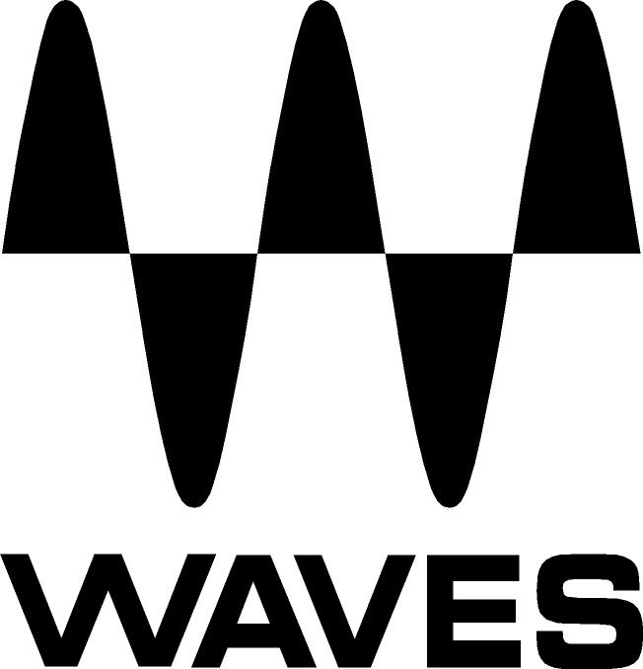
PRESS RELEASE
Contact: Clyne Media, Inc.
Tel: (615) 662-1616
Fax: (615) 662-1636

FOR IMMEDIATE RELEASE

Waves Audio Introduces SoundGrid® BR1, an AVB-to-SoundGrid Bridge for PreSonus AVB Networks

147th AES Convention, New York, NY, October 16, 2019 — Waves Audio (booth 640), the world’s leading developer of professional audio signal processing technologies and leading maker of audio plugins for mixing, music production, mastering, sound design, broadcast, post-production and live sound, introduces SoundGrid BR1, an AVB-to-SoundGrid® bridge that adds real-time audio processing capabilities to AVB networks, for improved sound quality in AVB setups. SoundGrid BR1 currently supports PreSonus AVB networks.

SoundGrid BR1 allows you to integrate the power of Waves’ award-winning plugins into your AVB network. The BR1 is a rack-mountable unit that enables you to stream up to 64 audio channels between Waves SoundGrid and AVB protocols. It provides improved synchronization, audio processing at ultra-low latency, and reliability for switched Ethernet networks.

Suited for studio or live use, SoundGrid is an audio protocol for real-time audio processing and networking at near-zero latency. It gives you access to an impressive catalog of audio plugins that will enhance your sound production. From solving audio issues to adding vibe and character, introducing Waves plugins to your network will give your sound clarity, color and impact.

SoundGrid BR1 features:
- Up to 64 SoundGrid audio channels
- Up to 64 AVB channels
- Supported sample rates: 44.1–48 kHz
- Clock source: SoundGrid/AVB
- 1U half-rack (rack ears included)
- Currently supports PreSonus AVB networks

AVB Manager is included as a native app on Mac devices (macOS 10.10 or later) and on Windows devices through third party app at https://www.riedel.net.

To learn more, visit www.waves.com/hardware/soundgrid-br1.
…ends 237 words

Photo file: SoundGridBR1.JPG
Photo caption: Waves SoundGrid BR1, an AVB-to-SoundGrid® bridge that adds real-time audio processing capabilities to AVB networks

About Waves Audio Ltd.:
Waves is the world’s leading developer of audio DSP solutions for the professional, broadcast, and consumer electronics audio markets. Since its start in the early '90s with the introduction of the Q10 equalizer plugin, Waves has gone on to develop a comprehensive line of over 150 audio plugins, including industry standards like the L1 and L2 Ultramaximizers, popular vintage console models, and innovative mixing tools like Vocal Rider and the Artist Signature Series. For its accomplishments, Waves received a Technical GRAMMY® Award in 2011, and the Q10 was selected as an inductee into the TECnology Hall of Fame. In 2016, Waves released the eMotion LV1 mixer, a revolutionary live digital mixing console that provides real-time audio mixing for front-of-house, monitor, studio and broadcast engineers. Waves technologies are now used to improve sound quality in virtually every sector of the audio market, from recording, mixing, mastering and post-production to broadcast, live sound, and consumer electronics. Waves has over 25 years of expertise in the development of psychoacoustic signal processing algorithms that leverage knowledge of human auditory perception to radically improve perceived sound quality. Waves’ award-winning processors are utilized to improve sound quality in the creation of hit records, major motion pictures, and top-selling video games worldwide. Waves offers computer software and hardware-plus-software solutions for the professional and broadcast markets. The company’s WavesLive division is a market leader in all live sound sectors, spearheading the development of solutions for all live platforms. Under its Maxx brand, Waves offers semiconductor and licensable algorithms for consumer electronics applications. Waves technologies dramatically enhance audio performance and are used by industry leaders such as Dell, Google, Fitbit, Acer, Asus, Hisense and more.

North America Offices:
Waves, Inc., 2800 Merchants Drive, Knoxville, TN 37912;
Tel: 865-909-9200, Fax: 865-909-9245, Email: info@waves.com,
Web: http://www.waves.com

Corporate Headquarters Israel:
Waves Ltd., Azrieli Center, The Triangle Tower, 32nd Floor, Tel Aviv 67023, Israel;
Tel: 972-3-608-4000, Fax: 972-3-608-4056, Email: info@waves.com,
Web: http://www.waves.com

Waves Public Relations:
Clyne Media, Inc., 169-B Belle Forest Circle, Nashville, TN 37221;
Tel: 615-662-1616, Fax: 615-662-1636, Email: robert@clynemedia.com,
Web: http://www.clynemedia.com

Waves Audio is exhibiting at booth 640 at the 147th AES Convention in New York.

